**DATA DRIVEN FRAMEWORK**

**PROJECT EXPLANATION =>ADD “BANK CUSTOMER LOGINS” PAGE TO EXISTING PROJECTS**

**IF WE RIGHT CLICK ON PROEJCT AND THEN RUN AS “MAVEN TEST”,IF IT DOESN’T SHOW AS “BUILD –SUCCESS” THEN RIGHT CLICK ON PROJECT AND CHOOSE CONFIGURE BUILD PATH AS “JDK 17” AND THEN RIGHT CLICK ON PROJECT AND THEN FORCEFULLY UPDATE ON “MODIFY SNAPSHOT/RELEASE” THEN “BUILD SUCCESS” WILL SHOW FOR “MAVEN TEST”**

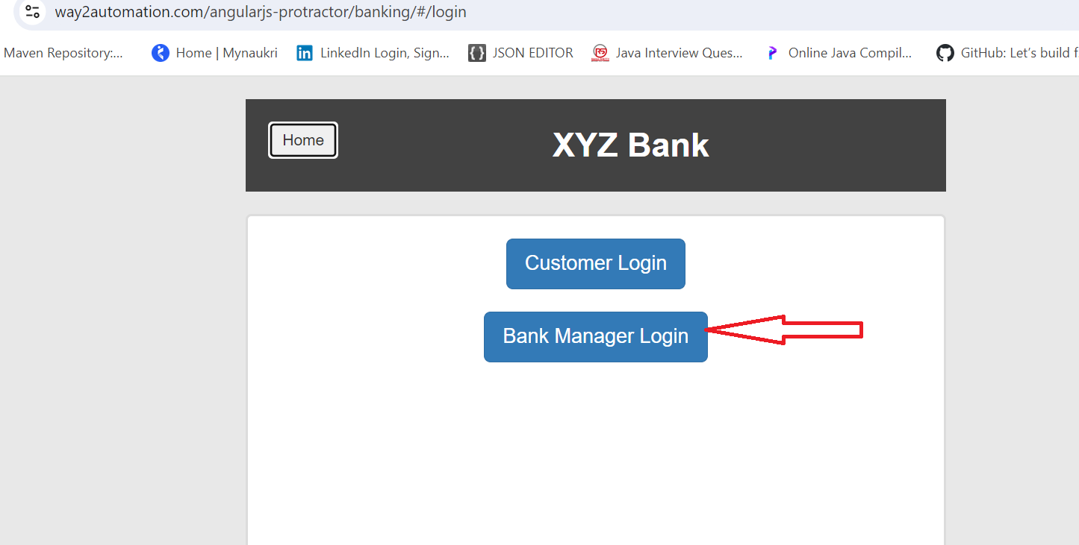

**ENTER THE FIRST NAME,LAST NAME AND POSTAL CODE USING THE EXCEL SHEET**

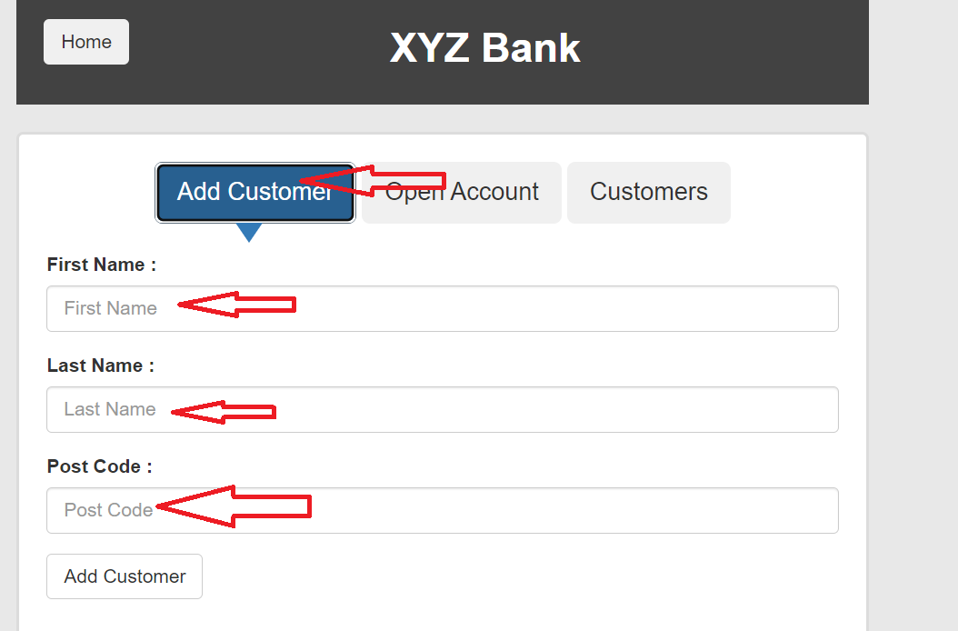

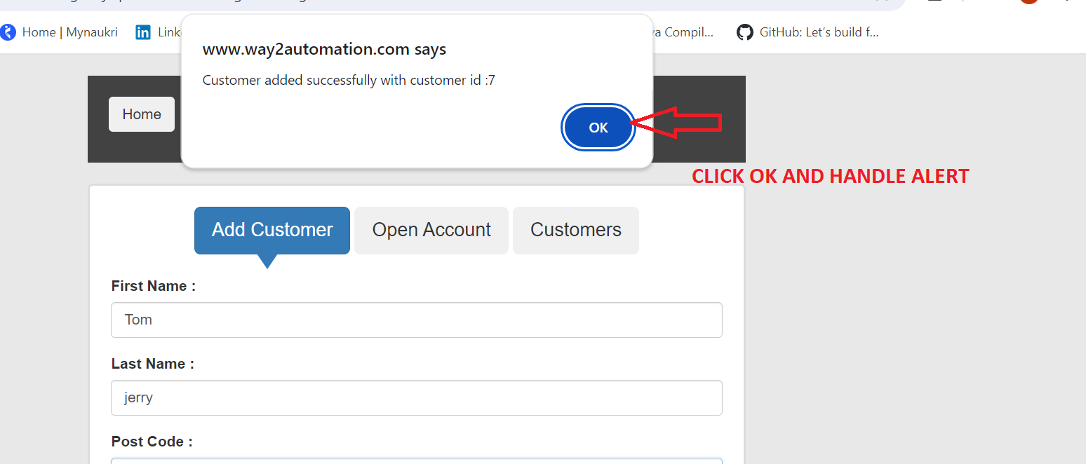

**STEP 1=>CREATE PROJECT STRUCTURE ARE AS BELOW**

**CREATE PACKAGE SUCH AS "BASE CLASS","LISTENER","ROUGH WORK","TESTCASES","UTLITIES" IN "SRC/TEST/JAVA"**

**CREATE FOLDER SUCH AS "DRIVER","EXCELSHEET","LOGS","PROPERTIES","RUNNER" IN "SRC/TEST/RESOURCES"**

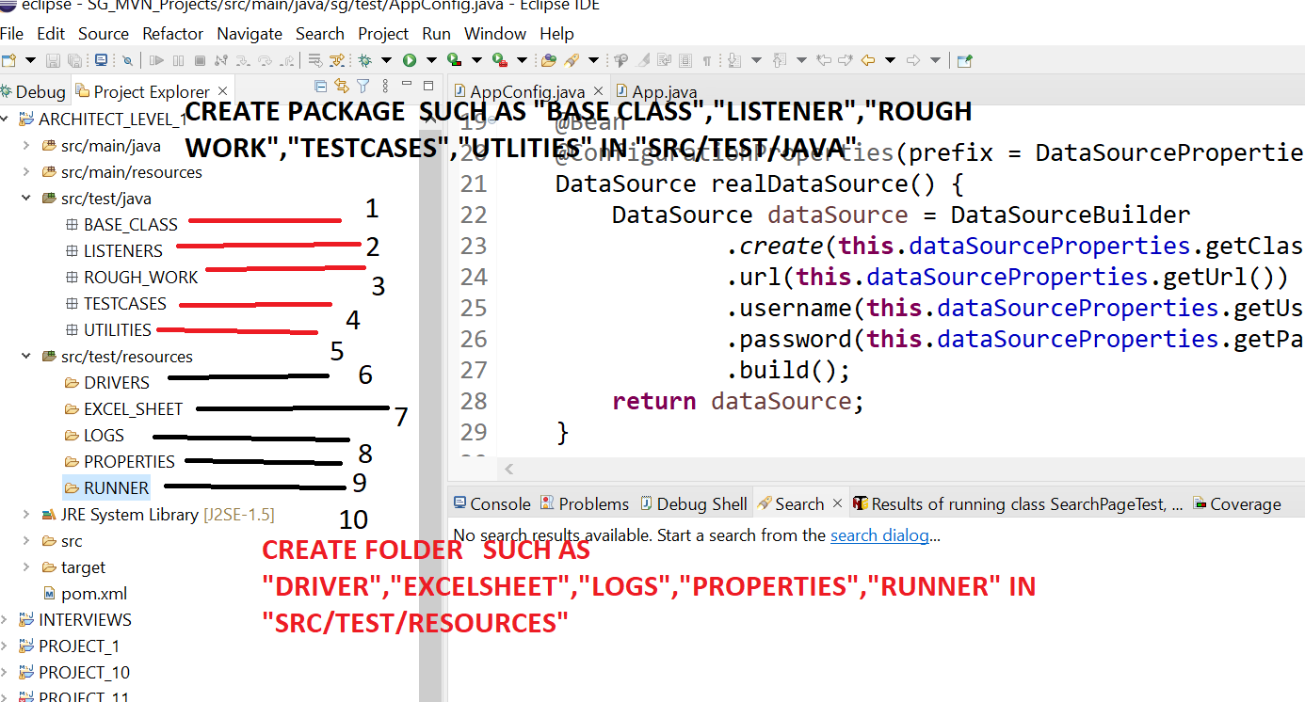

**STEP 2=>ADD BELOW DEPENDENCIES IN POM.XML SUCHAS**

**1)** selenium-java<4.0.0>

**2)** webdrivermanager<5.4.1>

**3)** testing<6.14.3>

**4)** extentreports<5.0.8>-com.aventstack

**5)** reporting<1.1.4>-org.uncommons

**6)** guice<4.1.0>-com.google.inject

**7)** log4j<1.2.17>

**8)** mail<1.4.7> -javax.mail

**9)** mysql-connector-java< 8.0.25 >

**10)** poi< 4.1.1 >- org.apache.poi

**11)** poi-ooxml<4.1.1 >- org.apache.poi

**12)** dom4j<1.6.1>

**13)** xmlbeans<3.1.0>

**14)** poi-ooxml-schemas<4.1.1>

**15)** guava-33.3.0-jre

**16)Add Below Plugin After Dependencies**

<build>

<plugins>

<plugin>

<groupId>org.apache.maven.plugins</groupId>

<artifactId>maven-surefire-plugin</artifactId>

<version>2.18.1</version>

<configuration>

<testFailureIgnore> **false** </testFailureIgnore>

<suiteXmlFiles>

<suiteXmlFile>src/test/resources/RUNNER/testng.xml</suiteXmlFile>

</suiteXmlFiles>

</configuration>

</plugin>

</plugins>

</build>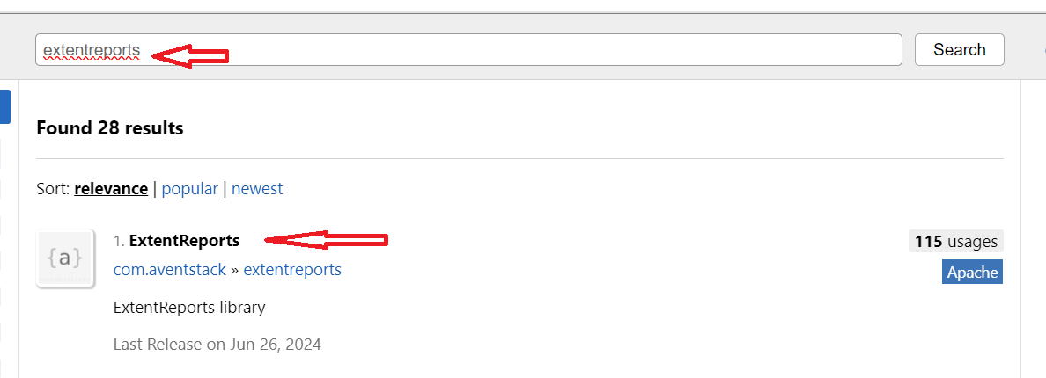

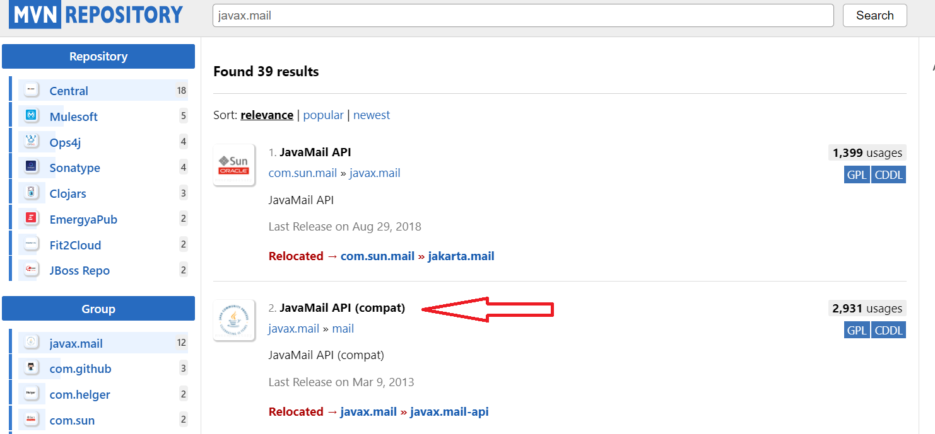

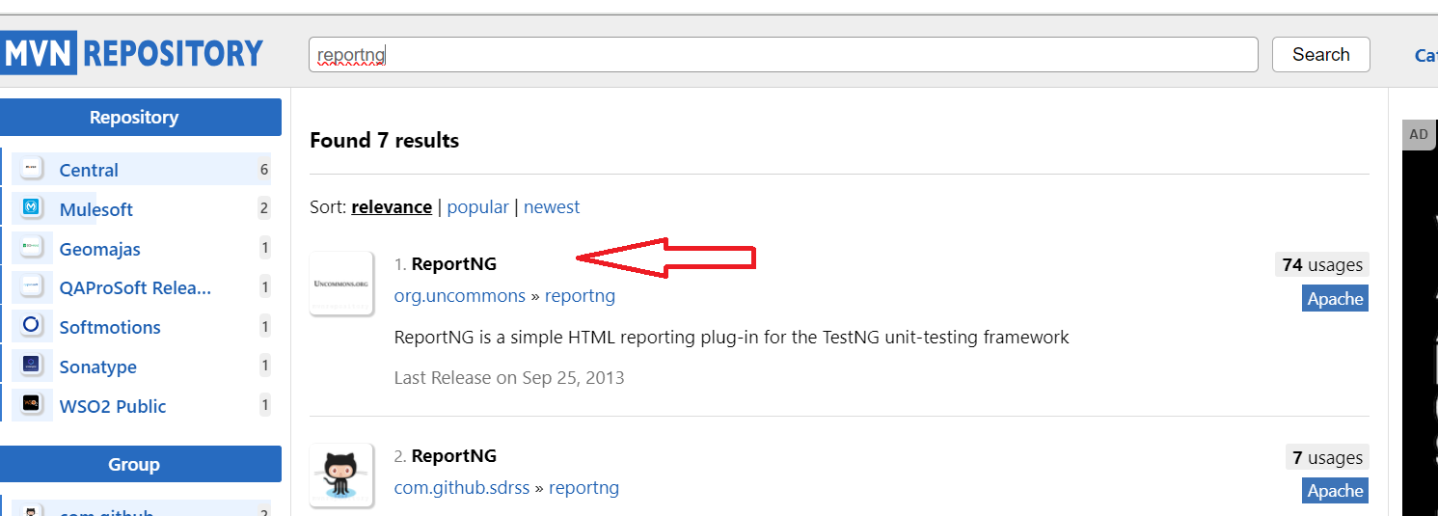

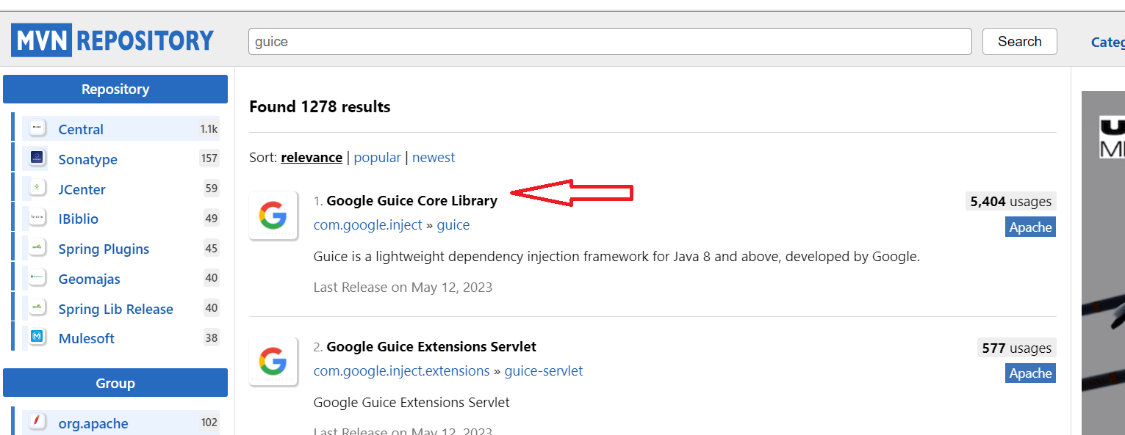

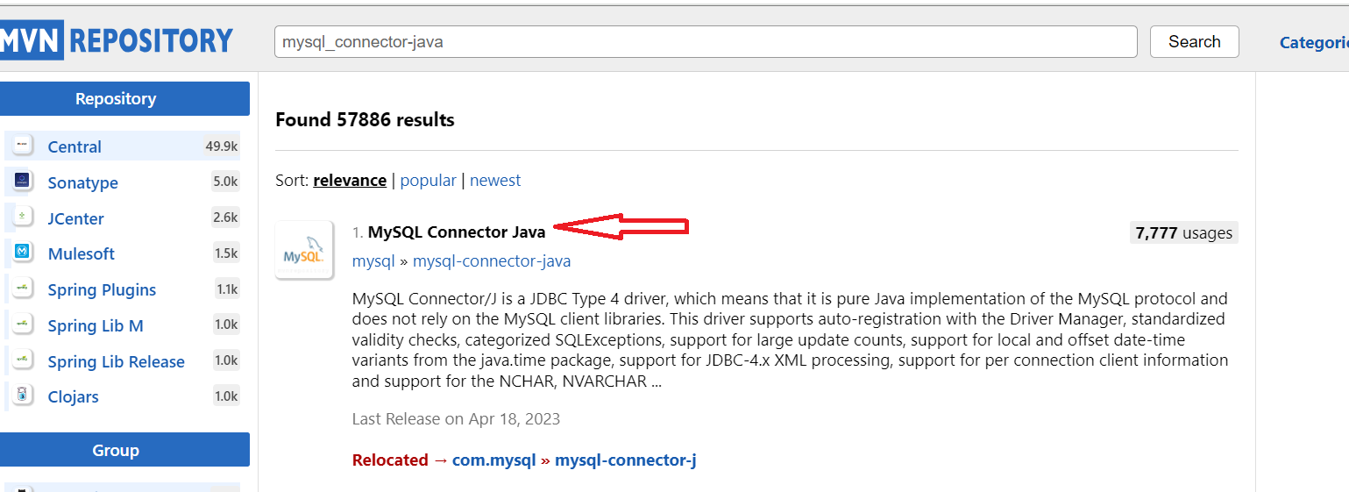

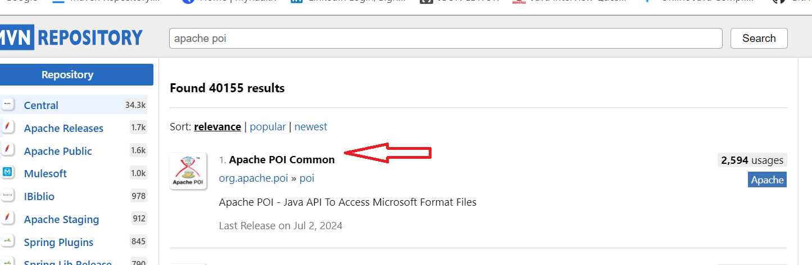

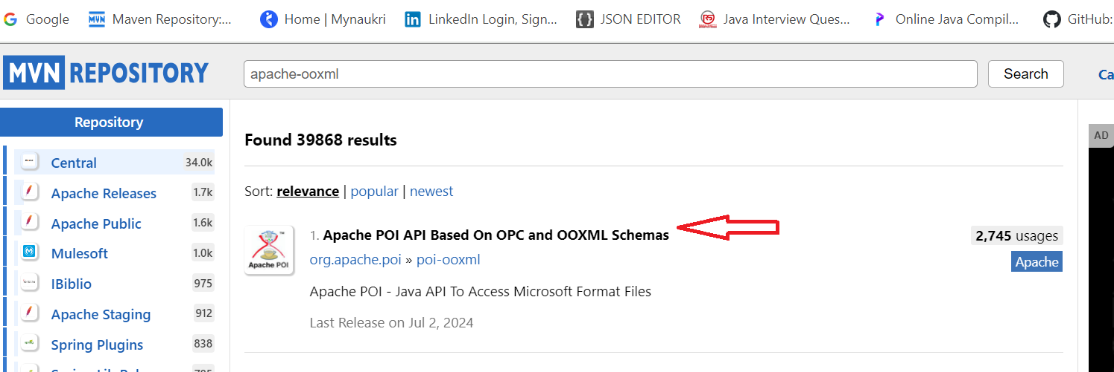

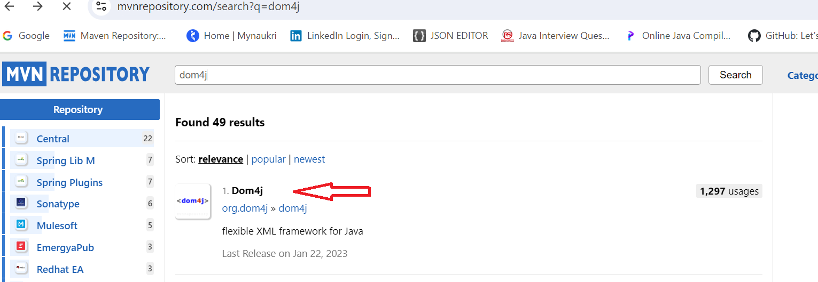

**STEP 3=>SAMPLE DEPENDENCIES IN PROJECT ARE AS FOLLOW**

<dependencies>

<!-- https://mvnrepository.com/artifact/org.testng/testng -->

<dependency>

<groupId>org.testng</groupId>

<artifactId>testng</artifactId>

<version>6.14.3</version>

</dependency>

<!-- https://mvnrepository.com/artifact/org.seleniumhq.selenium/selenium-java -->

<dependency>

<groupId>org.seleniumhq.selenium</groupId>

<artifactId>selenium-java</artifactId>

<version>4.0.0</version>

</dependency>

<!-- https://mvnrepository.com/artifact/io.github.bonigarcia/webdrivermanager -->

<dependency>

<groupId>io.github.bonigarcia</groupId>

<artifactId>webdrivermanager</artifactId>

<version>4.4.3</version>

</dependency>

<!-- https://mvnrepository.com/artifact/com.aventstack/extentreports -->

<dependency>

<groupId>com.aventstack</groupId>

<artifactId>extentreports</artifactId>

<version>5.0.8</version>

</dependency>

<!-- https://mvnrepository.com/artifact/org.uncommons/reportng -->

<dependency>

<groupId>org.uncommons</groupId>

<artifactId>reportng</artifactId>

<version>1.1.4</version>

</dependency>

<!-- https://mvnrepository.com/artifact/com.google.inject/guice -->

<dependency>

<groupId>com.google.inject</groupId>

<artifactId>guice</artifactId>

<version>4.1.0</version>

</dependency>

<!-- https://mvnrepository.com/artifact/log4j/log4j -->

<dependency>

<groupId>log4j</groupId>

<artifactId>log4j</artifactId>

<version>1.2.17</version>

</dependency>

<!-- https://mvnrepository.com/artifact/javax.mail/mail -->

<dependency>

<groupId>javax.mail</groupId>

<artifactId>mail</artifactId>

<version>1.4.7</version>

</dependency>

<!-- https://mvnrepository.com/artifact/mysql/mysql-connector-java -->

<dependency>

<groupId>mysql</groupId>

<artifactId>mysql-connector-java</artifactId>

<version>8.0.25</version>

</dependency>

<!-- POI JARS STARTS -->

<!-- https://mvnrepository.com/artifact/org.apache.poi/poi -->

<dependency>

<groupId>org.apache.poi</groupId>

<artifactId>poi</artifactId>

<version>4.1.1</version>

</dependency>

<!-- https://mvnrepository.com/artifact/org.apache.poi/poi-ooxml -->

<dependency>

<groupId>org.apache.poi</groupId>

<artifactId>poi-ooxml</artifactId>

<version>4.1.1</version>

</dependency>

<!-- https://mvnrepository.com/artifact/dom4j/dom4j -->

<dependency>

<groupId>dom4j</groupId>

<artifactId>dom4j</artifactId>

<version>1.6.1</version>

</dependency>

<!-- https://mvnrepository.com/artifact/org.apache.xmlbeans/xmlbeans -->

<dependency>

<groupId>org.apache.xmlbeans</groupId>

<artifactId>xmlbeans</artifactId>

<version>3.1.0</version>

</dependency>

<!-- https://mvnrepository.com/artifact/org.apache.poi/poi-ooxml-schemas -->

<dependency>

<groupId>org.apache.poi</groupId>

<artifactId>poi-ooxml-schemas</artifactId>

<version>4.1.1</version>

</dependency>

<!-- POI JARS ENDS -->

<!-- https://mvnrepository.com/artifact/com.google.guava/guava -->

<dependency>

<groupId>com.google.guava</groupId>

<artifactId>guava</artifactId>

<version>33.3.0-jre</version>

</dependency>

</dependencies>

<build>

<plugins>

<plugin>

<groupId>org.apache.maven.plugins</groupId>

<artifactId>maven-surefire-plugin</artifactId>

<version>2.18.1</version>

<configuration>

<testFailureIgnore> false </testFailureIgnore>

<suiteXmlFiles>

<suiteXmlFile>src/test/resources/RUNNER/testng.xml</suiteXmlFile>

</suiteXmlFiles>

</configuration>

</plugin>

</plugins>

</build>

**STEP 4=>CREATE TESTNG.XML FILE IN “RUNNER “ FOLDER AND PROVIDE THE SAME LOCATION IN MAVEN SUREFIRE PLUGINS**

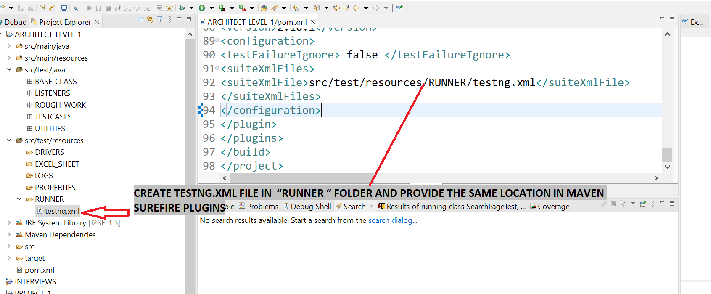

**STEP 5&STEP 6=> NEED TO ADD TWO PROPERTIES WITH EXTENSION AS ".properties" TO STORE LOCATOR AND BROWSER NAME**

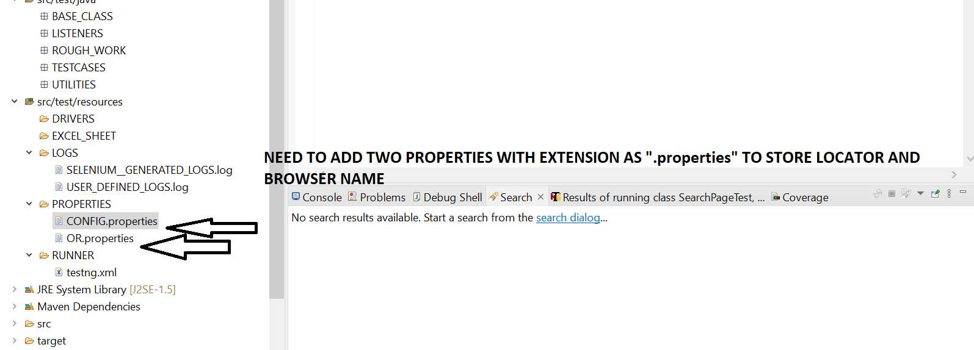

**STEP 7=>WRITE BELOW DETAILS IN “CONFIG.PROPERTIES” FILE SUCH AS BROWSER NAME AND TEST SITE URL**

**=>**BROWSER=CHROME

TESTSITEURL=https://www.way2automation.com/angularjs-protractor/banking/#/login

chromepath=\DRIVERS\chromedriver.exe

geckodriverpath=./DRIVERS\\geckodriver.exe

ie_driverpath=./DRIVERS\\msedgedriver.exe

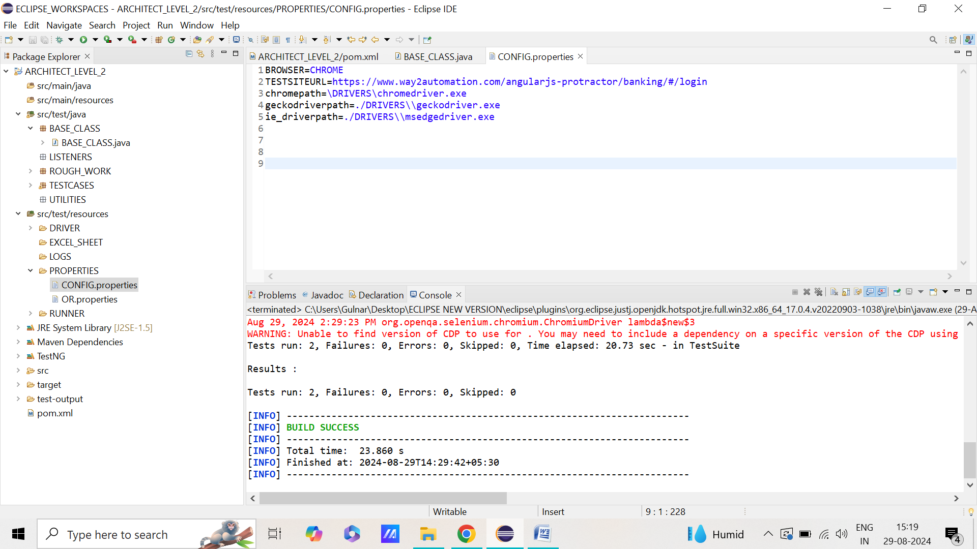

**STEP 8=> WRITE BELOW DETAILS IN “OR .PROPERTIES” FILE AND TEST SITE URL WRITING XPATH IN “OR.PROPERTIES” USING THE CSS SELECTOR**

**=>** SEARCH_PRODUCT=input#search_product

SUBMIT_SEARCH=button#submit_search

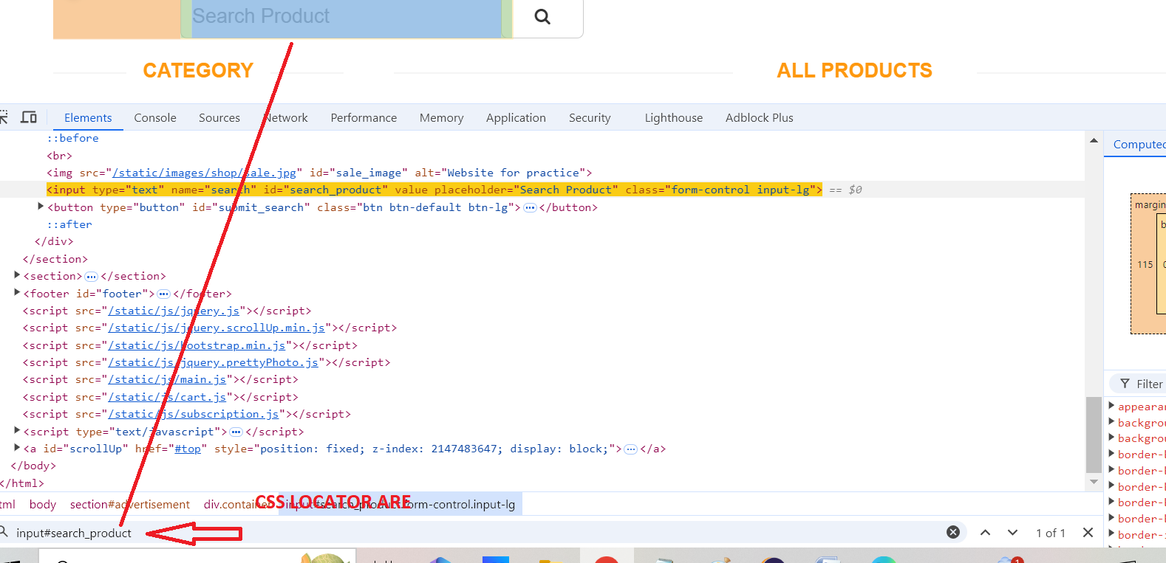

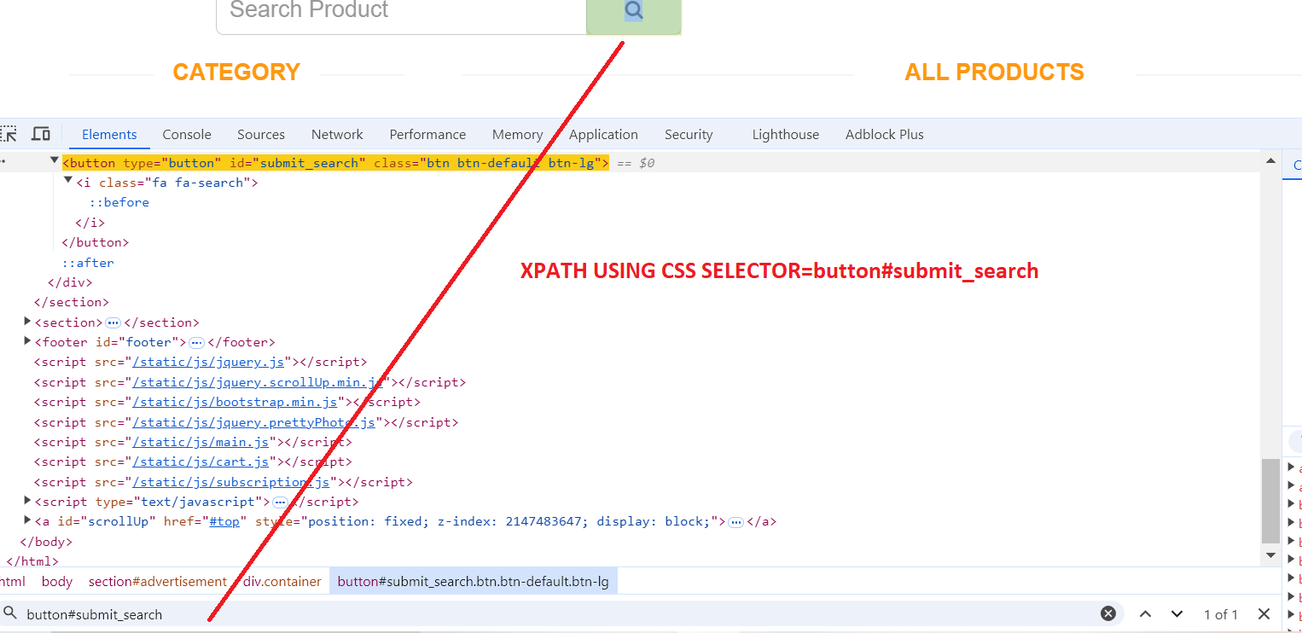

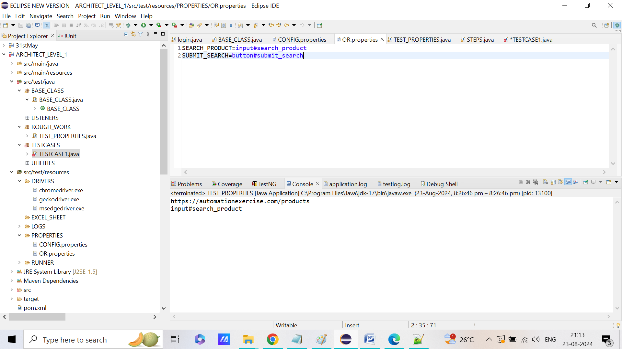

**STEP 9=>WRITE CLASS NAMED “TESTPROPERTIES” IN “ROUGH PACKAGE” AND WRITE BELOW CODE TO LAUNCH PROPERITES FILE**

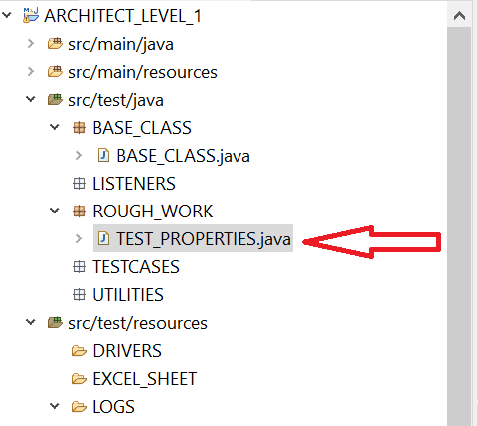

**package** ROUGH_WORK;

**import** java.io.FileInputStream;

**import** java.io.FileNotFoundException;

**import** java.io.IOException;

**import** java.util.Properties;

**public** **class** TEST_PROPERTIES {

**public** **static** **void** main(String[] args) **throws** IOException

{

Properties config=**new** Properties();

Properties OR=**new** Properties();

FileInputStream fis=**new** FileInputStream(System.*getProperty*("user.dir")+"\\src\\test\\resources\\PROPERTIES\\CONFIG.properties");

config.load(fis);

System.***out***.println(config.getProperty("TESTSITEURL"));

fis=**new** FileInputStream(System.*getProperty*("user.dir")+"\\src\\test\\resources\\PROPERTIES\\OR.properties");

config.load(fis);

System.***out***.println(config.getProperty("SEARCH_PRODUCT"));

}

}

**STEP 10=>RIGHT CLICK ON “TEST PROPERTIES” CLASS AND RUN AND CHECK WHETHER IT IS ABLE TO FETCH THE PROPERTIES FROM “CONFIG” AND “OR”PROPERTIES IN CONSOLE PAGE OR NOT?**

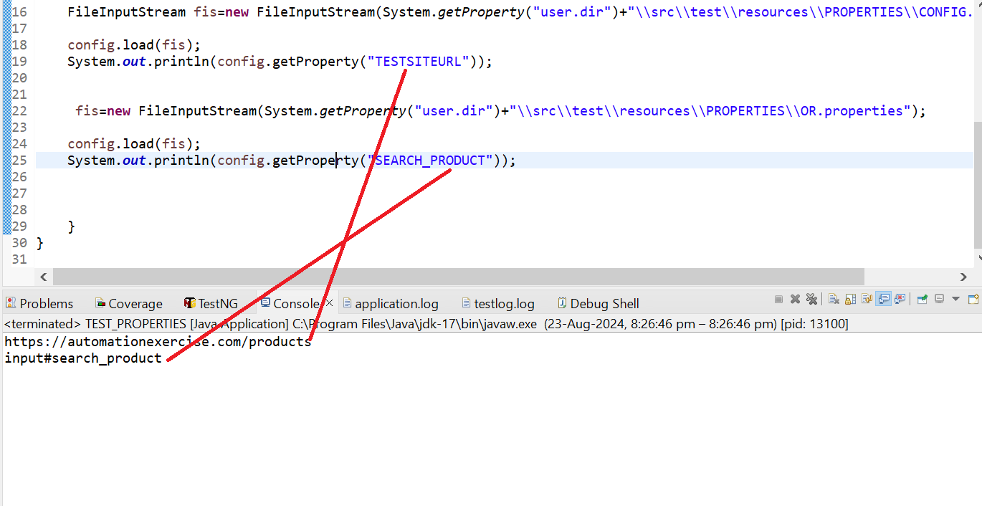

**STEP 11=> ADD THE DRIVER SUCH AS CHROME ETC IN YOUR PROJECTS**

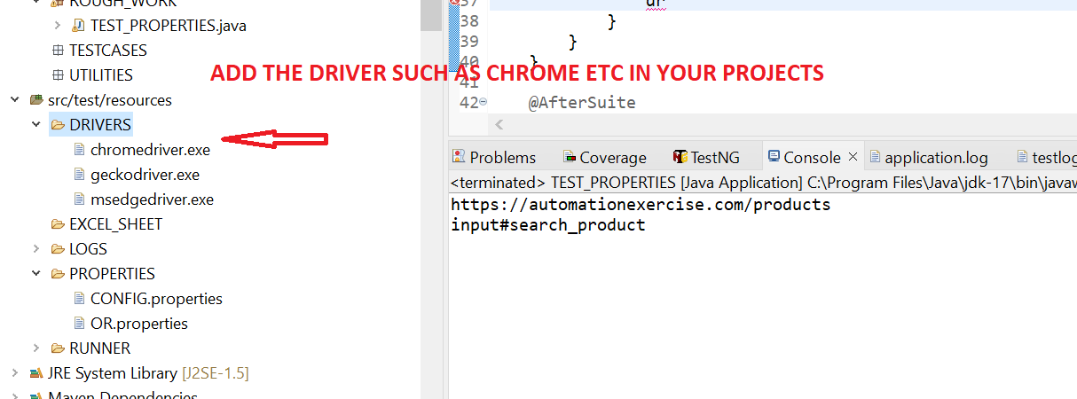

**STEP 12=> NOW WE CREATE BASICS BASE CLASS “BASE PACKAGE” AND WRITE BELOW CODE**

**package** BASE_CLASS;

**import** java.io.FileInputStream;

**import** java.io.IOException;

**import** java.time.Duration;

**import** java.util.Properties;

**import** org.openqa.selenium.WebDriver;

**import** org.openqa.selenium.chrome.ChromeDriver;

**import** org.openqa.selenium.chrome.ChromeOptions;

**import** org.openqa.selenium.edge.EdgeDriver;

**import** org.openqa.selenium.edge.EdgeOptions;

**import** org.openqa.selenium.firefox.FirefoxDriver;

**import** org.openqa.selenium.firefox.FirefoxOptions;

**import** org.openqa.selenium.support.ui.WebDriverWait;

**import** org.testng.annotations.AfterSuite;

**import** org.testng.annotations.BeforeSuite;

**import** io.github.bonigarcia.wdm.WebDriverManager;

**public** **class** BASE_CLASS {

**public** **static** WebDriver *driver*;

**public** Properties config = **new** Properties();

**public** Properties OR = **new** Properties();

**public** **static** WebDriverWait *wait* ;

@BeforeSuite

**public** **void** setup() **throws** IOException, InterruptedException

{

**if** (*driver* == **null**)

{

FileInputStream fis = **new** FileInputStream(

System.*getProperty*("user.dir") + "\\src\\test\\resources\\PROPERTIES\\CONFIG.properties");

config.load(fis);

fis = **new** FileInputStream(

System.*getProperty*("user.dir") + "\\src\\test\\resources\\PROPERTIES\\OR.properties");

OR.load(fis);

**if**(config.getProperty("BROWSER").equals("CHROME"))

{

System.*setProperty*("Webdriver.chrome.driver",config.getProperty("chromepath"));

ChromeOptions option = **new** ChromeOptions();

option.addArguments("--remote-allow-origins=*");

WebDriverManager.*chromedriver*().setup();

*driver* = **new** ChromeDriver(option);

}

**else** **if**(config.getProperty("BROWSER").equals("firefox"))

{

System.*setProperty*("Webdriver.gecko.driver",config.getProperty("geckodriverpath"));

FirefoxOptions option = **new** FirefoxOptions();

//option.addArguments("--remote-allow-origins=*");

WebDriverManager.*firefoxdriver*().setup();

*driver* = **new** FirefoxDriver(option);

}

**else** **if**(config.getProperty("BROWSER").equals("ie"))

{

System.*setProperty*("Webdriver.edge.driver",config.getProperty("ie_driverpath"));

EdgeOptions option = **new** EdgeOptions ();

option.addArguments("--remote-allow-origins=*");

WebDriverManager.*edgedriver*().setup();

*driver* =**new** EdgeDriver(option);

}

*driver*.get(config.getProperty("TESTSITEURL"));

Thread.*sleep*(3000);

*driver*.manage().window().maximize();

*driver*.manage().deleteAllCookies();

*driver*.manage().timeouts().implicitlyWait(Duration.*ofHours*(2));

*wait* = **new** WebDriverWait(*driver*, Duration.*ofSeconds*(10));

}

}

@AfterSuite

**public** **void** Tearup() {

**if**(*driver*!=**null**)

{

*driver*.quit();

}

}

}

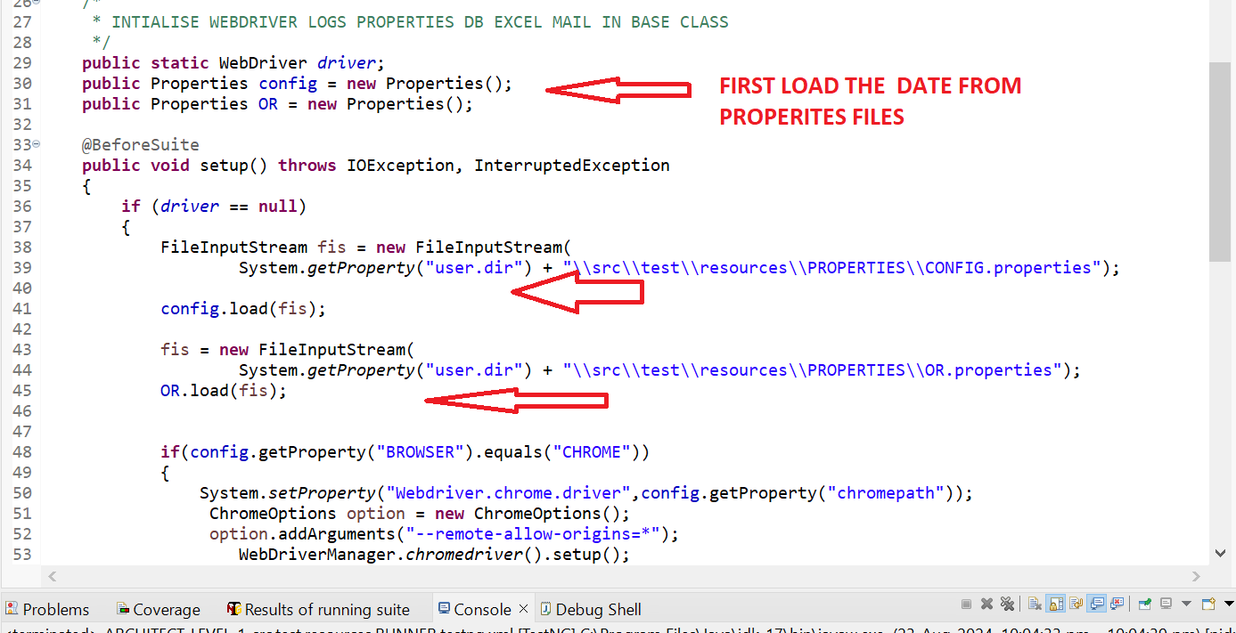

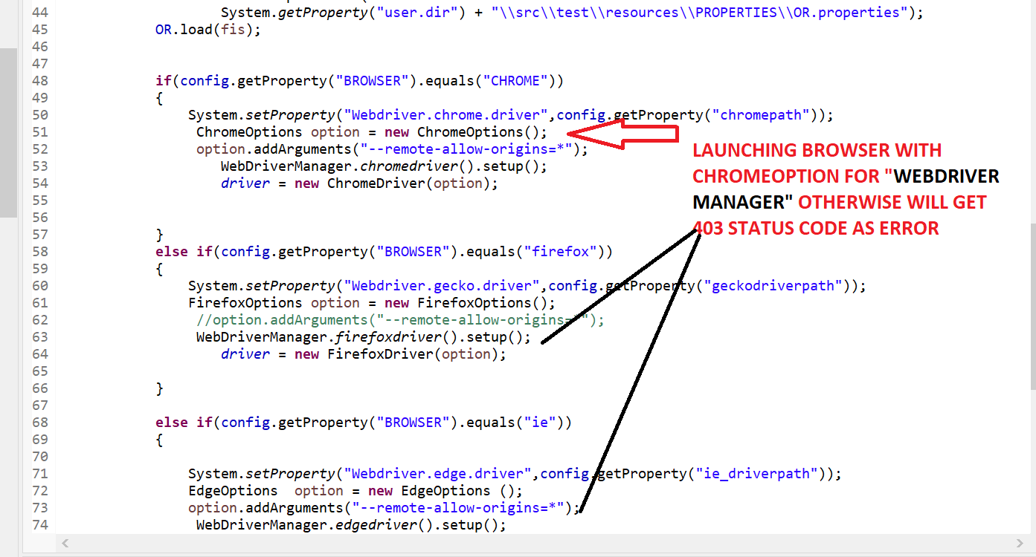

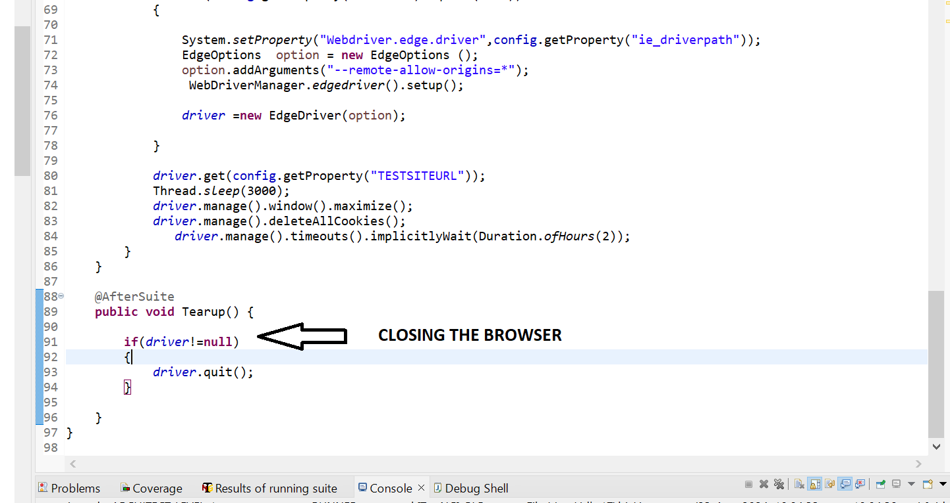

**STEP 13=> ADD TESTNG JAR AND CONFIGURE BUILD PATH**

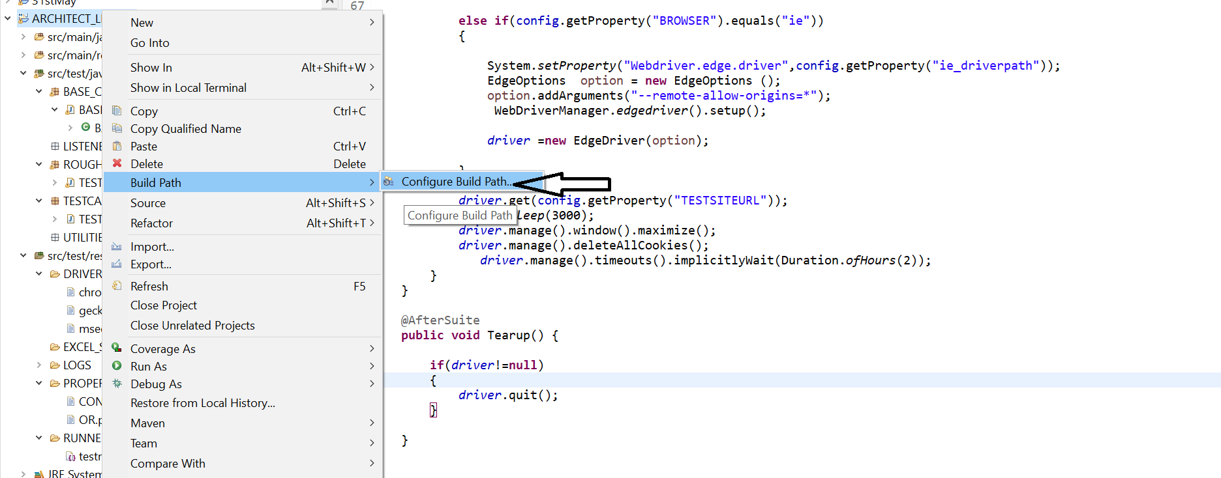

**STEP 14=>NOW WE WILL CREATE TESTCASE 1 IN “TESTCASE” PACKAGE and WRITE BELOW CODE**

**package** TESTCASES;

**import** org.openqa.selenium.Alert;

**import** org.openqa.selenium.By;

**import** org.openqa.selenium.support.ui.ExpectedConditions;

**import** org.testng.Assert;

**import** org.testng.Reporter;

**import** org.testng.annotations.DataProvider;

**import** org.testng.annotations.Test;

**import** BASE_CLASS.BASE_CLASS;

**public** **class** TESTCASE1 **extends** BASE_CLASS

{

@Test

**public** **void** method1() **throws** InterruptedException

{

Thread.*sleep*(3000);

*driver*.findElement(By.*xpath*(OR.getProperty("customer_login"))).click();

Thread.*sleep*(2000);

*driver*.findElement(By.*xpath*(OR.getProperty("Addcusotmer"))).click();

}

@Test

**public** **void** method6() **throws** Throwable

{

Thread.*sleep*(3000);

*driver*.findElement(By.*xpath*(OR.getProperty("firstname"))).sendKeys("FirstName");

Thread.*sleep*(2000);

*driver*.findElement(By.*xpath*(OR.getProperty("lastname"))).sendKeys("lastName");

Thread.*sleep*(2000);

*driver*.findElement(By.*xpath*(OR.getProperty("postalcode"))).sendKeys("postcalCode");

Thread.*sleep*(2000);

*driver*.findElement(By.*xpath*(OR.getProperty("add_cusomter_button"))).click();

}

}

**STEP 15=> IF WE COMMENT THE "ADD AGRUMENT" LINE ,WE GIVE GET ERROR AS "INVALID STATUS CODE=403**

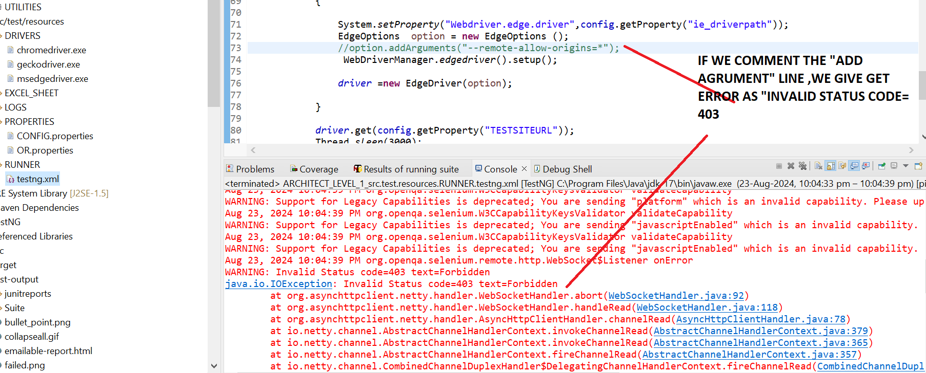

**STEP 15=> CREATE BELOW TESTNG.XML FILE AND RIGHT CLICK ON TESNT.XML FILE AND RUN AS “TESTNG SUITE”**

<?xml version="1.0" encoding="UTF-8"?>

<!DOCTYPE suite SYSTEM "http://testng.org/testng-1.0.dtd" >

<suite name="Suite">

<test name="TESTCASE1">

<classes>

<class name="TESTCASES.TESTCASE1"/>

</classes>

</test> <!-- Test -->

</suite> <!-- Suite -->

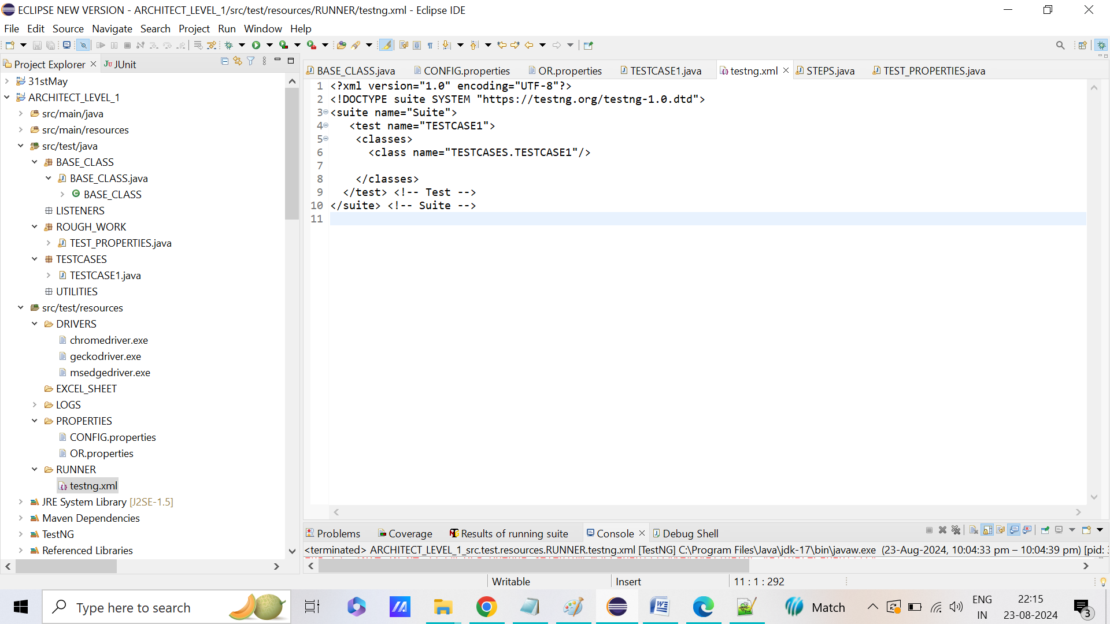

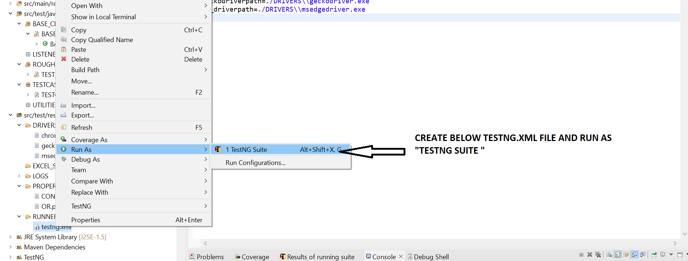

**STEP 16=> RIGHT CLICK AND RUN AS “MAVEN TEST ”.IT SHOULD WORK AS EXEPECTED .NOW RUN THE APPLICATION ON ALL THREE BROWSER AND CHECK IT IS RUNNING THE TEST CASES 1 AS EXPECTED AND REPORT IS GETTING GENERATED IN “TEST-OUTPUT” FOLDER**

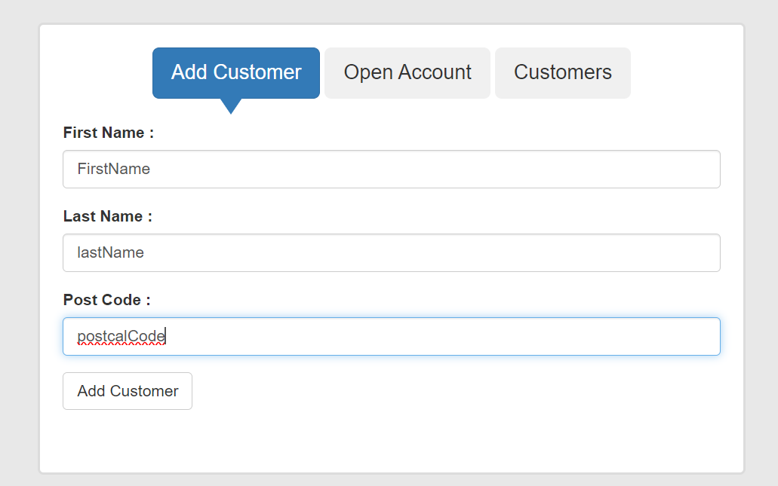

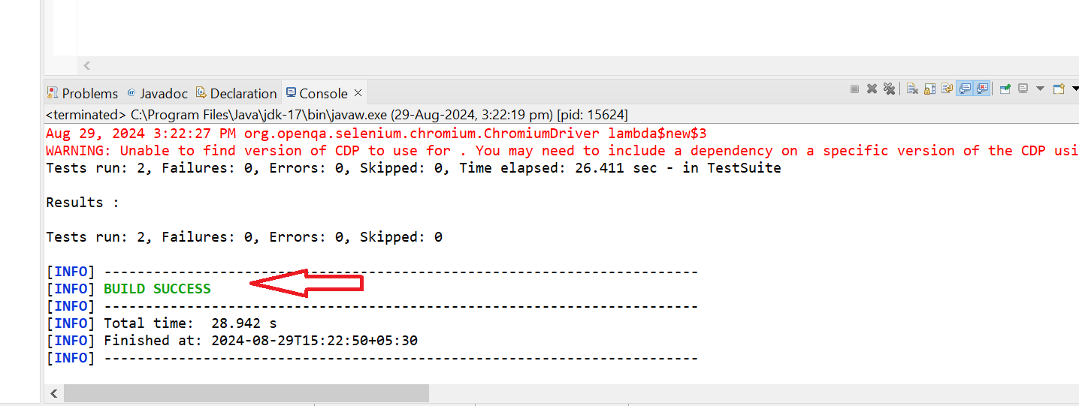

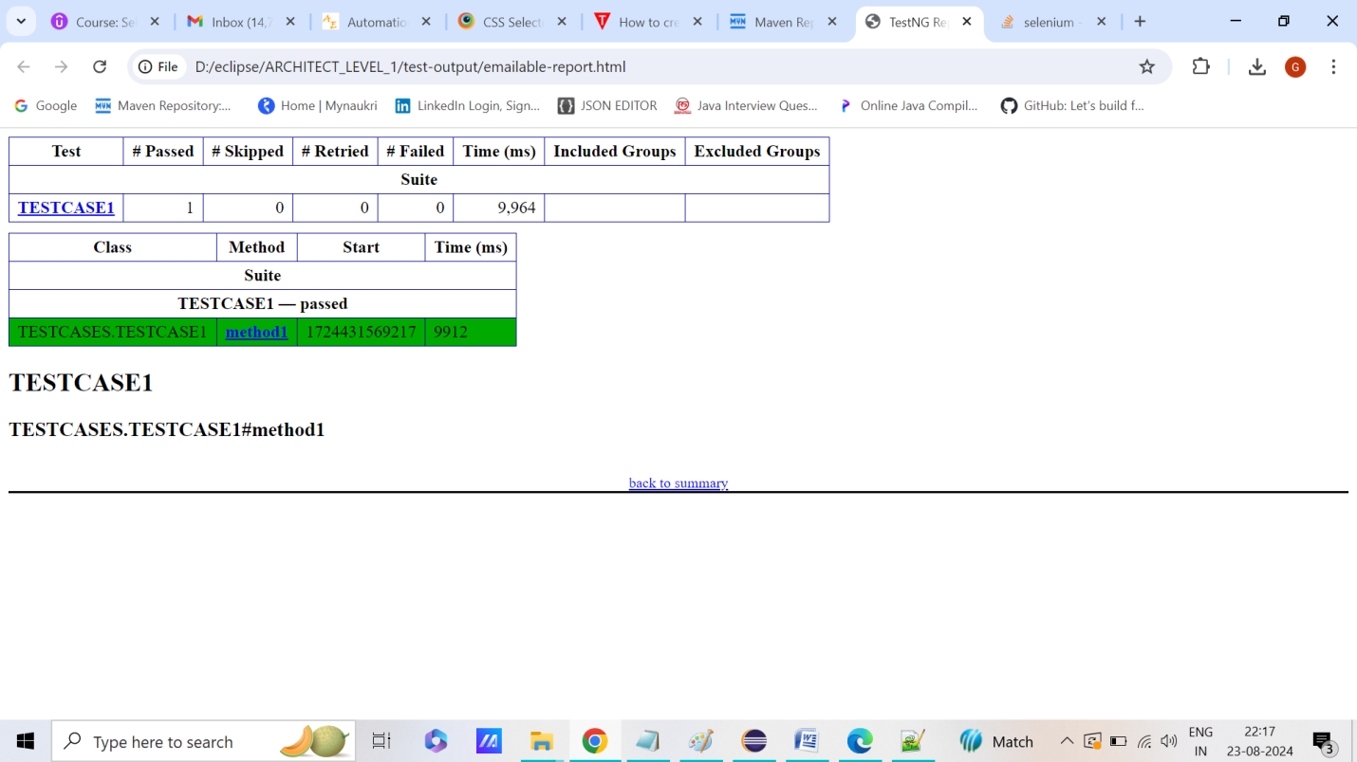

**STEP 17=>HOW TO GENERATE LOGS?**

**STEPS 1=>DOWNLOAD “LOG 4J” DEPENEDENCIES AS IT IS ALREADY DOWNLOADED and also LOG 4J JAR FILE USING “CONFIGURE BUILD PATH”**

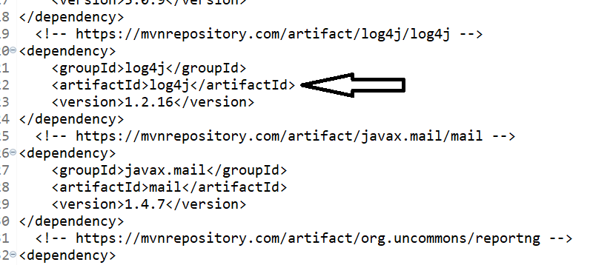

**STEPS 2=>ADD NEW FILE AS EXTENSION As “LOG4J.properties” and WRITE BELOW CODE THERE WHERE NEED TO PROVIDE THE FOLDER NAME IN “log4j.appender.Appender.File” AS LOGS WILL BE GENERATED IN THAT FOLDER AND FILE NAME WILL BE WRITTEN ALONG WITH CURRENT DATE TIME**

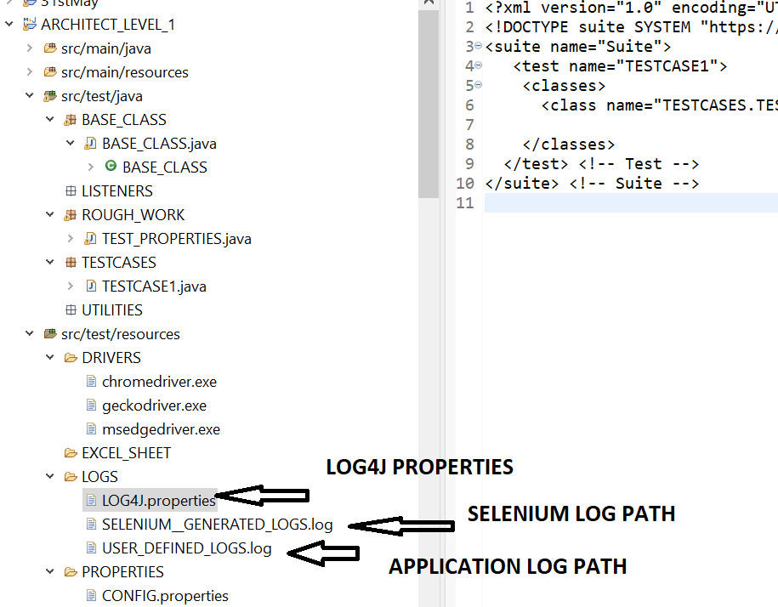

**log4j.rootLogger=INFO, Appender**

**log4j.appender.Appender=org.apache.log4j.FileAppender**

**log4j.appender.Appender.File=src/test/resources/LOGS/app_${current.date}_log.txt**

**log4j.appender.Appender.layout=org.apache.log4j.PatternLayout**

**log4j.appender.Appender.layout.ConversionPattern=%-7p %d [%t] %c %x - %m%n**

**log4j.appender.Appender.Append=false**

**log4j.appender.file.maxFileSize=5000KB**

**log4j.appender.file.maxBackupIndex=3**

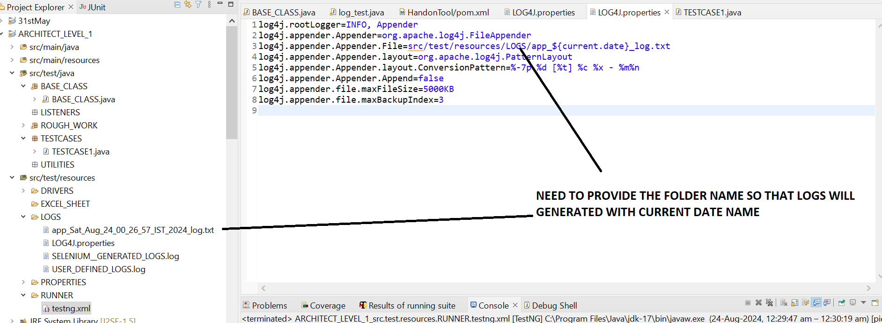

**IMPORTANT CODE FOR LOG GENERATION ARE AS FOLLOW=>NEED TO MENTION THE CURRENT CLASSNAME IN LOGGER =LOG=LOGGER.LOG(CLASSNAME.GETNAME())**

**public** **static** Logger *log* = Logger.*getLogger*(BASE_CLASS.**class**.getName());

@BeforeSuite

**public** **void** setup() **throws** IOException, InterruptedException

{

Date d = **new** Date();

System.*setProperty*("current.date", d.toString().replace(":", "_").replace(" ", "_"));

PropertyConfigurator.*configure*("D:\\eclipse\\ARCHITECT_LEVEL_1\\src\\test\\resources\\LOGS\\LOG4J.properties");

}

**IN PROPERTY CONFIGURATOR ,NEED TO PROVIDE THE LOG 4J.PROPERTIES PATH AND THEN CALLED “*LOG*.INFO("CONFIG FILE IS LOADED!!!");” IN EVERY METHOD &RUN THE PROJECTS AND REFRESH THE PROJECTS.LOG WILL AUTOMATICALLY GET GENERATED**

**IN “LOGS FOLDER “ WITH CURRENT DATE TIME AS SAME MENTIONED IN “LOG4J.PROPERTIES”**

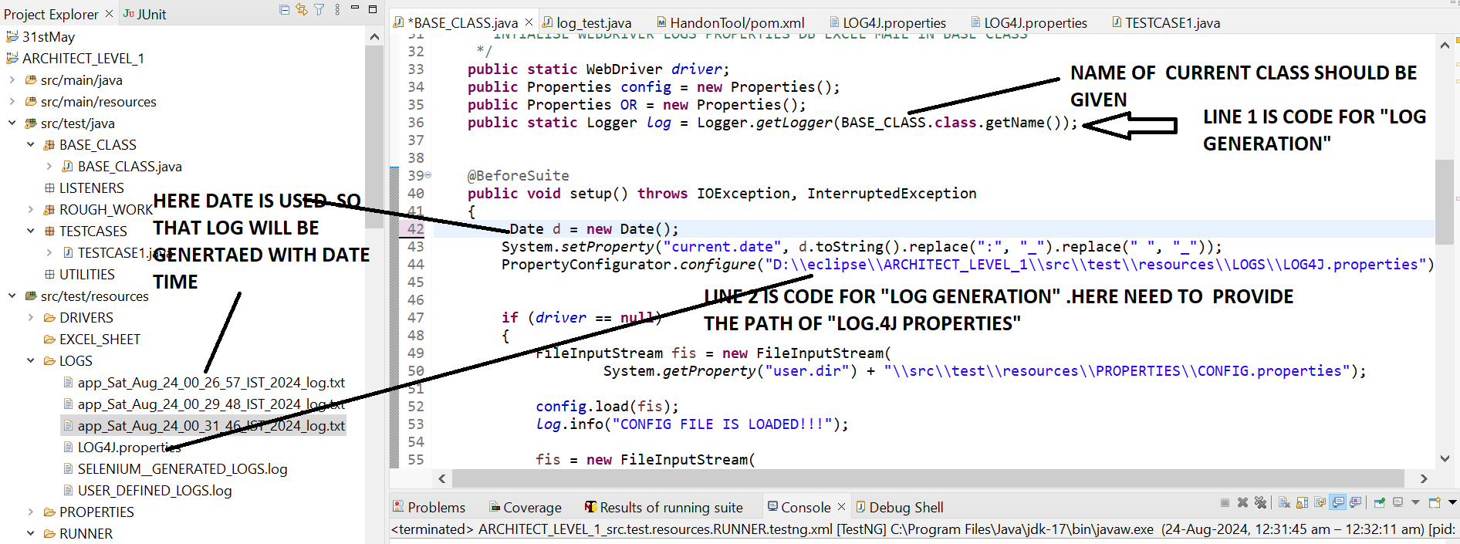

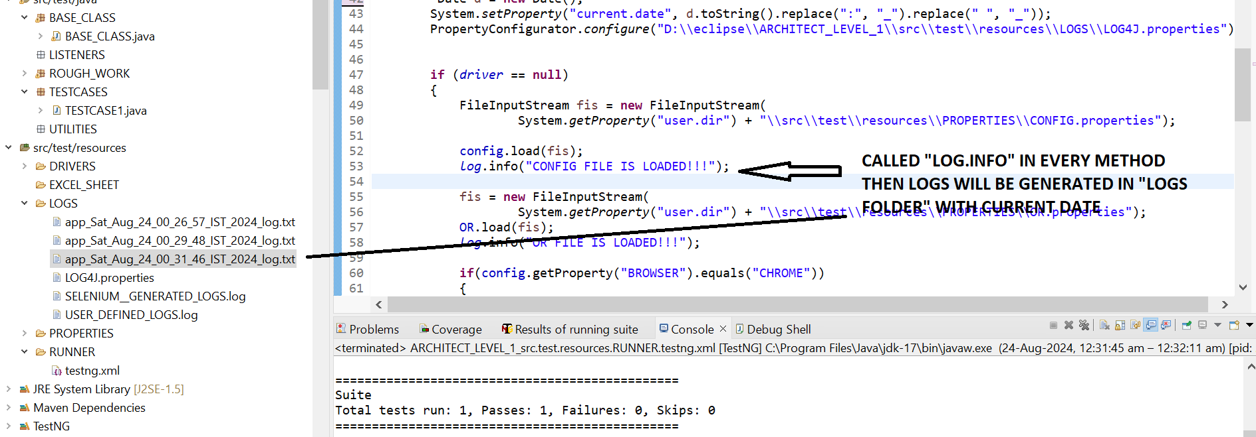

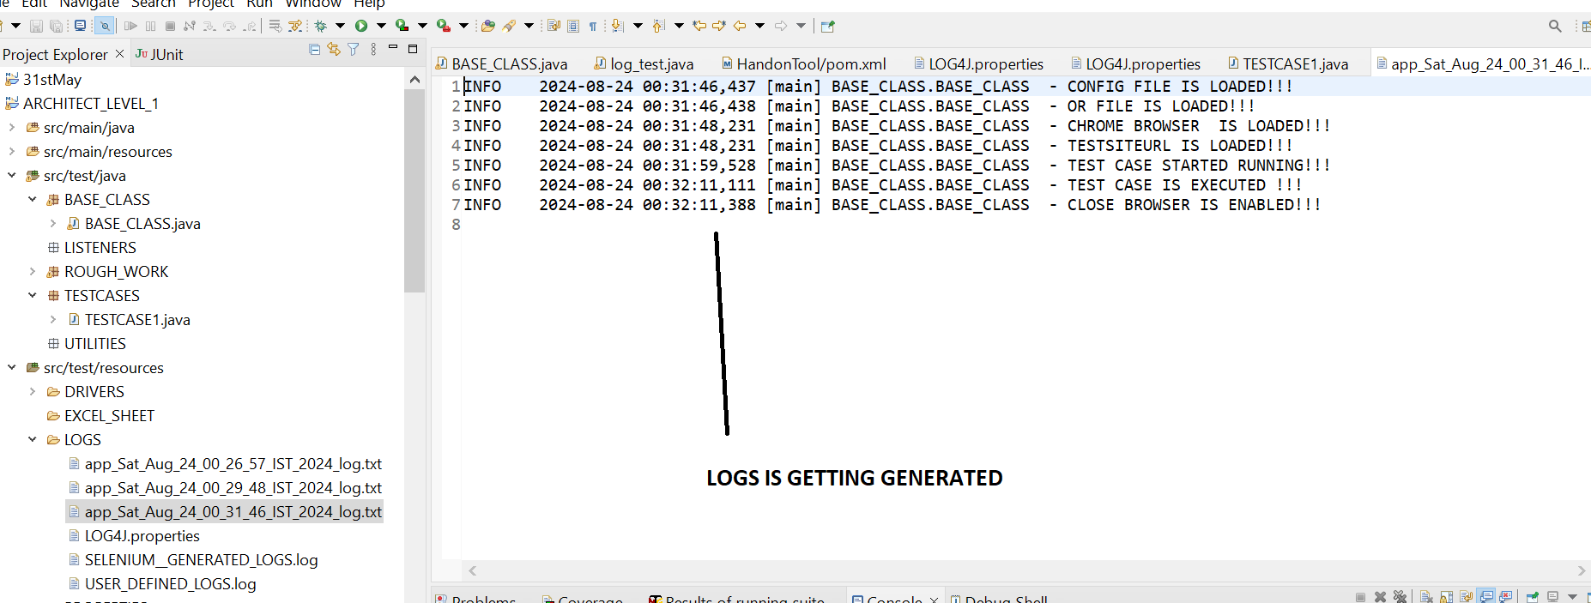

**STEPS 5=>UPDATED CODE IN “BASE CLASS” WITH LOGS GENERATION CODE**

**package** BASE_CLASS;

**import** java.io.FileInputStream;

**import** java.io.IOException;

**import** java.time.Duration;

**import** java.util.Date;

**import** java.util.Properties;

**import** org.apache.log4j.Logger;

**import** org.apache.log4j.PropertyConfigurator;

**import** org.openqa.selenium.WebDriver;

**import** org.openqa.selenium.chrome.ChromeDriver;

**import** org.openqa.selenium.chrome.ChromeOptions;

**import** org.openqa.selenium.edge.EdgeDriver;

**import** org.openqa.selenium.edge.EdgeOptions;

**import** org.openqa.selenium.firefox.FirefoxDriver;

**import** org.openqa.selenium.firefox.FirefoxOptions;

**import** org.openqa.selenium.support.ui.WebDriverWait;

**import** org.testng.annotations.AfterSuite;

**import** org.testng.annotations.BeforeSuite;

**import** io.github.bonigarcia.wdm.WebDriverManager;

**public** **class** BASE_CLASS {

**public** **static** WebDriver *driver*;

**public** Properties config = **new** Properties();

**public** Properties OR = **new** Properties();

**public** **static** WebDriverWait *wait* ;

**public** **static** Logger *log* = Logger.*getLogger*(BASE_CLASS.**class**.getName());

@BeforeSuite

**public** **void** setup() **throws** IOException, InterruptedException

{

Date d = **new** Date();

System.*setProperty*("current.date", d.toString().replace(":", "_").replace(" ", "_"));

PropertyConfigurator.*configure*("C:\\Users\\Gulnar\\Desktop\\Automation Notes\\Framework_ARCHITECT_LEVEL\\DATA_DRIVEN_FRAMEWORK\\ARCHITECT_LEVEL_2\\src\\test\\resources\\LOGS\\log4j.properties");

**if** (*driver* == **null**)

{

FileInputStream fis = **new** FileInputStream(

System.*getProperty*("user.dir") + "\\src\\test\\resources\\PROPERTIES\\CONFIG.properties");

config.load(fis);

fis = **new** FileInputStream(

System.*getProperty*("user.dir") + "\\src\\test\\resources\\PROPERTIES\\OR.properties");

OR.load(fis);

**if**(config.getProperty("BROWSER").equals("CHROME"))

{

System.*setProperty*("Webdriver.chrome.driver",config.getProperty("chromepath"));

ChromeOptions option = **new** ChromeOptions();

option.addArguments("--remote-allow-origins=*");

WebDriverManager.*chromedriver*().setup();

*driver* = **new** ChromeDriver(option);

*log*.info("chrome driver is Excueted");

}

**else** **if**(config.getProperty("BROWSER").equals("firefox"))

{

System.*setProperty*("Webdriver.gecko.driver",config.getProperty("geckodriverpath"));

FirefoxOptions option = **new** FirefoxOptions();

//option.addArguments("--remote-allow-origins=*");

WebDriverManager.*firefoxdriver*().setup();

*driver* = **new** FirefoxDriver(option);

*log*.info("firefox driver is Excueted");

}

**else** **if**(config.getProperty("BROWSER").equals("ie"))

{

System.*setProperty*("Webdriver.edge.driver",config.getProperty("ie_driverpath"));

EdgeOptions option = **new** EdgeOptions ();

option.addArguments("--remote-allow-origins=*");

WebDriverManager.*edgedriver*().setup();

*driver* =**new** EdgeDriver(option);

*log*.info("edge driver is Excueted");

}

*driver*.get(config.getProperty("TESTSITEURL"));

Thread.*sleep*(3000);

*driver*.manage().window().maximize();

*driver*.manage().deleteAllCookies();

*driver*.manage().timeouts().implicitlyWait(Duration.*ofHours*(2));

*wait* = **new** WebDriverWait(*driver*, Duration.*ofSeconds*(10));

*log*.info("TESTSITEURL is Excueted");

}

}

@AfterSuite

**public** **void** Tearup() {

**if**(*driver*!=**null**)

{

*driver*.quit();

}

*log*.info("close Browser is Excueted");

}

}

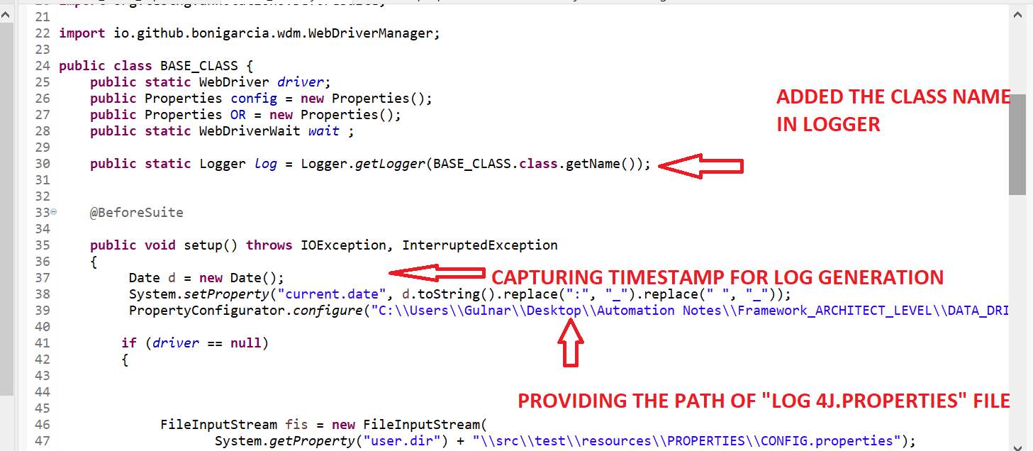

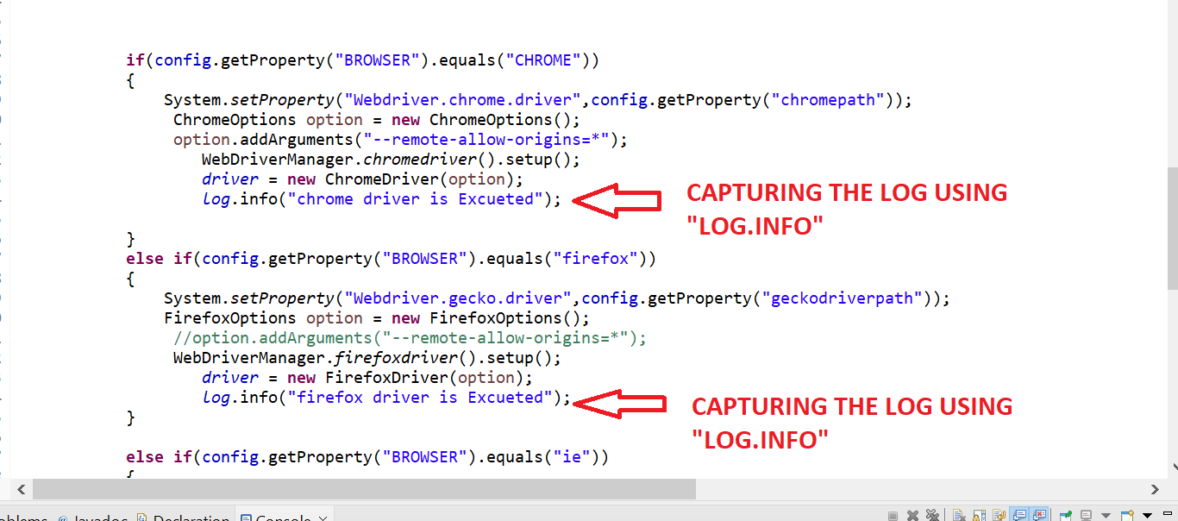

**STEPS 6=> ADD “LOGGER.INFO” IN EVERY TESTCASE WHERE U WANT TO GENERATE LOGS SUCH AS TEST CASE 1 THAT WE HAVE CREATED AND THERE WE WRITE “LOG.INFO” TO GENERATE LOGS**

**package** TESTCASES;

**import** org.openqa.selenium.Alert;

**import** org.openqa.selenium.By;

**import** org.openqa.selenium.support.ui.ExpectedConditions;

**import** org.testng.Assert;

**import** org.testng.Reporter;

**import** org.testng.annotations.DataProvider;

**import** org.testng.annotations.Test;

**import** BASE_CLASS.BASE_CLASS;

**public** **class** TESTCASE1 **extends** BASE_CLASS

{

@Test

**public** **void** method1() **throws** InterruptedException

{

*log*.info("Method 1 of Test Case 1 is Excueted");

Thread.*sleep*(3000);

*driver*.findElement(By.*xpath*(OR.getProperty("customer_login"))).click();

Thread.*sleep*(2000);

*driver*.findElement(By.*xpath*(OR.getProperty("Addcusotmer"))).click();

*log*.info("Method 1 of Test Case 1 is completed");

}

@Test

**public** **void** method2() **throws** Throwable

{

*log*.info("Method 2 of Test Case 1 is Excueted");

Thread.*sleep*(3000);

*driver*.findElement(By.*xpath*(OR.getProperty("firstname"))).sendKeys("FirstName");

Thread.*sleep*(2000);

*driver*.findElement(By.*xpath*(OR.getProperty("lastname"))).sendKeys("lastName");

Thread.*sleep*(2000);

*driver*.findElement(By.*xpath*(OR.getProperty("postalcode"))).sendKeys("postcalCode");

Thread.*sleep*(2000);

*driver*.findElement(By.*xpath*(OR.getProperty("add_cusomter_button"))).click();

*log*.info("Method 2 of Test Case 1 is completed");

}

}

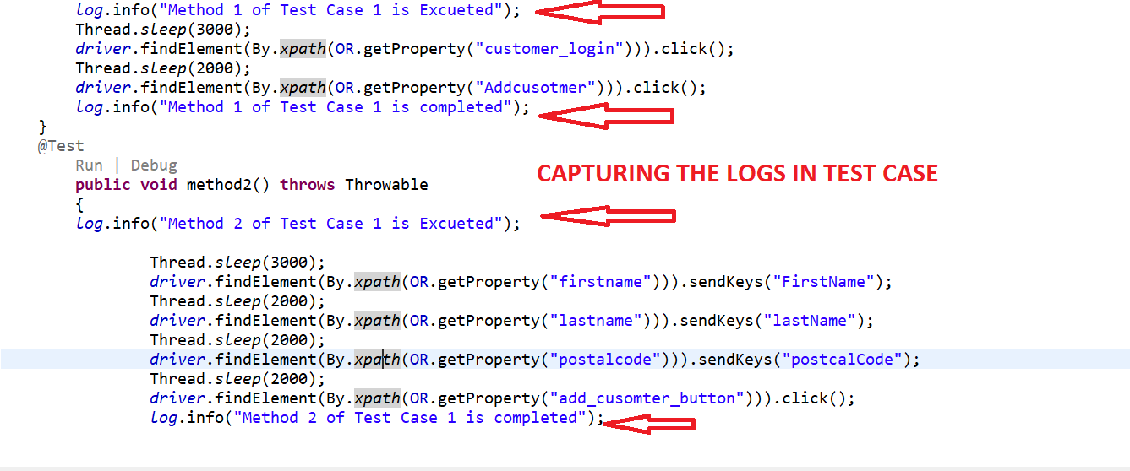

**STEPS 7=>NOW RUN THE PROJECT AND REFRESH THE PROJECTS,LOGS WILL BE GENERTAED WITH CURRENT DATE IN “LOGS FOLDER” AS LOG FOLDER IS MENTIONED IN “LOG.4J PROPERTIES”**

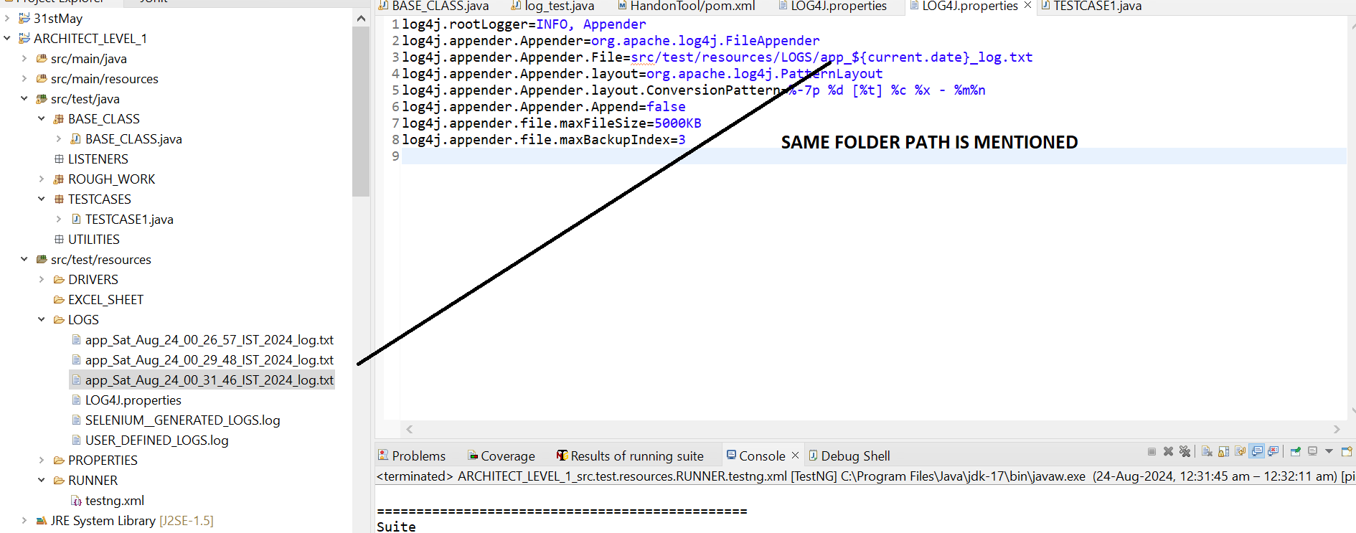



**ISSUE 1=>IF LOGS IS GETTING GENERATED IN CONSOLE INSTEAD OF INSIDE OF LOG FOLDER THEN THEN CHECK PACKAGE THAT U HAVE IMPORTED ,IT SHOULD BE APACHE.LOG 4J ONLY**

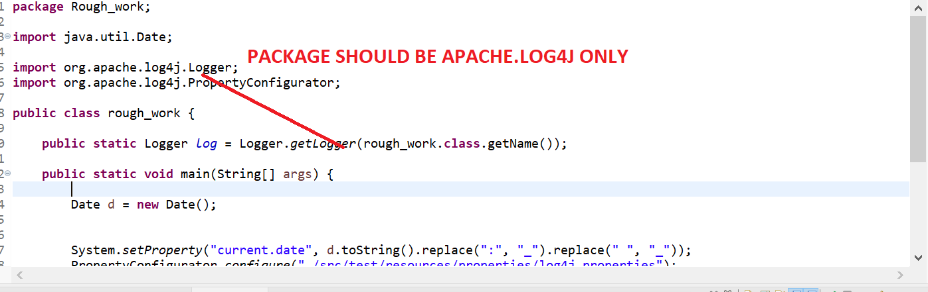

**STEP 18=>HOW TO PUT ASSERTION?**

**STEPS 1=>ADD TESTNG DEPENDENCIES IN YOUR PROJECTS**

**STEPS 2=>CREATE METHOD IN BASE CLASS AS “IS ELEMENT PRESENT” THEN CALL THAT METHOD IN TEST CASE TO CHECK IF ELEMENT IS PRESESNT OR NOT?**

**public** **boolean** IsElementPresent(By by)

{

**try**

{

*driver*.findElement(by);

**return** **true**;

}

**catch**(NoSuchElementException e)

{

**return** **false**;

}

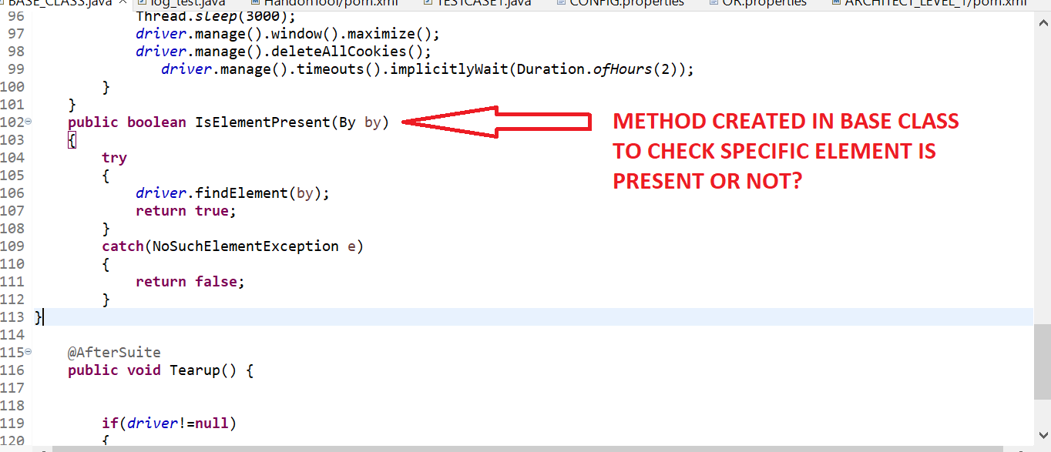

**STEPS 3=> THEN CALL THAT METHOD IN TEST CASE TO CHECK IF ELEMENT IS PRESESNT OR NOT?**

Assert.*assertTrue*(IsElementPresent

(By.*xpath*(OR.getProperty("add_cusomter_button"))),"Login not successful");

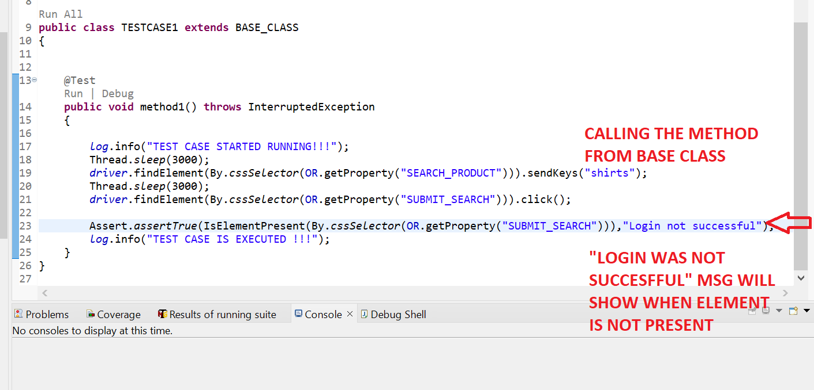

**THE UPDATED CODE WITH TEST CASE 1 AND BASE CLASS WITH HANDLING ALERT ARE AS FOLLOW**

**BASE CLASS. .JAVA**

**package** BASE_CLASS;

**import** java.io.FileInputStream;

**import** java.io.IOException;

**import** java.time.Duration;

**import** java.util.Date;

**import** java.util.NoSuchElementException;

**import** java.util.Properties;

**import** org.apache.log4j.Logger;

**import** org.apache.log4j.PropertyConfigurator;

**import** org.openqa.selenium.By;

**import** org.openqa.selenium.WebDriver;

**import** org.openqa.selenium.chrome.ChromeDriver;

**import** org.openqa.selenium.chrome.ChromeOptions;

**import** org.openqa.selenium.edge.EdgeDriver;

**import** org.openqa.selenium.edge.EdgeOptions;

**import** org.openqa.selenium.firefox.FirefoxDriver;

**import** org.openqa.selenium.firefox.FirefoxOptions;

**import** org.openqa.selenium.support.ui.WebDriverWait;

**import** org.testng.annotations.AfterSuite;

**import** org.testng.annotations.BeforeSuite;

**import** io.github.bonigarcia.wdm.WebDriverManager;

**public** **class** BASE_CLASS {

**public** **static** WebDriver *driver*;

**public** Properties config = **new** Properties();

**public** Properties OR = **new** Properties();

**public** **static** WebDriverWait *waits* ;

**public** **static** Logger *log* = Logger.*getLogger*(BASE_CLASS.**class**.getName());

@BeforeSuite

**public** **void** setup() **throws** IOException, InterruptedException

{

Date d = **new** Date();

System.*setProperty*("current.date", d.toString().replace(":", "_").replace(" ", "_"));

PropertyConfigurator.*configure*("C:\\Users\\Gulnar\\Desktop\\Automation Notes\\Framework_ARCHITECT_LEVEL\\DATA_DRIVEN_FRAMEWORK\\ARCHITECT_LEVEL_2\\src\\test\\resources\\LOGS\\log4j.properties");

**if** (*driver* == **null**)

{

FileInputStream fis = **new** FileInputStream(

System.*getProperty*("user.dir") + "\\src\\test\\resources\\PROPERTIES\\CONFIG.properties");

config.load(fis);

fis = **new** FileInputStream(

System.*getProperty*("user.dir") + "\\src\\test\\resources\\PROPERTIES\\OR.properties");

OR.load(fis);

**if**(config.getProperty("BROWSER").equals("CHROME"))

{

System.*setProperty*("Webdriver.chrome.driver",config.getProperty("chromepath"));

ChromeOptions option = **new** ChromeOptions();

option.addArguments("--remote-allow-origins=*");

WebDriverManager.*chromedriver*().setup();

*driver* = **new** ChromeDriver(option);

*log*.info("chrome driver is Excueted");

}

**else** **if**(config.getProperty("BROWSER").equals("firefox"))

{

System.*setProperty*("Webdriver.gecko.driver",config.getProperty("geckodriverpath"));

FirefoxOptions option = **new** FirefoxOptions();

//option.addArguments("--remote-allow-origins=*");

WebDriverManager.*firefoxdriver*().setup();

*driver* = **new** FirefoxDriver(option);

*log*.info("firefox driver is Excueted");

}

**else** **if**(config.getProperty("BROWSER").equals("ie"))

{

System.*setProperty*("Webdriver.edge.driver",config.getProperty("ie_driverpath"));

EdgeOptions option = **new** EdgeOptions ();

option.addArguments("--remote-allow-origins=*");

WebDriverManager.*edgedriver*().setup();

*driver* =**new** EdgeDriver(option);

*log*.info("edge driver is Excueted");

}

*driver*.get(config.getProperty("TESTSITEURL"));

Thread.*sleep*(3000);

*driver*.manage().window().maximize();

*driver*.manage().deleteAllCookies();

*driver*.manage().timeouts().implicitlyWait(Duration.*ofHours*(2));

*waits* = **new** WebDriverWait(*driver*, Duration.*ofHours*(2));

*log*.info("TESTSITEURL is Excueted");

}

}

**public** **boolean** IsElementPresent(By by)

{

**try**

{

*driver*.findElement(by);

**return** **true**;

}

**catch**(NoSuchElementException e)

{

**return** **false**;

}

}

@AfterSuite

**public** **void** Tearup() {

**if**(*driver*!=**null**)

{

*driver*.quit();

}

*log*.info("close Browser is Excueted");

}

}

**TEST CASE 1.JAVA**

**package** TESTCASES;

**import** org.openqa.selenium.Alert;

**import** org.openqa.selenium.By;

**import** org.openqa.selenium.support.ui.ExpectedConditions;

**import** org.testng.Assert;

**import** org.testng.Reporter;

**import** org.testng.annotations.DataProvider;

**import** org.testng.annotations.Test;

**import** BASE_CLASS.BASE_CLASS;

**public** **class** TESTCASE1 **extends** BASE_CLASS

{

@Test

**public** **void** method1() **throws** InterruptedException

{

*log*.info("Method 1 of Test Case 1 is Excueted");

Thread.*sleep*(3000);

*driver*.findElement(By.*xpath*(OR.getProperty("customer_login"))).click();

Thread.*sleep*(2000);

*driver*.findElement(By.*xpath*(OR.getProperty("Addcusotmer"))).click();

*log*.info("Method 1 of Test Case 1 is completed");

}

@Test

**public** **void** method2() **throws** Throwable

{

*log*.info("Method 2 of Test Case 1 is Excueted");

Thread.*sleep*(3000);

*driver*.findElement(By.*xpath*(OR.getProperty("firstname"))).sendKeys("FirstName");

Thread.*sleep*(2000);

*driver*.findElement(By.*xpath*(OR.getProperty("lastname"))).sendKeys("lastName");

Thread.*sleep*(2000);

*driver*.findElement(By.*xpath*(OR.getProperty("postalcode"))).sendKeys("postcalCode");

Thread.*sleep*(2000);

Assert.*assertTrue*(IsElementPresent

(By.*xpath*(OR.getProperty("add_cusomter_button"))),"Login not successful");

*driver*.findElement(By.*xpath*(OR.getProperty("add_cusomter_button"))).click();

Thread.*sleep*(4000);

//Wait for the alert to be displayed and store it in a variable

Alert alert = *waits*.until(ExpectedConditions.*alertIsPresent*());

//Store the alert text in a variable

String text = alert.getText();

System.***out***.println("Text is "+text);

//Press the OK button

Assert.*assertTrue*(alert.getText().contains("Customer added successfully with customer id"));

Thread.*sleep*(2000);

alert.accept();

*log*.info("Method 2 of Test Case 1 is completed");

}

}

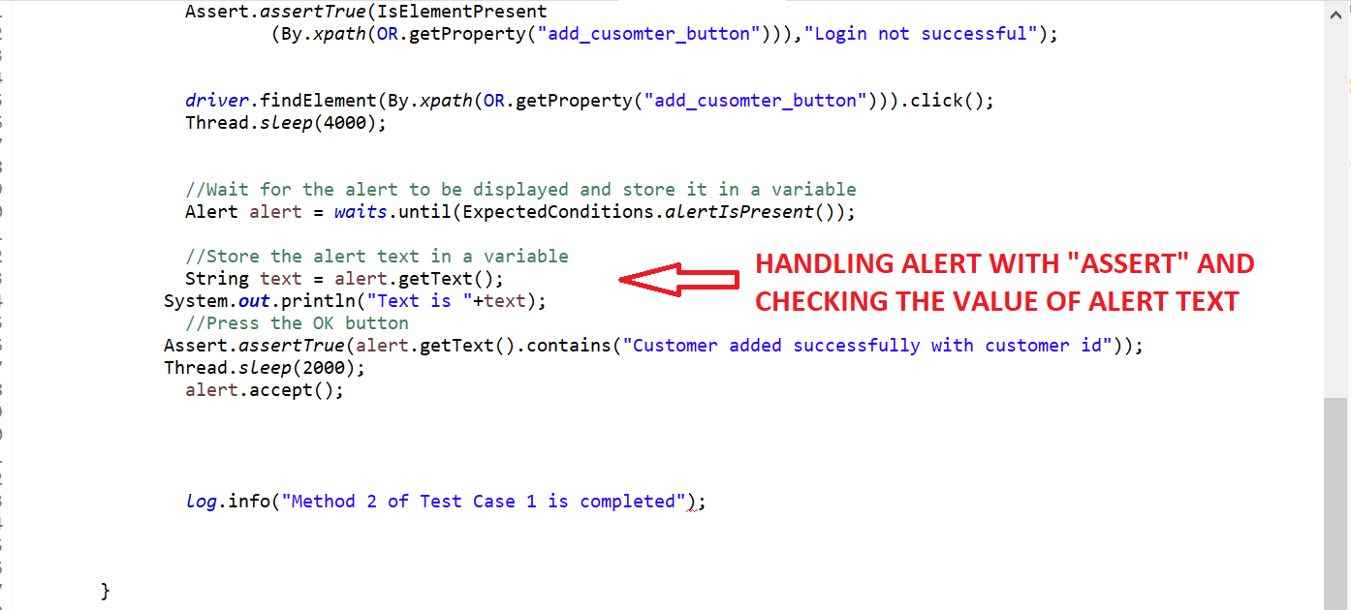

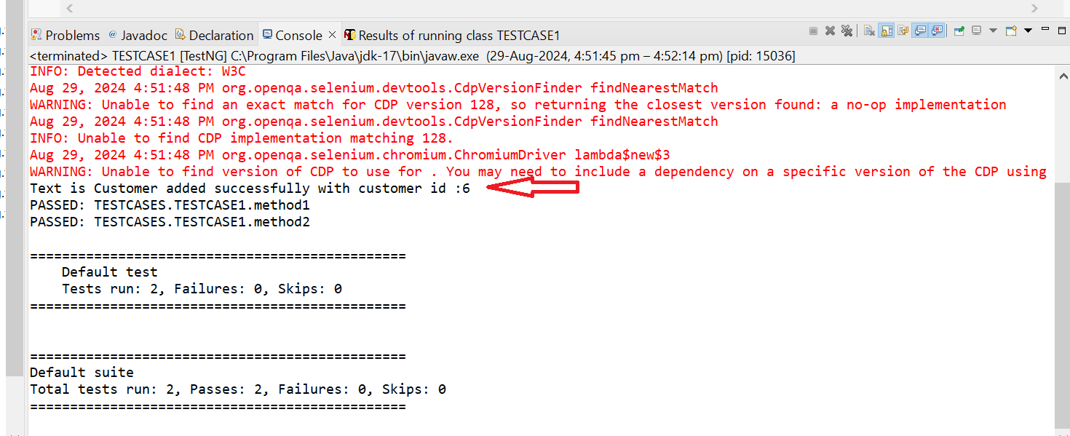

**STEP 19=>WHAT ARE DATA PROVIDER ?HOW TO USE THEM IN APPLICATION?**

**IF WE RIGHT CLICK ON PROEJCT AND THEN RUN AS “MAVEN TEST”,IF IT DOESN’T SHOW AS “BUILD –SUCCESS” THEN RIGHT CLICK ON PROJECT AND CHOOSE CONFIGURE BUILD PATH AS “JDK 17” AND THEN RIGHT CLICK ON PROJECT AND THEN FORCEFULLY UPDATE ON “MODIFY SNAPSHOT/RELEASE” THEN “BUILD SUCCESS” WILL SHOW FOR “MAVEN TEST”**

**STEPS 1=>CREATE BELOW EXCEL SHEET IN “EXCEL FOLDER” IN “SRC/TEST/RESOURCE” INORDER TO FETCH ROW AND COLUMN VALUES**

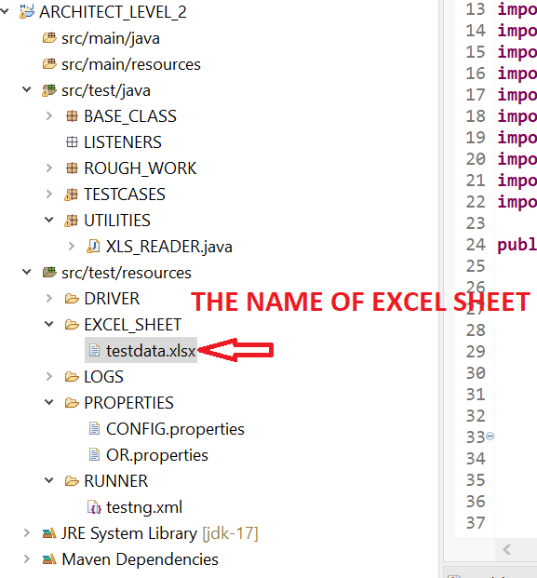

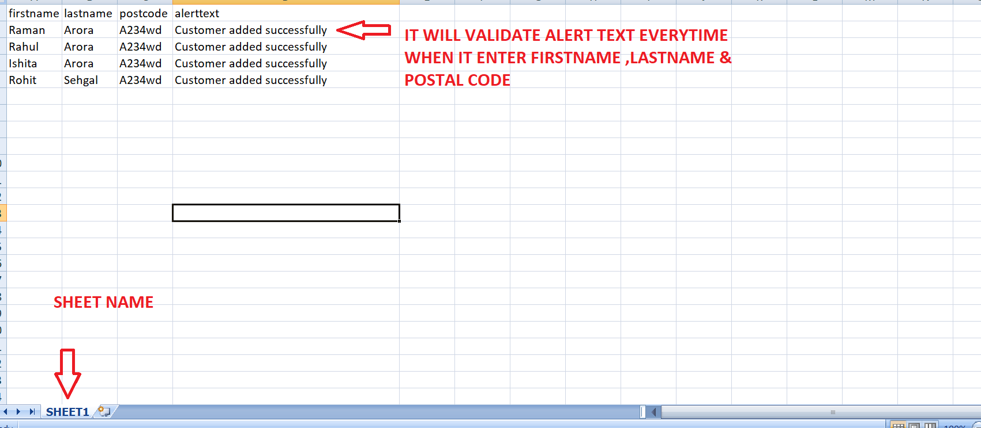

**STEPS 2=> CREATE THE XLS READER CLASS CREATED IN "UTLITIES" MODULE CREATE “EXCEL READER CLASS” AND MENTION THE PATH OF EXCEL SHEET .CALL THE SAME EXCEL SHEET HERE IN "XLS READER**

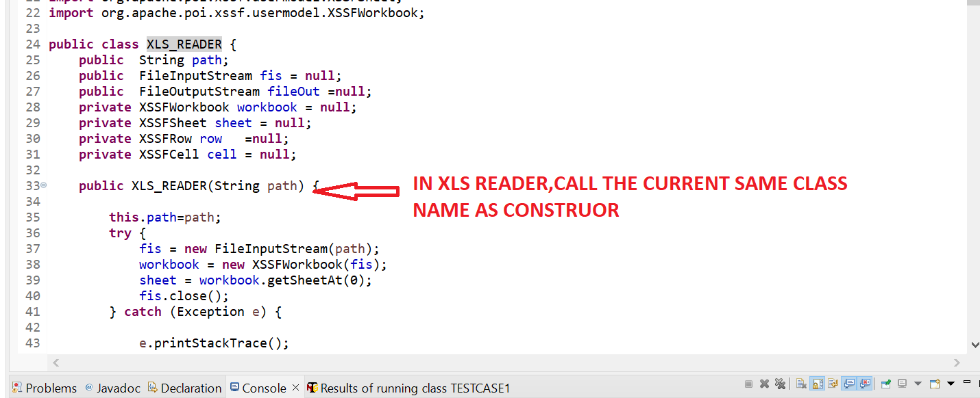

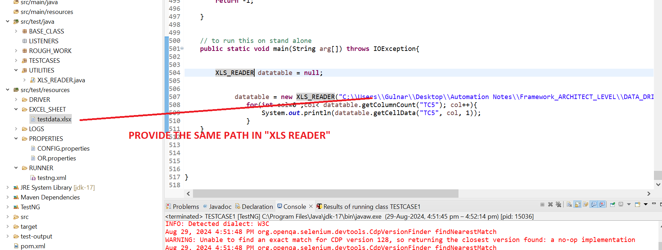

**package** UTILITIES;

**import** java.io.FileInputStream;

**import** java.io.FileOutputStream;

**import** java.io.IOException;

**import** java.util.Calendar;

**import** org.apache.poi.common.usermodel.HyperlinkType;

**import** org.apache.poi.hssf.usermodel.HSSFDateUtil;

**import** org.apache.poi.hssf.util.HSSFColor;

**import** org.apache.poi.ss.usermodel.CellStyle;

**import** org.apache.poi.ss.usermodel.CellType;

**import** org.apache.poi.ss.usermodel.FillPatternType;

**import** org.apache.poi.ss.usermodel.IndexedColors;

**import** org.apache.poi.xssf.usermodel.XSSFCell;

**import** org.apache.poi.xssf.usermodel.XSSFCellStyle;

**import** org.apache.poi.xssf.usermodel.XSSFCreationHelper;

**import** org.apache.poi.xssf.usermodel.XSSFFont;

**import** org.apache.poi.xssf.usermodel.XSSFHyperlink;

**import** org.apache.poi.xssf.usermodel.XSSFRow;

**import** org.apache.poi.xssf.usermodel.XSSFSheet;

**import** org.apache.poi.xssf.usermodel.XSSFWorkbook;

**public** **class** EXCEL_READER {

**public** String path;

**public** FileInputStream fis = **null**;

**public** FileOutputStream fileOut =**null**;

**private** XSSFWorkbook workbook = **null**;

**private** XSSFSheet sheet = **null**;

**private** XSSFRow row =**null**;

**private** XSSFCell cell = **null**;

**public** EXCEL_READER(String path) {

**this**.path=path;

**try** {

fis = **new** FileInputStream(path);

workbook = **new** XSSFWorkbook(fis);

sheet = workbook.getSheetAt(0);

fis.close();

} **catch** (Exception e) {

e.printStackTrace();

}

}

// returns the row count in a sheet

**public** **int** getRowCount(String sheetName){

**int** index = workbook.getSheetIndex(sheetName);

**if**(index==-1)

**return** 0;

**else**{

sheet = workbook.getSheetAt(index);

**int** number=sheet.getLastRowNum()+1;

**return** number;

}

}

// returns the data from a cell

**public** String getCellData(String sheetName,String colName,**int** rowNum){

**try**{

**if**(rowNum <=0)

**return** "";

**int** index = workbook.getSheetIndex(sheetName);

**int** col_Num=-1;

**if**(index==-1)

**return** "";

sheet = workbook.getSheetAt(index);

row=sheet.getRow(0);

**for**(**int** i=0;i<row.getLastCellNum();i++){

//System.out.println(row.getCell(i).getStringCellValue().trim());

**if**(row.getCell(i).getStringCellValue().trim().equals(colName.trim()))

col_Num=i;

}

**if**(col_Num==-1)

**return** "";

sheet = workbook.getSheetAt(index);

row = sheet.getRow(rowNum-1);

**if**(row==**null**)

**return** "";

cell = row.getCell(col_Num);

**if**(cell==**null**)

**return** "";

**if**(cell.getCellType()==CellType.***STRING***)

**return** cell.getStringCellValue();

**else** **if**(cell.getCellType()==CellType.***NUMERIC*** || cell.getCellType()==CellType.***FORMULA*** ){

String cellText = String.*valueOf*(cell.getNumericCellValue());

**if** (HSSFDateUtil.*isCellDateFormatted*(cell)) {

**double** d = cell.getNumericCellValue();

Calendar cal =Calendar.*getInstance*();

cal.setTime(HSSFDateUtil.*getJavaDate*(d));

cellText =

(String.*valueOf*(cal.get(Calendar.***YEAR***))).substring(2);

cellText = cal.get(Calendar.***DAY_OF_MONTH***) + "/" +

cal.get(Calendar.***MONTH***)+1 + "/" +

cellText;

}

**return** cellText;

}**else** **if**(cell.getCellType()==CellType.***BLANK***)

**return** "";

**else**

**return** String.*valueOf*(cell.getBooleanCellValue());

}

**catch**(Exception e){

e.printStackTrace();

**return** "row "+rowNum+" or column "+colName +" does not exist in xls";

}

}

// returns the data from a cell

**public** String getCellData(String sheetName,**int** colNum,**int** rowNum){

**try**{

**if**(rowNum <=0)

**return** "";

**int** index = workbook.getSheetIndex(sheetName);

**if**(index==-1)

**return** "";

sheet = workbook.getSheetAt(index);

row = sheet.getRow(rowNum-1);

**if**(row==**null**)

**return** "";

cell = row.getCell(colNum);

**if**(cell==**null**)

**return** "";

**if**(cell.getCellType()==CellType.***STRING***)

**return** cell.getStringCellValue();

**else** **if**(cell.getCellType()==CellType.***NUMERIC*** || cell.getCellType()==CellType.***FORMULA*** ){

String cellText = String.*valueOf*(cell.getNumericCellValue());

**if** (HSSFDateUtil.*isCellDateFormatted*(cell)) {

// format in form of M/D/YY

**double** d = cell.getNumericCellValue();

Calendar cal =Calendar.*getInstance*();

cal.setTime(HSSFDateUtil.*getJavaDate*(d));

cellText =

(String.*valueOf*(cal.get(Calendar.***YEAR***))).substring(2);

cellText = cal.get(Calendar.***MONTH***)+1 + "/" +

cal.get(Calendar.***DAY_OF_MONTH***) + "/" +

cellText;

}

**return** cellText;

}**else** **if**(cell.getCellType()==CellType.***BLANK***)

**return** "";

**else**

**return** String.*valueOf*(cell.getBooleanCellValue());

}

**catch**(Exception e){

e.printStackTrace();

**return** "row "+rowNum+" or column "+colNum +" does not exist in xls";

}

}

// returns true if data is set successfully else false

**public** **boolean** setCellData(String sheetName,String colName,**int** rowNum, String data){

**try**{

fis = **new** FileInputStream(path);

workbook = **new** XSSFWorkbook(fis);

**if**(rowNum<=0)

**return** **false**;

**int** index = workbook.getSheetIndex(sheetName);

**int** colNum=-1;

**if**(index==-1)

**return** **false**;

sheet = workbook.getSheetAt(index);

row=sheet.getRow(0);

**for**(**int** i=0;i<row.getLastCellNum();i++){

//System.out.println(row.getCell(i).getStringCellValue().trim());

**if**(row.getCell(i).getStringCellValue().trim().equals(colName))

colNum=i;

}

**if**(colNum==-1)

**return** **false**;

sheet.autoSizeColumn(colNum);

row = sheet.getRow(rowNum-1);

**if** (row == **null**)

row = sheet.createRow(rowNum-1);

cell = row.getCell(colNum);

**if** (cell == **null**)

cell = row.createCell(colNum);

cell.setCellValue(data);

fileOut = **new** FileOutputStream(path);

workbook.write(fileOut);

fileOut.close();

}

**catch**(Exception e){

e.printStackTrace();

**return** **false**;

}

**return** **true**;

}

// returns true if data is set successfully else false

**public** **boolean** setCellData(String sheetName,String colName,**int** rowNum, String data,String url){

**try**{

fis = **new** FileInputStream(path);

workbook = **new** XSSFWorkbook(fis);

**if**(rowNum<=0)

**return** **false**;

**int** index = workbook.getSheetIndex(sheetName);

**int** colNum=-1;

**if**(index==-1)

**return** **false**;

sheet = workbook.getSheetAt(index);

row=sheet.getRow(0);

**for**(**int** i=0;i<row.getLastCellNum();i++){

**if**(row.getCell(i).getStringCellValue().trim().equalsIgnoreCase(colName))

colNum=i;

}

**if**(colNum==-1)

**return** **false**;

sheet.autoSizeColumn(colNum);

row = sheet.getRow(rowNum-1);

**if** (row == **null**)

row = sheet.createRow(rowNum-1);

cell = row.getCell(colNum);

**if** (cell == **null**)

cell = row.createCell(colNum);

cell.setCellValue(data);

XSSFCreationHelper createHelper = workbook.getCreationHelper();

//cell style for hyperlinks

CellStyle hlink_style = workbook.createCellStyle();

XSSFFont hlink_font = workbook.createFont();

hlink_font.setUnderline(XSSFFont.***U_SINGLE***);

hlink_font.setColor(IndexedColors.***BLUE***.getIndex());

hlink_style.setFont(hlink_font);

//hlink_style.setWrapText(true);

XSSFHyperlink link = createHelper.createHyperlink(HyperlinkType.***FILE***);

link.setAddress(url);

cell.setHyperlink(link);

cell.setCellStyle(hlink_style);

fileOut = **new** FileOutputStream(path);

workbook.write(fileOut);

fileOut.close();

}

**catch**(Exception e){

e.printStackTrace();

**return** **false**;

}

**return** **true**;

}

// returns true if sheet is created successfully else false

**public** **boolean** addSheet(String sheetname){

FileOutputStream fileOut;

**try** {

workbook.createSheet(sheetname);

fileOut = **new** FileOutputStream(path);

workbook.write(fileOut);

fileOut.close();

} **catch** (Exception e) {

e.printStackTrace();

**return** **false**;

}

**return** **true**;

}

// returns true if sheet is removed successfully else false if sheet does not exist

**public** **boolean** removeSheet(String sheetName){

**int** index = workbook.getSheetIndex(sheetName);

**if**(index==-1)

**return** **false**;

FileOutputStream fileOut;

**try** {

workbook.removeSheetAt(index);

fileOut = **new** FileOutputStream(path);

workbook.write(fileOut);

fileOut.close();

} **catch** (Exception e) {

e.printStackTrace();

**return** **false**;

}

**return** **true**;

}

// returns true if column is created successfully

**public** **boolean** addColumn(String sheetName,String colName){

**try**{

fis = **new** FileInputStream(path);

workbook = **new** XSSFWorkbook(fis);

**int** index = workbook.getSheetIndex(sheetName);

**if**(index==-1)

**return** **false**;

XSSFCellStyle style = workbook.createCellStyle();

style.setFillForegroundColor(HSSFColor.HSSFColorPredefined.***GREY_40_PERCENT***.getIndex());

style.setFillPattern(FillPatternType.***SOLID_FOREGROUND***);

sheet=workbook.getSheetAt(index);

row = sheet.getRow(0);

**if** (row == **null**)

row = sheet.createRow(0);

**if**(row.getLastCellNum() == -1)

cell = row.createCell(0);

**else**

cell = row.createCell(row.getLastCellNum());

cell.setCellValue(colName);

cell.setCellStyle(style);

fileOut = **new** FileOutputStream(path);

workbook.write(fileOut);

fileOut.close();

}**catch**(Exception e){

e.printStackTrace();

**return** **false**;

}

**return** **true**;

}

// removes a column and all the contents

**public** **boolean** removeColumn(String sheetName, **int** colNum) {

**try**{

**if**(!isSheetExist(sheetName))

**return** **false**;

fis = **new** FileInputStream(path);

workbook = **new** XSSFWorkbook(fis);

sheet=workbook.getSheet(sheetName);

XSSFCellStyle style = workbook.createCellStyle();

style.setFillForegroundColor(HSSFColor.HSSFColorPredefined.***GREY_40_PERCENT***.getIndex());

XSSFCreationHelper createHelper = workbook.getCreationHelper();

style.setFillPattern(FillPatternType.***NO_FILL***);

**for**(**int** i =0;i<getRowCount(sheetName);i++){

row=sheet.getRow(i);

**if**(row!=**null**){

cell=row.getCell(colNum);

**if**(cell!=**null**){

cell.setCellStyle(style);

row.removeCell(cell);

}

}

}

fileOut = **new** FileOutputStream(path);

workbook.write(fileOut);

fileOut.close();

}

**catch**(Exception e){

e.printStackTrace();

**return** **false**;

}

**return** **true**;

}

// find whether sheets exists

**public** **boolean** isSheetExist(String sheetName){

**int** index = workbook.getSheetIndex(sheetName);

**if**(index==-1){

index=workbook.getSheetIndex(sheetName.toUpperCase());

**if**(index==-1)

**return** **false**;

**else**

**return** **true**;

}

**else**

**return** **true**;

}

// returns number of columns in a sheet

**public** **int** getColumnCount(String sheetName){

// check if sheet exists

**if**(!isSheetExist(sheetName))

**return** -1;

sheet = workbook.getSheet(sheetName);

row = sheet.getRow(0);

**if**(row==**null**)

**return** -1;

**return** row.getLastCellNum();

}

//String sheetName, String testCaseName,String keyword ,String URL,String message

**public** **boolean** addHyperLink(String sheetName,String screenShotColName,String testCaseName,**int** index,String url,String message){

url=url.replace('\\', '/');

**if**(!isSheetExist(sheetName))

**return** **false**;

sheet = workbook.getSheet(sheetName);

**for**(**int** i=2;i<=getRowCount(sheetName);i++){

**if**(getCellData(sheetName, 0, i).equalsIgnoreCase(testCaseName)){

setCellData(sheetName, screenShotColName, i+index, message,url);

**break**;

}

}

**return** **true**;

}

**public** **int** getCellRowNum(String sheetName,String colName,String cellValue){

**for**(**int** i=2;i<=getRowCount(sheetName);i++){

**if**(getCellData(sheetName,colName , i).equalsIgnoreCase(cellValue)){

**return** i;

}

}

**return** -1;

}

// to run this on stand alone

**public** **static** **void** main(String arg[]) **throws** IOException{

EXCEL_READER datatable = **null**;

datatable = **new** EXCEL_READER("D:\\eclipse\\ARCHITECT_LEVEL_1\\src\\test\\resources\\EXCEL_SHEET\\EXCEL_SHEET_DATA_PROVIDER_CREATED.xlsx");

**for**(**int** col=0 ;col< datatable.getColumnCount("TC5"); col++){

System.***out***.println(datatable.getCellData("TC5", col, 1));

}

}

}

**STEPS 3=>MAKE “STATIC” TO BOTH PROPERTIES VARAIBLE IN BASE CLASS**

**STEPS 4=> CREATE “XLS_READER” IN BASE CLASS=>**

**public** **static** XLS_READER *excel* = **new** XLS_READER(

System.*getProperty*("user.dir") +"\\src\\test\\resources\\EXCEL_SHEET\\testdata.xlsx");

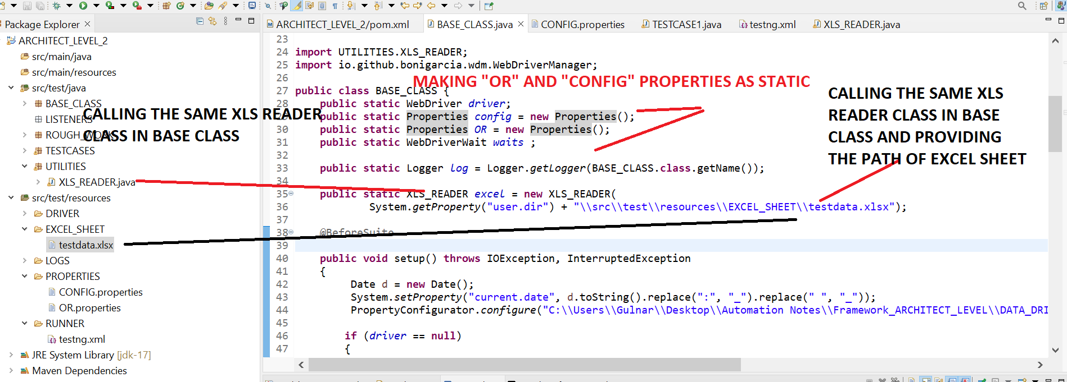

**STEPS 4=>WRITE BELOW CODE IN TESTCASE1 .REMEMEBER TEST CASE 2 WILL START WHERE TEST CASE 1 WILL STOP AS WE HAVE METHOD SUCH AS “BEFORE SUITE” AND “AFTERSUITE” IN BASE CLASS FOR LAUNCHING DRIVER AND QUITING THE DRIVER SO TEST CASE WILL PICK THE APPLICATION WHERE TESTCASE 1 WILL STOPS=>@TEST(DATAPROVIDER) => NEED TO WRITE ONLY THOSE METHOD SUCHAS FIRSTNAEM,LASTNAME ETC THAT WE WANT TO FETCH FROM EXCEL SHEET ONLY**

**package** TESTCASES;

**import** org.openqa.selenium.Alert;

**import** org.openqa.selenium.By;

**import** org.openqa.selenium.support.ui.ExpectedConditions;

**import** org.testng.Assert;

**import** org.testng.Reporter;

**import** org.testng.annotations.DataProvider;

**import** org.testng.annotations.Test;

**import** BASE_CLASS.BASE_CLASS;

**import** UTILITIES.XLS_READER;

**public** **class** TESTCASE1 **extends** BASE_CLASS

{

@Test

**public** **void** method1() **throws** InterruptedException

{

*log*.info("Method 1 of Test Case 1 is Excueted");

Thread.*sleep*(3000);

*driver*.findElement(By.*xpath*(*OR*.getProperty("customer_login"))).click();

Thread.*sleep*(2000);

*driver*.findElement(By.*xpath*(*OR*.getProperty("Addcusotmer"))).click();

*log*.info("Method 1 of Test Case 1 is completed");

}

@Test(dataProvider="DataProvide_4")

**public** **void** method2(String firstname,String lastname,String postcode,String alerttext) **throws** Throwable

{

*log*.info("Method 2 of Test Case 1 is Excueted");

Thread.*sleep*(3000);

*driver*.findElement(By.*xpath*(*OR*.getProperty("firstname"))).sendKeys(firstname);

Thread.*sleep*(2000);

*driver*.findElement(By.*xpath*(*OR*.getProperty("lastname"))).sendKeys(lastname);

Thread.*sleep*(2000);

*driver*.findElement(By.*xpath*(*OR*.getProperty("postalcode"))).sendKeys(postcode);

Thread.*sleep*(2000);

Assert.*assertTrue*(IsElementPresent

(By.*xpath*(*OR*.getProperty("add_cusomter_button"))),"Login not successful");

*driver*.findElement(By.*xpath*(*OR*.getProperty("add_cusomter_button"))).click();

Thread.*sleep*(4000);

//Wait for the alert to be displayed and store it in a variable

Alert alert = *waits*.until(ExpectedConditions.*alertIsPresent*());

//Store the alert text in a variable

String text = alert.getText();

System.***out***.println("Text is "+text);

//Press the OK button

Assert.*assertTrue*(alert.getText().contains(alerttext));

Thread.*sleep*(2000);

alert.accept();

*log*.info("Method 2 of Test Case 1 is completed");

}

@DataProvider(name="DataProvide_4")

**public** Object[][] getData() {

**if** (*excel* == **null**) {

*excel* = **new** XLS_READER("C:\\Users\\Gulnar\\Desktop\\Automation Notes\\Framework_ARCHITECT_LEVEL\\DATA_DRIVEN_FRAMEWORK\\ARCHITECT_LEVEL_2\\src\\test\\resources\\EXCEL_SHEET\\testdata.xlsx");

}

String sheetName = "SHEET1";

**int** rows = *excel*.getRowCount(sheetName);

**int** cols = *excel*.getColumnCount(sheetName);

Object[][] data = **new** Object[rows-1][cols];

**for** (**int** rowNum = 2; rowNum <= rows; rowNum++) {

**for** (**int** colNum = 0; colNum < cols; colNum++) {

data[rowNum - 2][colNum] = *excel*.getCellData(sheetName, colNum, rowNum);

}

}

**return** data;

}

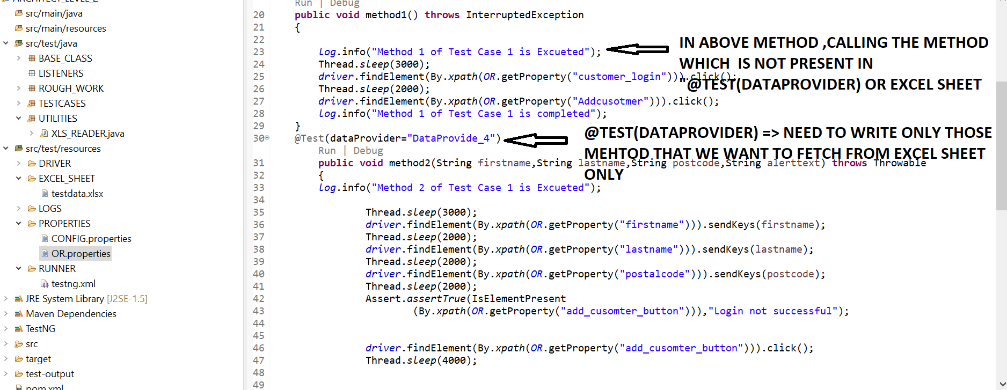

**STEPS 5=> CALL THE SAME “SHEETNAME” IN “DATA PROVIDER” OTHERWISE PROGRAM WILL NOT RUN.CREATE BELOW TEST CASE WITH “DATAPROVIDER” IN “TESTCASE2”. REMEMEBER TEST CASE 2 WILL START WHERE TEST CASE 1 WILL STOP AS WE HAVE METHOD SUCH AS “BEFORE SUITE” AND “AFTERSUITE” IN BASE CLASS FOR LAUNCHING DRIVER AND QUITING THE DRIVER=> @TEST(DATAPROVIDER) => NEED TO WRITE ONLY THOSE METHOD SUCHAS FIRSTNAEM,LASTNAME ETC THAT WE WANT TO FETCH FROM EXCEL SHEET ONLY**

**IF WE RIGHT CLICK ON PROEJCT AND THEN RUN AS “MAVEN TEST”,IF IT DOESN’T SHOW AS “BUILD –SUCCESS” THEN RIGHT CLICK ON PROJECT AND CHOOSE CONFIGURE BUILD PATH AS “JDK 17” AND THEN RIGHT CLICK ON PROJECT AND THEN FORCEFULLY UPDATE ON “MODIFY SNAPSHOT/RELEASE” THEN “BUILD SUCCESS” WILL SHOW FOR “MAVEN TEST”**

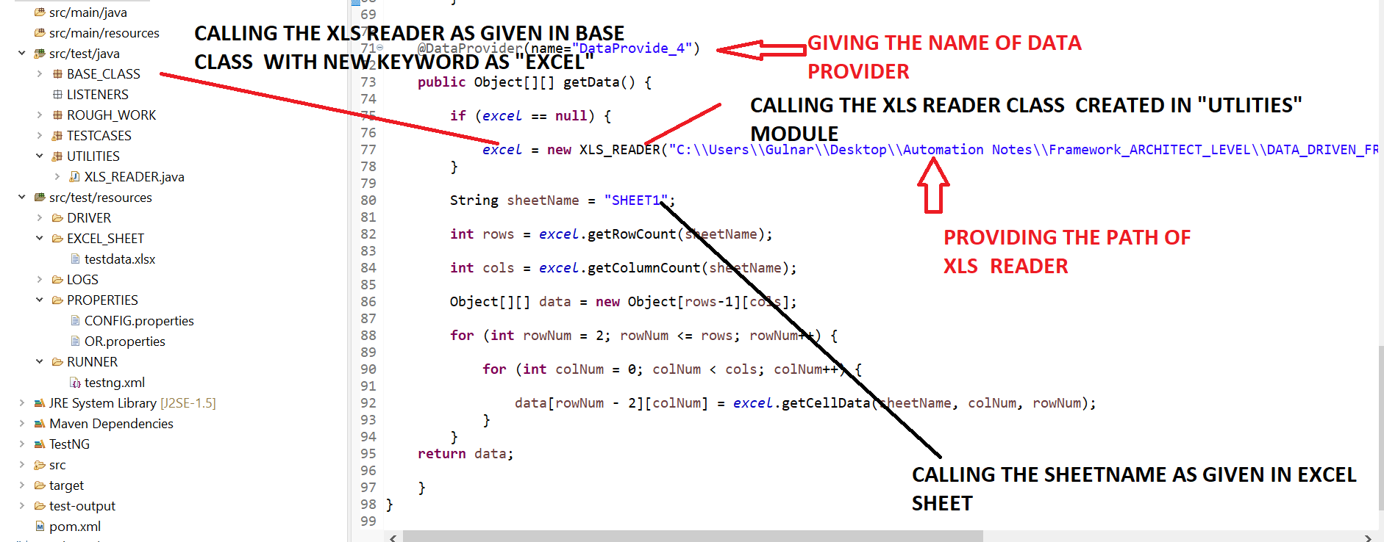

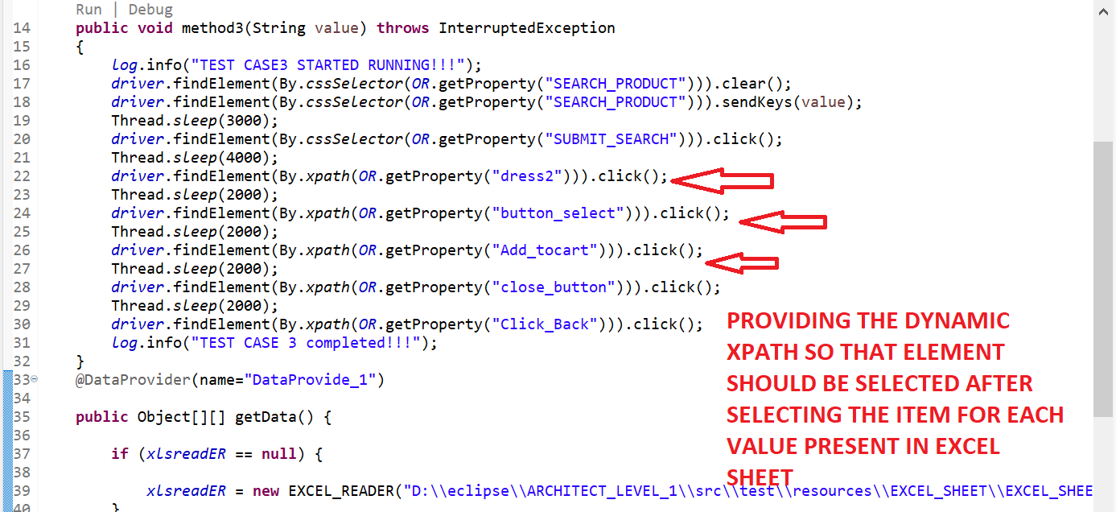

**OR PROPERTIES**

#BankLogins

customer_login=(//*[@class='btn btn-primary btn-lg'])[2]

Addcusotmer=//*[@ng-class='btnClass1']

firstname=//*[@ng-model='fName']

lastname=//*[@ng-model='lName']

postalcode=//*[@ng-model='postCd']

add_cusomter_button=//*[@class='btn btn-default']

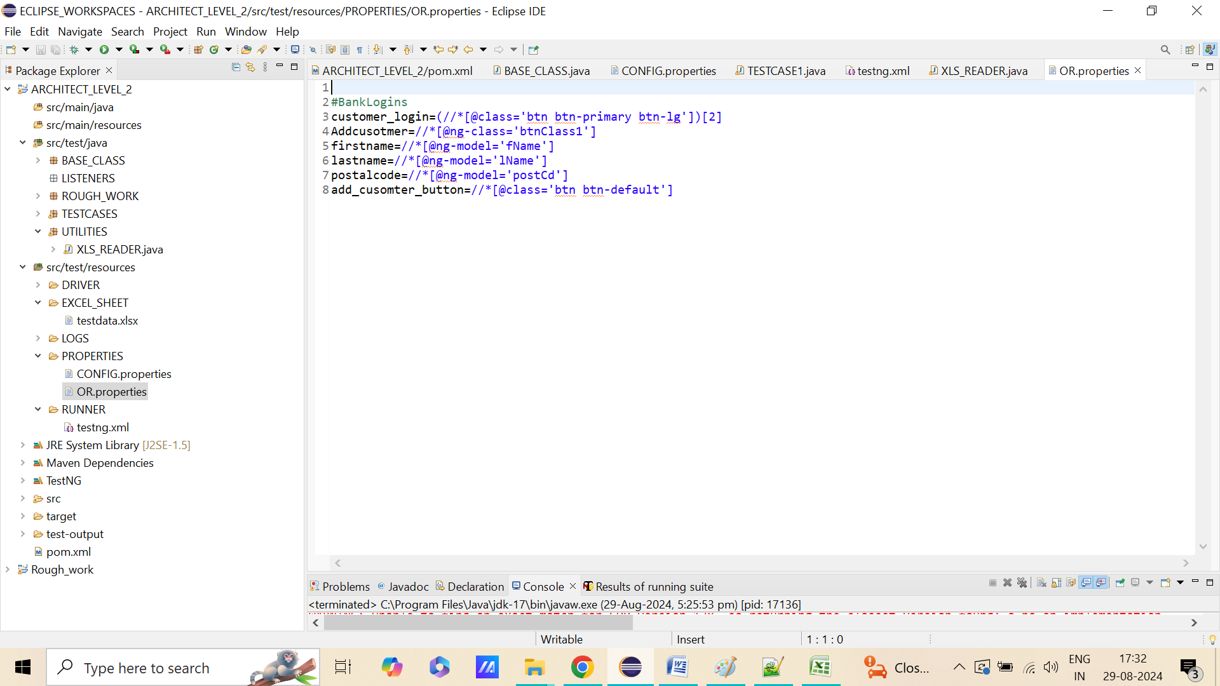

**STEPS 6=>CALL TWO TESTCASES IN “TESTNG.XML” FILE.**

<?xml version="1.0" encoding="UTF-8"?>

<!DOCTYPE suite SYSTEM "http://testng.org/testng-1.0.dtd" >

<suite name="Suite">

<test name="TESTCASE1">

<classes>

<class name="TESTCASES.TESTCASE1"/>

</classes>

</test> <!-- Test -->

</suite> <!-- Suite -->

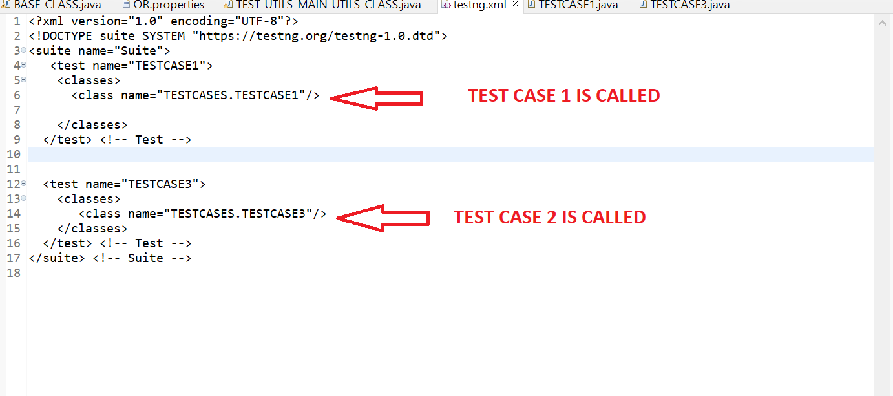

**STEPS 7=>THE UPDATED CODE IN “BASE CLASS ARE AS FOLLOW**

**package** BASE_CLASS;

**import** java.io.FileInputStream;

**import** java.io.IOException;

**import** java.time.Duration;

**import** java.util.Date;

**import** java.util.NoSuchElementException;

**import** java.util.Properties;

**import** org.apache.log4j.Logger;

**import** org.apache.log4j.PropertyConfigurator;

**import** org.openqa.selenium.By;

**import** org.openqa.selenium.WebDriver;

**import** org.openqa.selenium.chrome.ChromeDriver;

**import** org.openqa.selenium.chrome.ChromeOptions;

**import** org.openqa.selenium.edge.EdgeDriver;

**import** org.openqa.selenium.edge.EdgeOptions;

**import** org.openqa.selenium.firefox.FirefoxDriver;

**import** org.openqa.selenium.firefox.FirefoxOptions;

**import** org.openqa.selenium.support.ui.WebDriverWait;

**import** org.testng.annotations.AfterSuite;

**import** org.testng.annotations.BeforeSuite;

**import** UTILITIES.XLS_READER;

**import** io.github.bonigarcia.wdm.WebDriverManager;

**public** **class** BASE_CLASS {

**public** **static** WebDriver *driver*;

**public** **static** Properties *config* = **new** Properties();

**public** **static** Properties *OR* = **new** Properties();

**public** **static** WebDriverWait *waits* ;

**public** **static** Logger *log* = Logger.*getLogger*(BASE_CLASS.**class**.getName());

**public** **static** XLS_READER *excel* = **new** XLS_READER(

System.*getProperty*("user.dir") + "\\src\\test\\resources\\EXCEL_SHEET\\testdata.xlsx");

@BeforeSuite

**public** **void** setup() **throws** IOException, InterruptedException

{

Date d = **new** Date();

System.*setProperty*("current.date", d.toString().replace(":", "_").replace(" ", "_"));

PropertyConfigurator.*configure*("C:\\Users\\Gulnar\\Desktop\\Automation Notes\\Framework_ARCHITECT_LEVEL\\DATA_DRIVEN_FRAMEWORK\\ARCHITECT_LEVEL_2\\src\\test\\resources\\LOGS\\log4j.properties");

**if** (*driver* == **null**)

{

FileInputStream fis = **new** FileInputStream(

System.*getProperty*("user.dir") + "\\src\\test\\resources\\PROPERTIES\\CONFIG.properties");

*config*.load(fis);

fis = **new** FileInputStream(

System.*getProperty*("user.dir") + "\\src\\test\\resources\\PROPERTIES\\OR.properties");

*OR*.load(fis);

**if**(*config*.getProperty("BROWSER").equals("CHROME"))

{

System.*setProperty*("Webdriver.chrome.driver",*config*.getProperty("chromepath"));

ChromeOptions option = **new** ChromeOptions();

option.addArguments("--remote-allow-origins=*");

WebDriverManager.*chromedriver*().setup();

*driver* = **new** ChromeDriver(option);

*log*.info("chrome driver is Excueted");

}

**else** **if**(*config*.getProperty("BROWSER").equals("firefox"))

{

System.*setProperty*("Webdriver.gecko.driver",*config*.getProperty("geckodriverpath"));

FirefoxOptions option = **new** FirefoxOptions();

//option.addArguments("--remote-allow-origins=*");

WebDriverManager.*firefoxdriver*().setup();

*driver* = **new** FirefoxDriver(option);

*log*.info("firefox driver is Excueted");

}

**else** **if**(*config*.getProperty("BROWSER").equals("ie"))

{

System.*setProperty*("Webdriver.edge.driver",*config*.getProperty("ie_driverpath"));

EdgeOptions option = **new** EdgeOptions ();

option.addArguments("--remote-allow-origins=*");

WebDriverManager.*edgedriver*().setup();

*driver* =**new** EdgeDriver(option);

*log*.info("edge driver is Excueted");

}

*driver*.get(*config*.getProperty("TESTSITEURL"));

Thread.*sleep*(3000);

*driver*.manage().window().maximize();

*driver*.manage().deleteAllCookies();

*driver*.manage().timeouts().implicitlyWait(Duration.*ofHours*(2));

*waits* = **new** WebDriverWait(*driver*, Duration.*ofHours*(2));

*log*.info("TESTSITEURL is Excueted");

}

}

**public** **boolean** IsElementPresent(By by)

{

**try**

{

*driver*.findElement(by);

**return** **true**;

}

**catch**(NoSuchElementException e)

{

**return** **false**;

}

}

@AfterSuite

**public** **void** Tearup() {

**if**(*driver*!=**null**)

{

*driver*.quit();

}

*log*.info("close Browser is Excueted");

}

}

**STEPS 8=> RIGHT CLICK ON PROJECT AND RUN AS “TESTNG”.IT SHOULD WORK AS EXPECTED=>IF WE RIGHT CLICK PN PROEJCT AND THEN RUN AS “MAVEN TEST”,IF IT DOESN’T SHOW AS “BUILD –SUCCESS” THEN RIGHT CLICK ON PROJECT AND CHOOSE CONFIGURE BUILD PATH AS “JDK 17” AND THEN RIGHT CLICK ON PROJECT AND THEN FORCEFULLY UPDATE ON “MODIFY SNAPSHOT/RELEASE”**

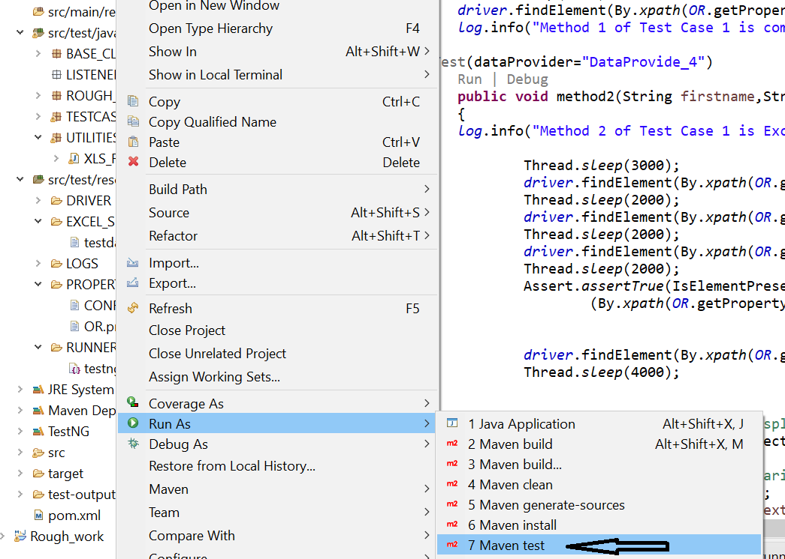

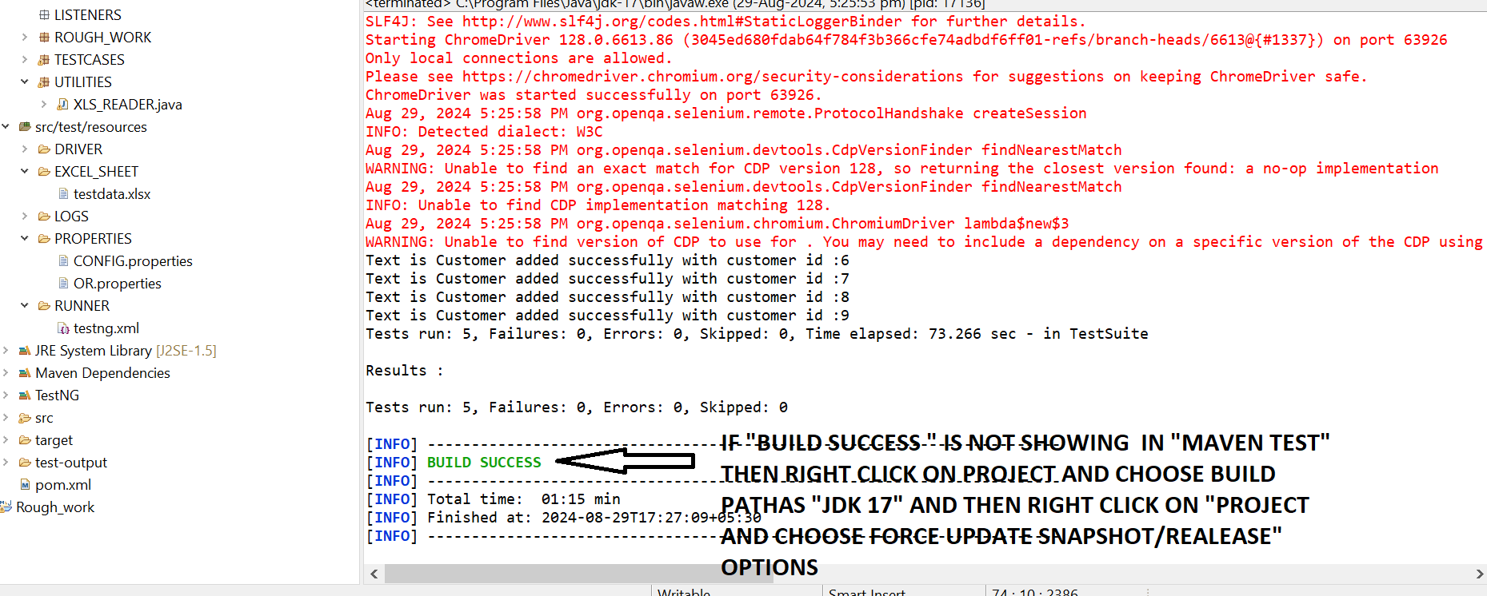

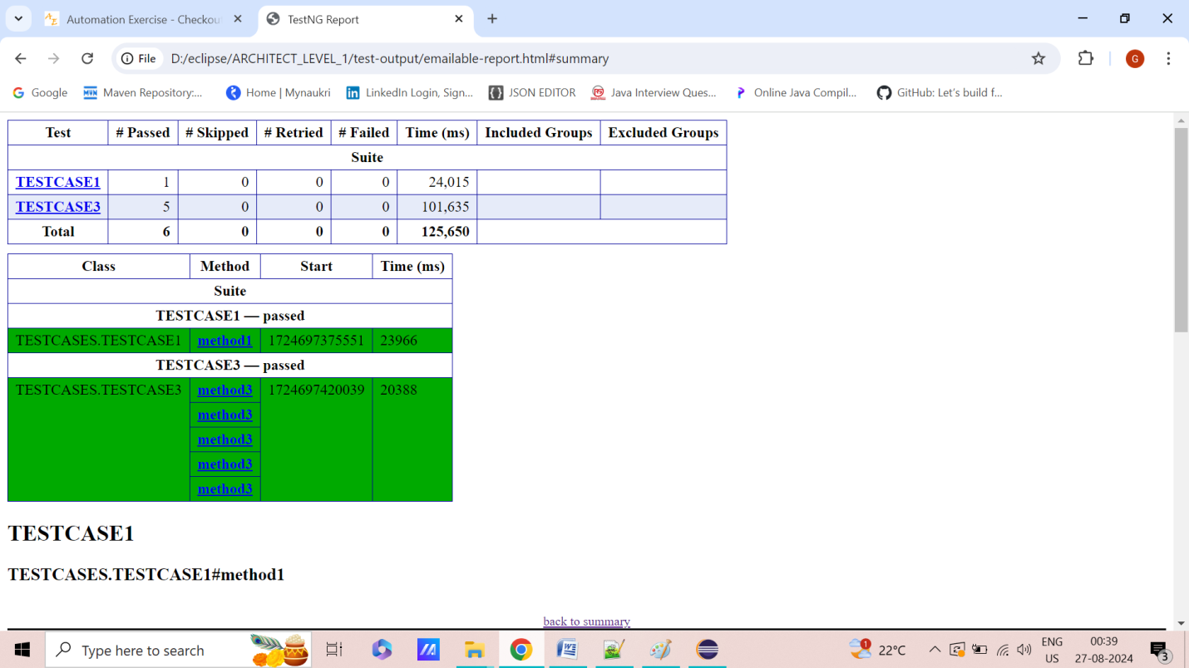

**EXPLANATION**

**CREATING THE NEW METHOD JUST FOR CLICKING "BANK CUSTOMER LOGIN" BUTTON AND CLICKING "ADD CUSTOMER BUTTON" AS IT CANNOT ADDED IN DATA PROVIDER METHOD.IN DATA PROVIDER ,"ONLY THOSE FIELD CAN BE WRITTEN THAT NEED TO FETCHED FROM EXCEL SHEET**

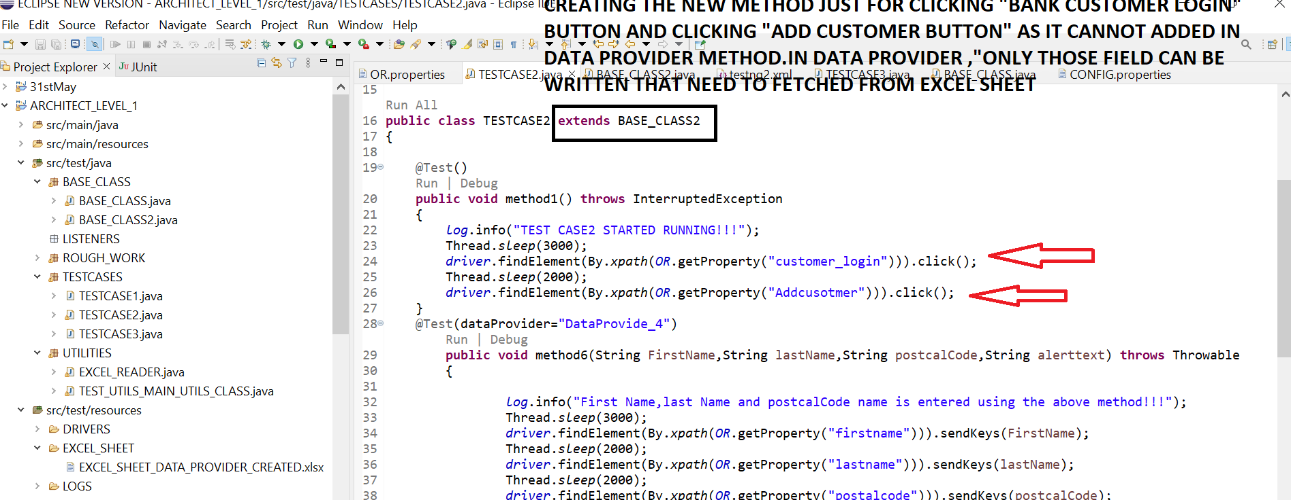

**GIVE SAME THE NAME OF EACH FIELD HERE SHOULD BE SAME AS IT IS PRESENT IN EXCEL SHEET THEN CALL THE SAME SHEET NAME AS PRESENT IN EXCEL SHEET**

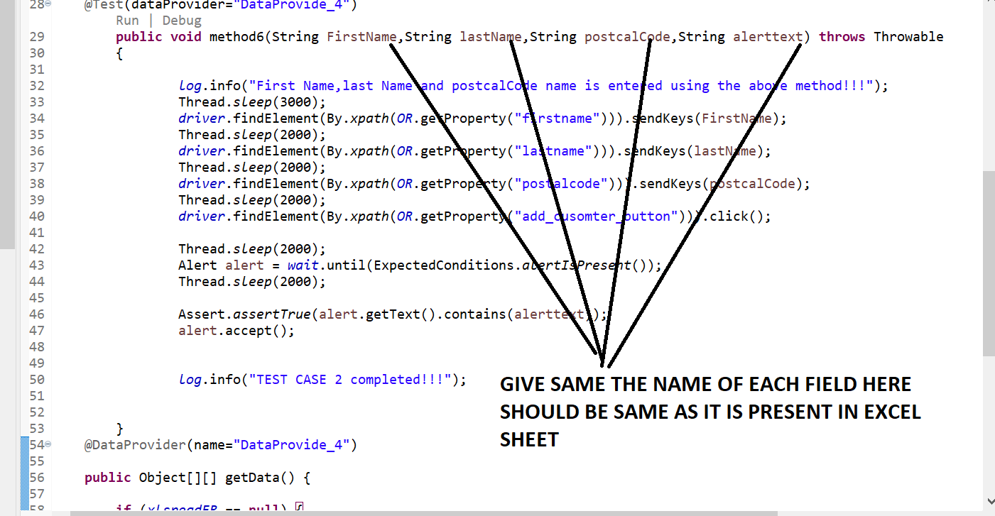

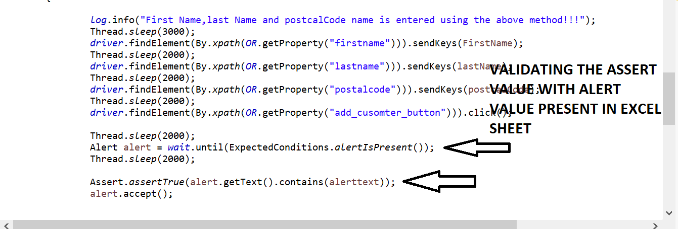

**THEN CALL THE SAME SHEET NAME AS PRESENT IN EXCEL SHEET**

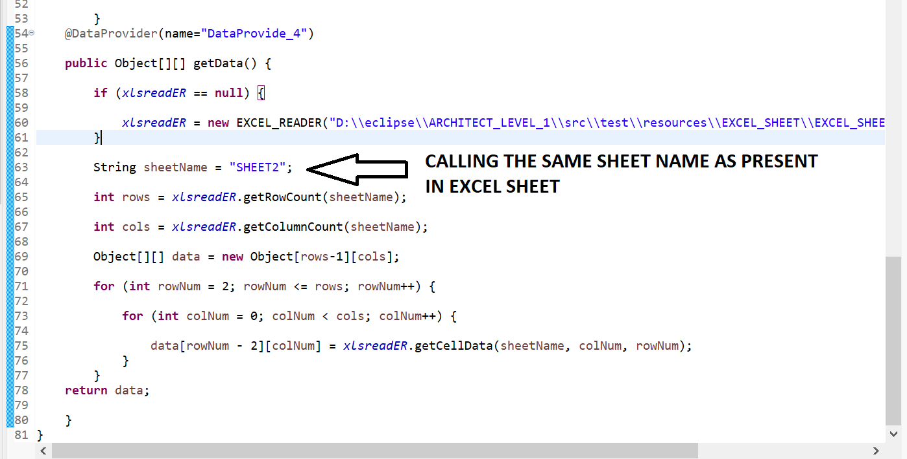

**STEPS 4=> CREATE “NEW TESTNG.XML” FILE WITH CALLING THE ABOVE TEST CASE**

<?xml version="1.0" encoding="UTF-8"?>

<!DOCTYPE suite SYSTEM "https://testng.org/testng-1.0.dtd">

<suite name="Suite">

<test name="TESTCASE1">

<classes>

<class name="TESTCASES.TESTCASE2"/>

</classes>

</test> <!-- Test -->

</suite> <!-- Suite -->

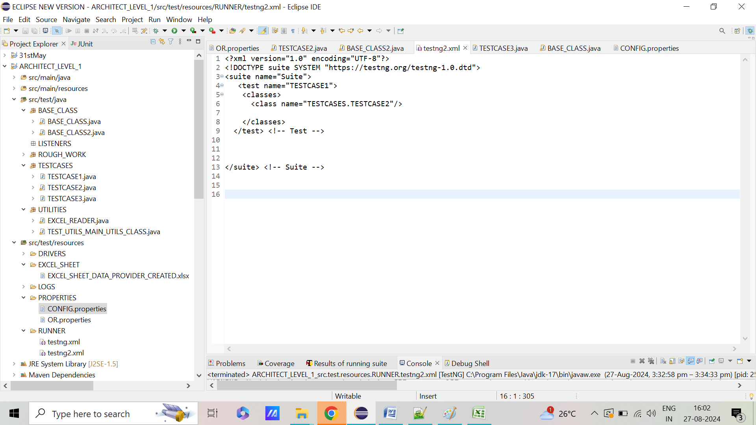

**STEPS 5=> RIGHT CLICK ON PROJECT AND RUN AS “TESTNG”.IT SHOULD WORK AS EXPECTED**

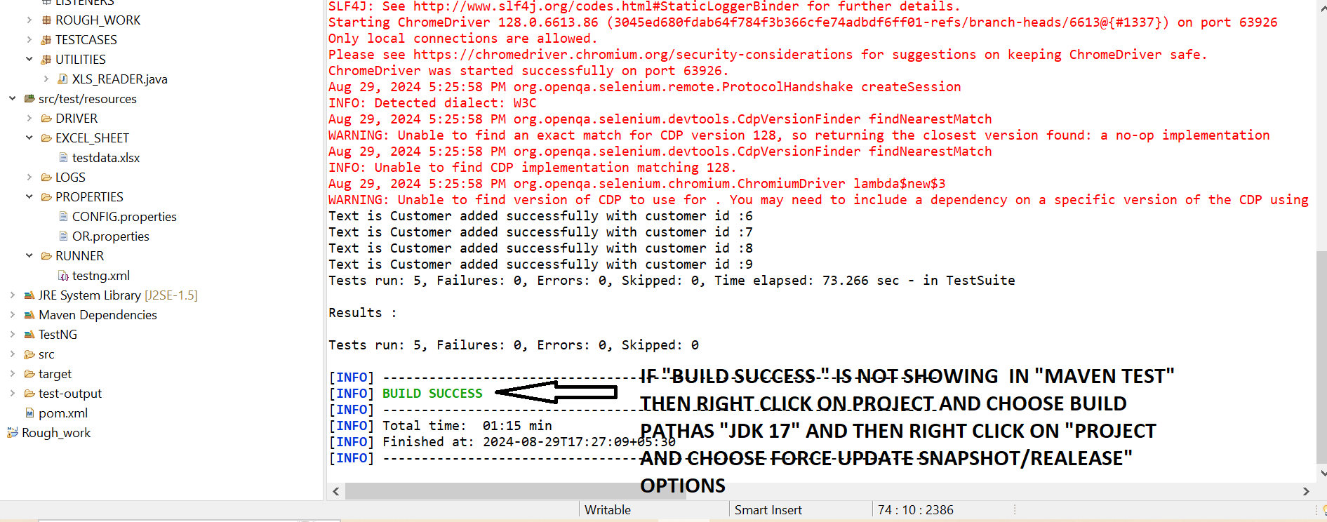

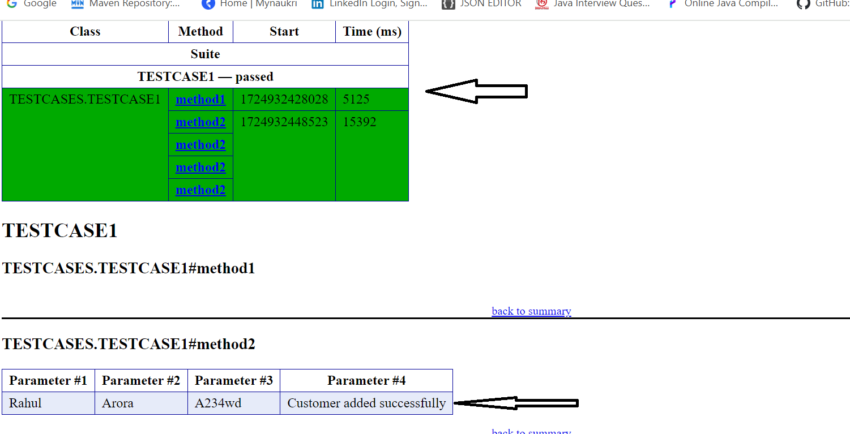

**RIGHT CLICK ON PROJECT THEN RUN AS :MAVEN TEST” ,IT SHOULD WORK AS EXPECTED**

**STEP 20=> WHAT ARE REPORTNG?HOW TO USE THEM IN APPLICATION?**

**STEPS 1=> ADD TWO DEPENDENCIES IN POM.XML SUCHAS “REPORTNG” AND “GUICE”**

**STEPS 2=> ADD TWO LINE OF CODE IN “TESTNG.XML” THAT WILL GENERATE CLEAN HTML AND XML REPORT WITH TIME STAMP**

<listeners>

<listener class-name="org.uncommons.reportng.HTMLReporter"/>

<listener class-name="org.uncommons.reportng.JUnitXMLReporter"/>

</listeners>

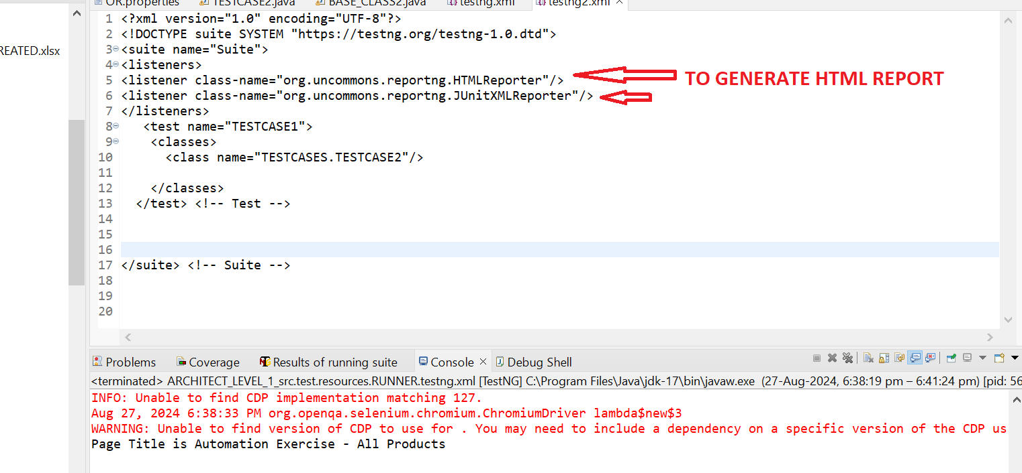

**STEPS 3=> REFRESH THE PROECT.THE REPORTNG REPORT WILL BE GENERATED IN "SUREFIRE FOLDER" ,THEN INSIDE HTML FOLDER AS "INDEX.HTML"**

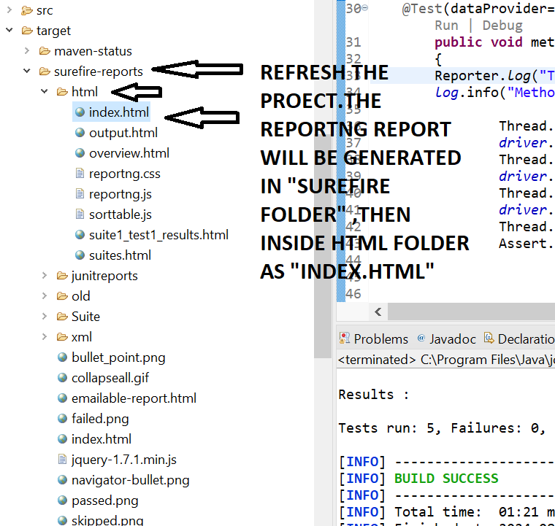

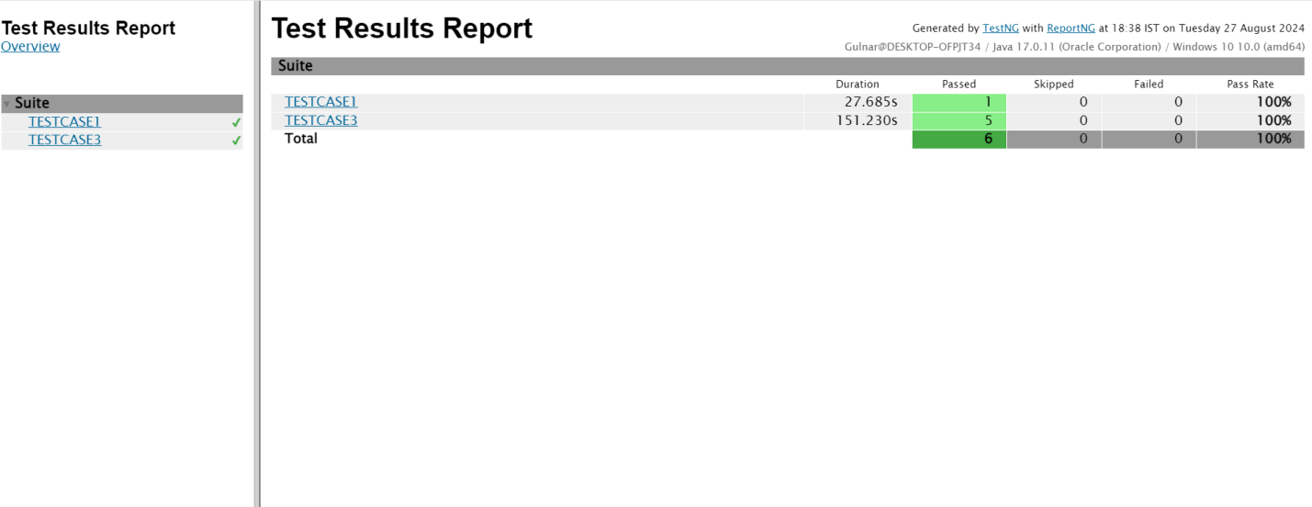

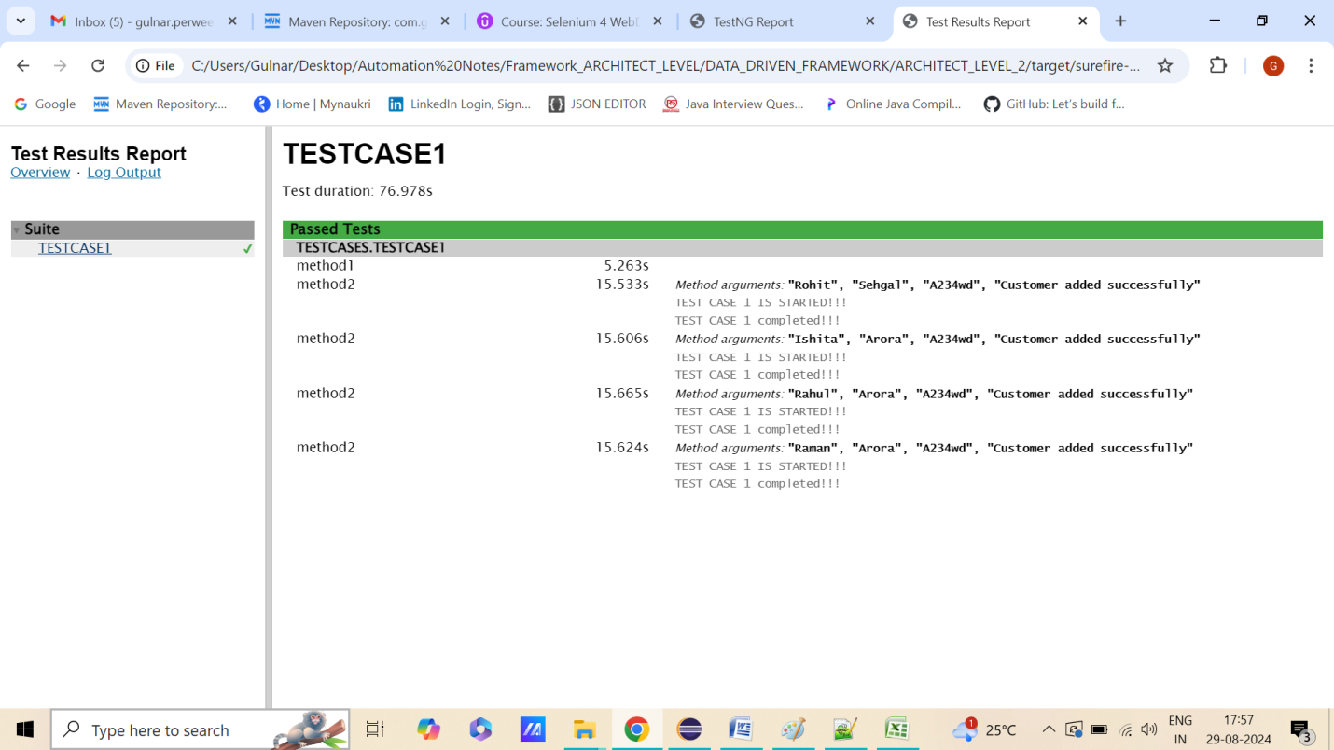

**STEPS 4=> HOW TO ADD CUSTOM MESSAGE FOR EVERY TEST CASES ?=>** **WE CAN USE "Reporter.log("TEST CASE 2 completed!!!");" IN EVERY TESTCASES TO DISPLAY CUSTOM MESSAGE**

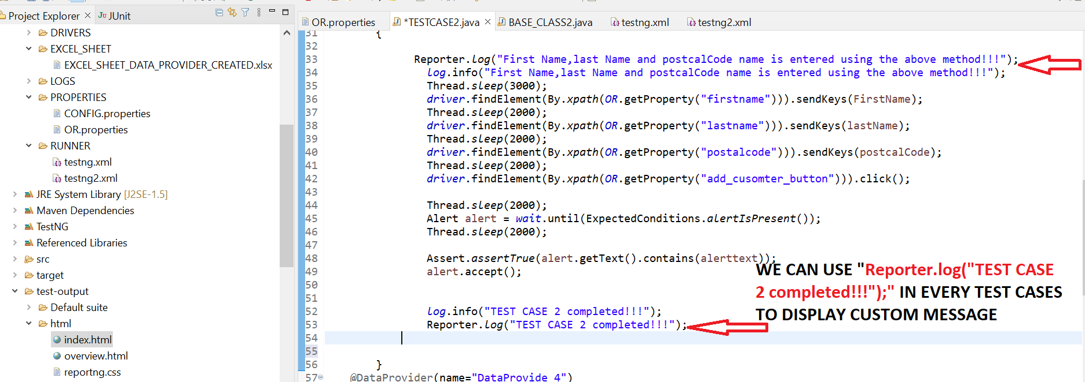

**STEPS 5=> CUSTOM MESSAGE IS DISPLAYED FOR “REPORTS” FOR “INDEX.HTML” IN”HTML FOLDER”**

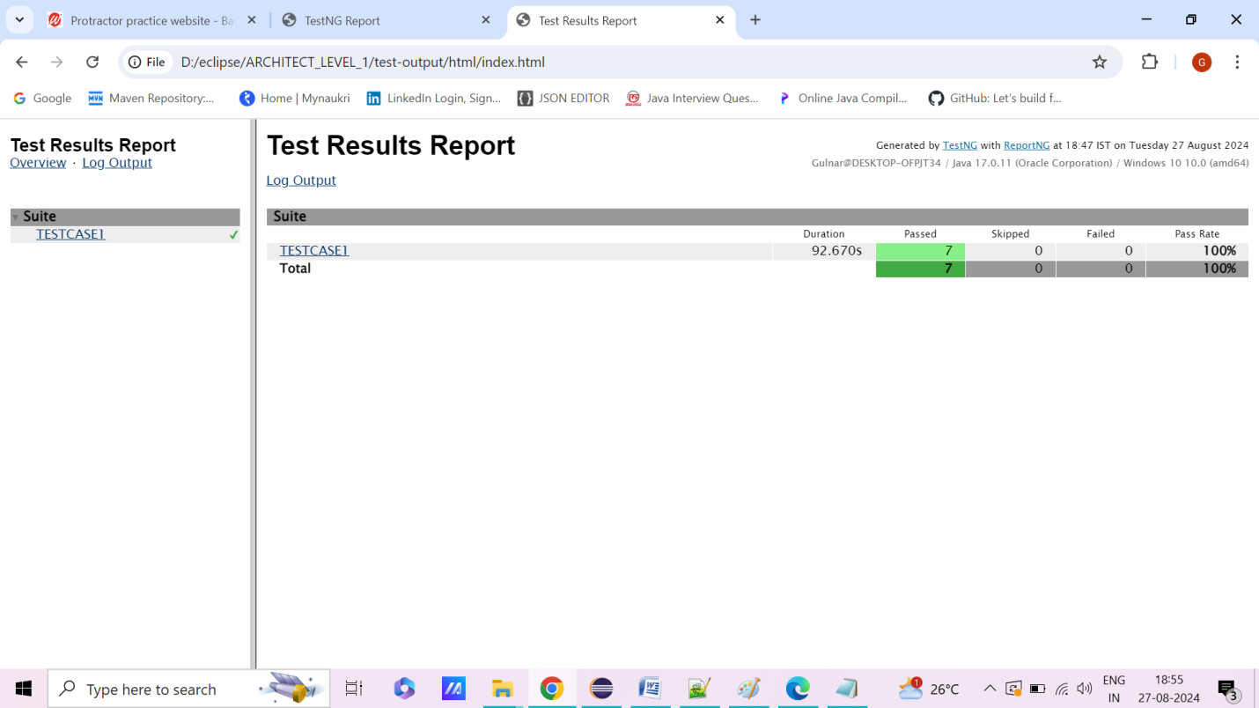

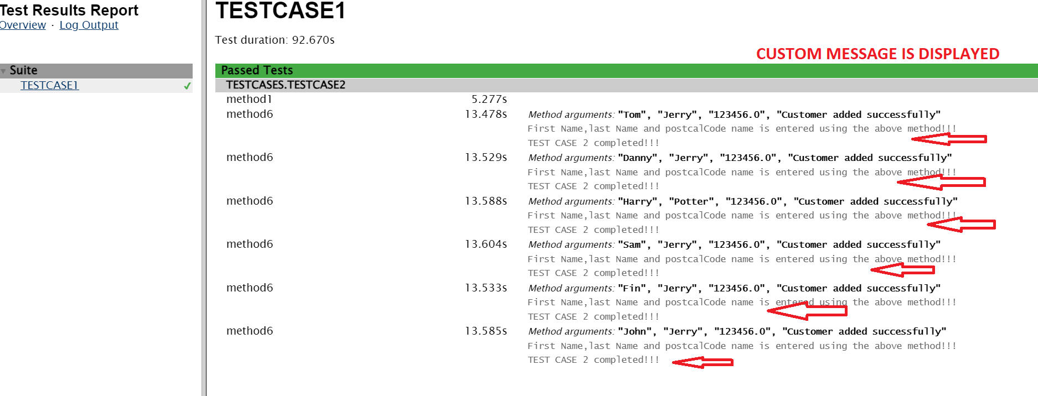

**STEP 21=> WHAT ARE LISTENERS?HOW TO USE THEM IN APPLICATION?HOW TO CAPTURE SCREENSHOT FOR FAILED AND PASSED TESTCASES USING “REPORTNG REPORT”?**

**STEPS 1=> CREATE NEW PACKAGE AND NEW CLASS FOR "CUSTOM LISTENER" IN "SRC/TEST/JAVA"**

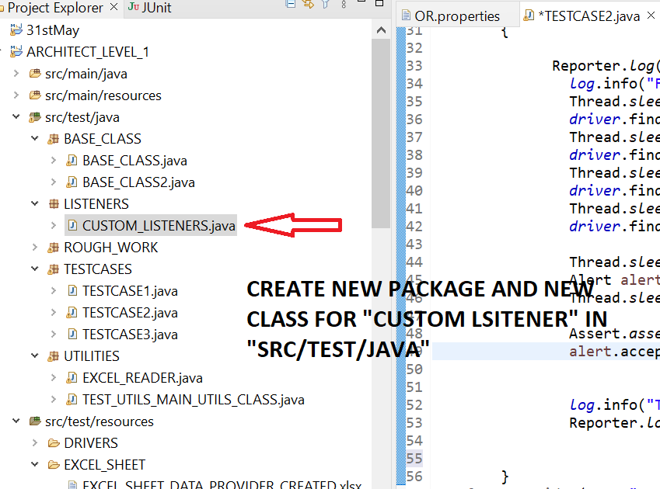

**STEPS 2=> CREATE NEW FOLDER WITH NAME AS “FAILED SCREENSHOT” AND “PASSED SCREENSHOT” FOLDER IN “HTML FOLDER” AND PROVIDE THE SAME PATH FOR “TAKES SCREENSHOT METHOD”=> INSIDE TARGET FOLDER,INSIDE SUREFIRE THEN INSIDE HTML ,SCREENSHOT WILL BE CAPTURED ONLY IN “HTML FOLDER ONLY” OTHERWISE IT WON’T CAPTURE SCREENSHOT INSIDE ANY OTHER FOLDER INSIDE HTML LIKE BELOW SCREENSHOT**

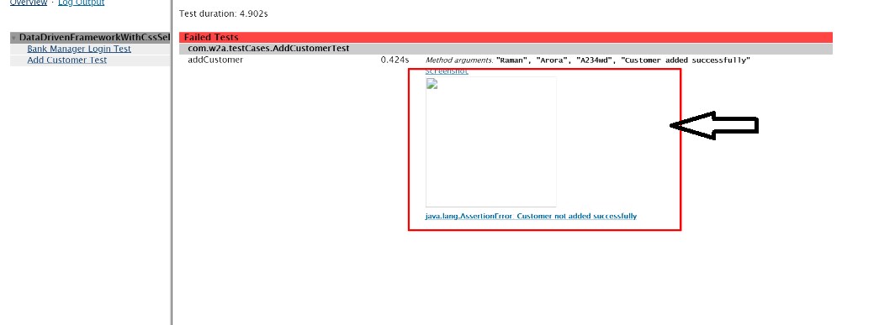

**STEPS 2=> CREATE NEW CLASS IN “TEST UTLIS” .THERE WILL BE WRITING METHOD WHICH IS COMMON TO ALL CLASS SUCHAS “TAKES SCREENSHOT”, DATAPROVIDER ETC FOR CAPTURING SCREENSHOT => SCREENSHOT WILL ONLY BE CAPTURED IF WE PROVIDE THE PATH AS “TARGET FOLDER,THEN INSIDE SUREFOLDER ,THEN INSIDE HTML FOLDER PATH ONLY”**

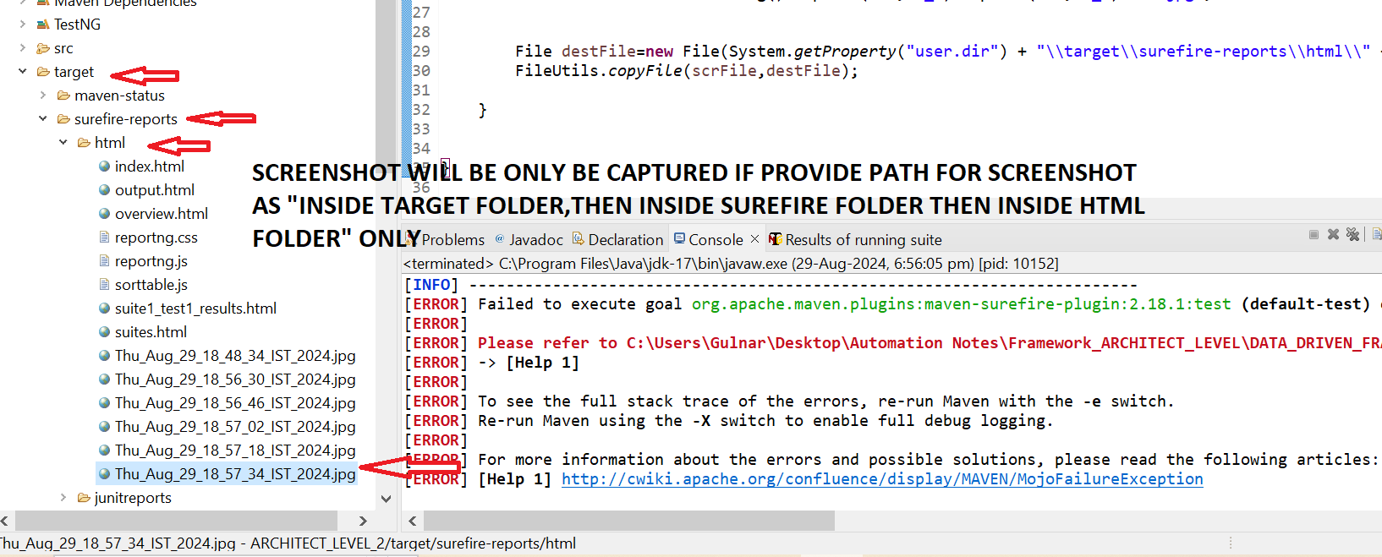

**package** UTILITIES;

**import** java.io.File;

**import** java.io.IOException;

**import** java.util.Date;

**import** org.apache.commons.io.FileUtils;

**import** org.openqa.selenium.OutputType;

**import** org.openqa.selenium.TakesScreenshot;

**import** BASE_CLASS.BASE_CLASS;

**public** **class** TEST_UTLIS **extends** BASE_CLASS

{

**public** **static** String *screenshotPath*;

**public** **static** String *screenshotName*;

**public** **static** **void** captureScreenshot_Failed_screesnhot() **throws** IOException

{

File scrFile = ((TakesScreenshot) *driver*).getScreenshotAs(OutputType.***FILE***);

Date d = **new** Date();

*screenshotName* = d.toString().replace(":", "_").replace(" ", "_") + ".jpg";

File destFile=**new** File(System.*getProperty*("user.dir") + "\\target\\surefire-reports\\html\\" + *screenshotName*);

FileUtils.*copyFile*(scrFile,destFile);

}

}

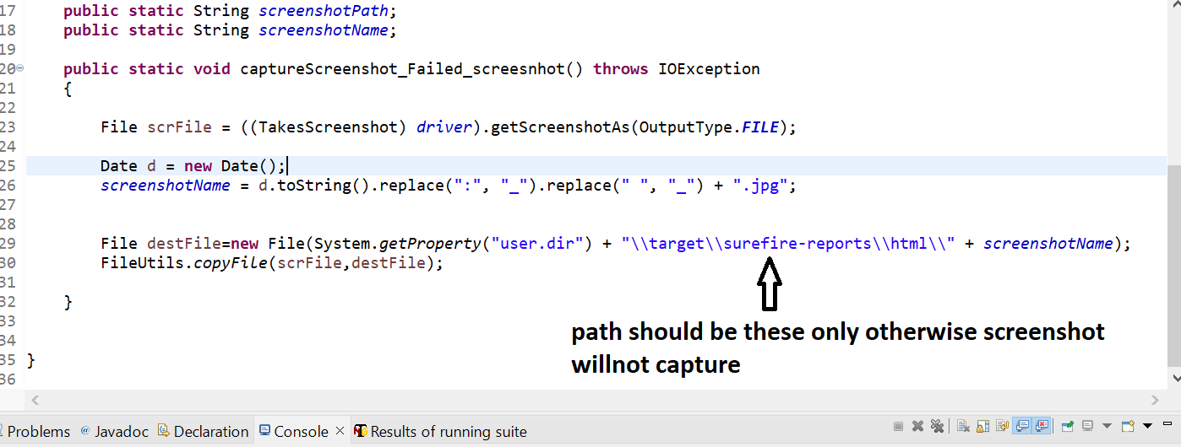

**BELOW CODE IS WRITTEN IN HTML TO CAPURE SCREENSHOT WITH VARAIBLE NAME "SCREENSHOTNAME" WHICH IS PRESENT IN "TESTUTILS CLASS"**

Reporter.*log*("<a target=\"_blank\" href="+ TEST_UTLIS.*screenshotName* +">Screenshot</a>");

Reporter.*log*("<br>");

Reporter.*log*("<br>");

Reporter.*log*("<a target=\"_blank\" href="+ TEST_UTLIS.*screenshotName* +"><img src="

+ TEST_UTLIS.*screenshotName* +" height=200 width=200></img></a>" );

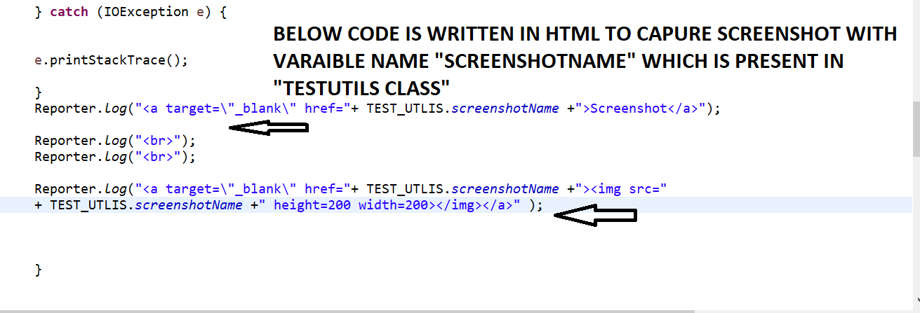

**STEPS 3=> ADD THE PACKAGE NAME AND CLASS NAME IN “TESTNG.XML” WITH CUSTOM LISTENER ANNOTATIONS**

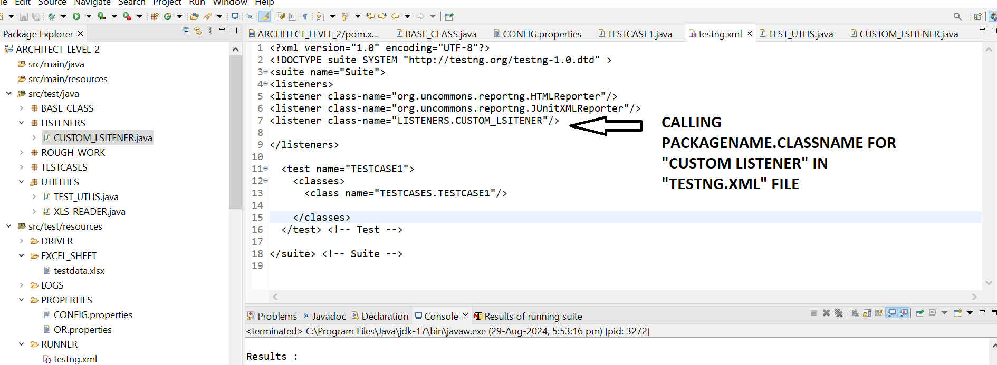

**STEPS 4=> ADD BELOW CODE IN “CUSTOMER LISTNER CLASS”**

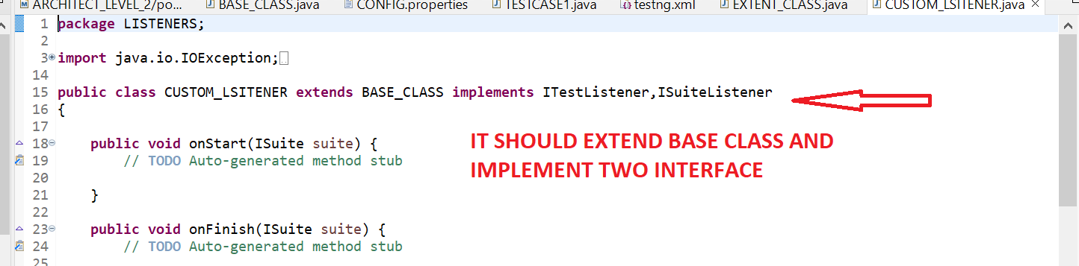

**package** LISTENERS;

**import** java.io.IOException;

**import** org.testng.ISuite;

**import** org.testng.ISuiteListener;

**import** org.testng.ITestContext;

**import** org.testng.ITestListener;

**import** org.testng.ITestResult;

**import** org.testng.Reporter;

**import** BASE_CLASS.BASE_CLASS;

**import** UTILITIES.TEST_UTLIS;

**public** **class** CUSTOM_LSITENER **extends** BASE_CLASS **implements** ITestListener,ISuiteListener

{

**public** **void** onStart(ISuite suite) {

// **TODO** Auto-generated method stub

}

**public** **void** onFinish(ISuite suite) {

// **TODO** Auto-generated method stub

}

**public** **void** onTestStart(ITestResult result) {

// **TODO** Auto-generated method stub

}

**public** **void** onTestSuccess(ITestResult result) {

System.*setProperty*("org.uncommons.reportng.escape-output", "false");

**try** {

TEST_UTLIS.*captureScreenshot_Failed_screesnhot*();

} **catch** (IOException e) {

e.printStackTrace();

}

Reporter.*log*("<a target=\"_blank\" href="+ TEST_UTLIS.*screenshotName* +">Screenshot</a>");

Reporter.*log*("<br>");

Reporter.*log*("<br>");

Reporter.*log*("<a target=\"_blank\" href="+ TEST_UTLIS.*screenshotName* +"><img src="+ TEST_UTLIS.*screenshotName* +" height=200 width=200></img></a>" );

}

**public** **void** onTestFailure(ITestResult result) {

// Setting up screenshot set up.

System.*setProperty*("org.uncommons.reportng.escape-output", "false");

**try** {

TEST_UTLIS.*captureScreenshot_Failed_screesnhot*();

} **catch** (IOException e) {

e.printStackTrace();

}

Reporter.*log*("<a target=\"_blank\" href="+ TEST_UTLIS.*screenshotName* +">Screenshot</a>");

Reporter.*log*("<br>");

Reporter.*log*("<br>");

Reporter.*log*("<a target=\"_blank\" href="+ TEST_UTLIS.*screenshotName* +"><img src="+ TEST_UTLIS.*screenshotName* +" height=200 width=200></img></a>" );

}

**public** **void** onTestSkipped(ITestResult result) {

// **TODO** Auto-generated method stub

}

**public** **void** onTestFailedButWithinSuccessPercentage(ITestResult result) {

// **TODO** Auto-generated method stub

}

**public** **void** onStart(ITestContext context) {

// **TODO** Auto-generated method stub

}

**public** **void** onFinish(ITestContext context) {

// **TODO** Auto-generated method stub

}

}

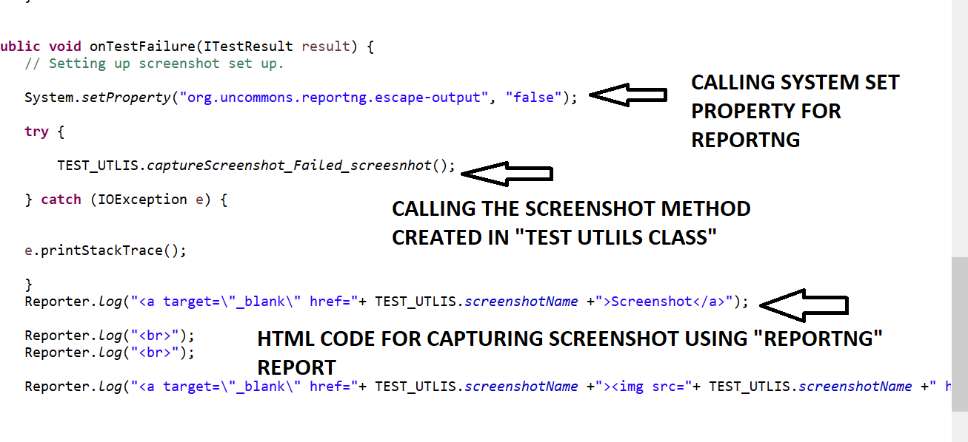

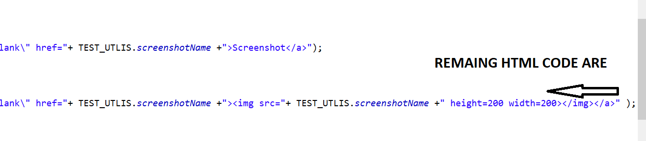

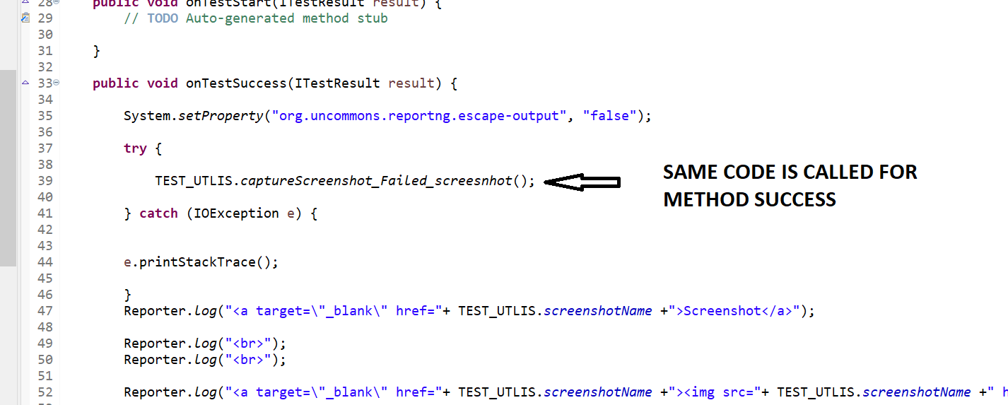

**STEPS 5=> FAIL THE TEST CASE INTENTIONALLY TO CHECK “SCREENSHOT” IS CAPTURED FOR FAILED TEST CASES OR NOT?=>** Assert.*assertTrue*(**false**);

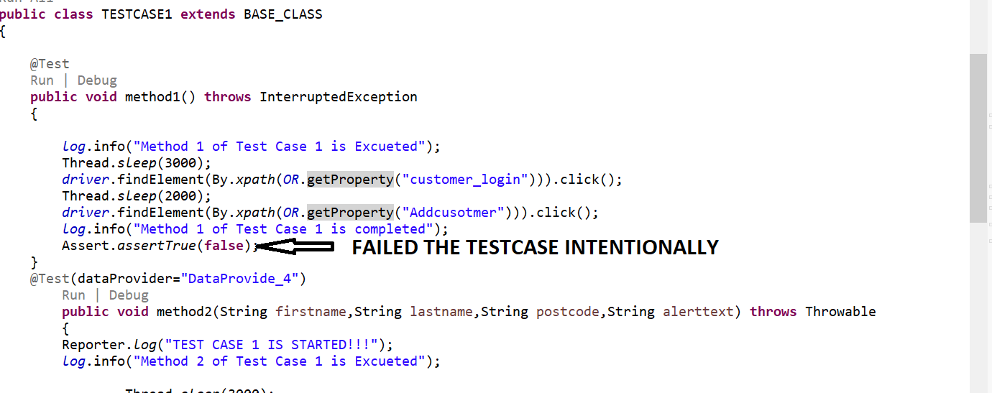

**STEPS 6=> REPORTNG REPORT WILL ONLY BE GENERATED ONLY IF WE RIGHT CLICK ON PROJECT AND RUN AS "MAVEN TEST" OTHERWISE REPORTNG REPORT WILL NOT BE GENERATED=>SCREENSHOT WILL ONLY BE CAPTURED IF WE PROVIDE THE PATH AS “TARGET FOLDER,THEN INSIDE SUREFIREFOLDER ,THEN INSIDE HTML FOLDER PATH ONLY”**

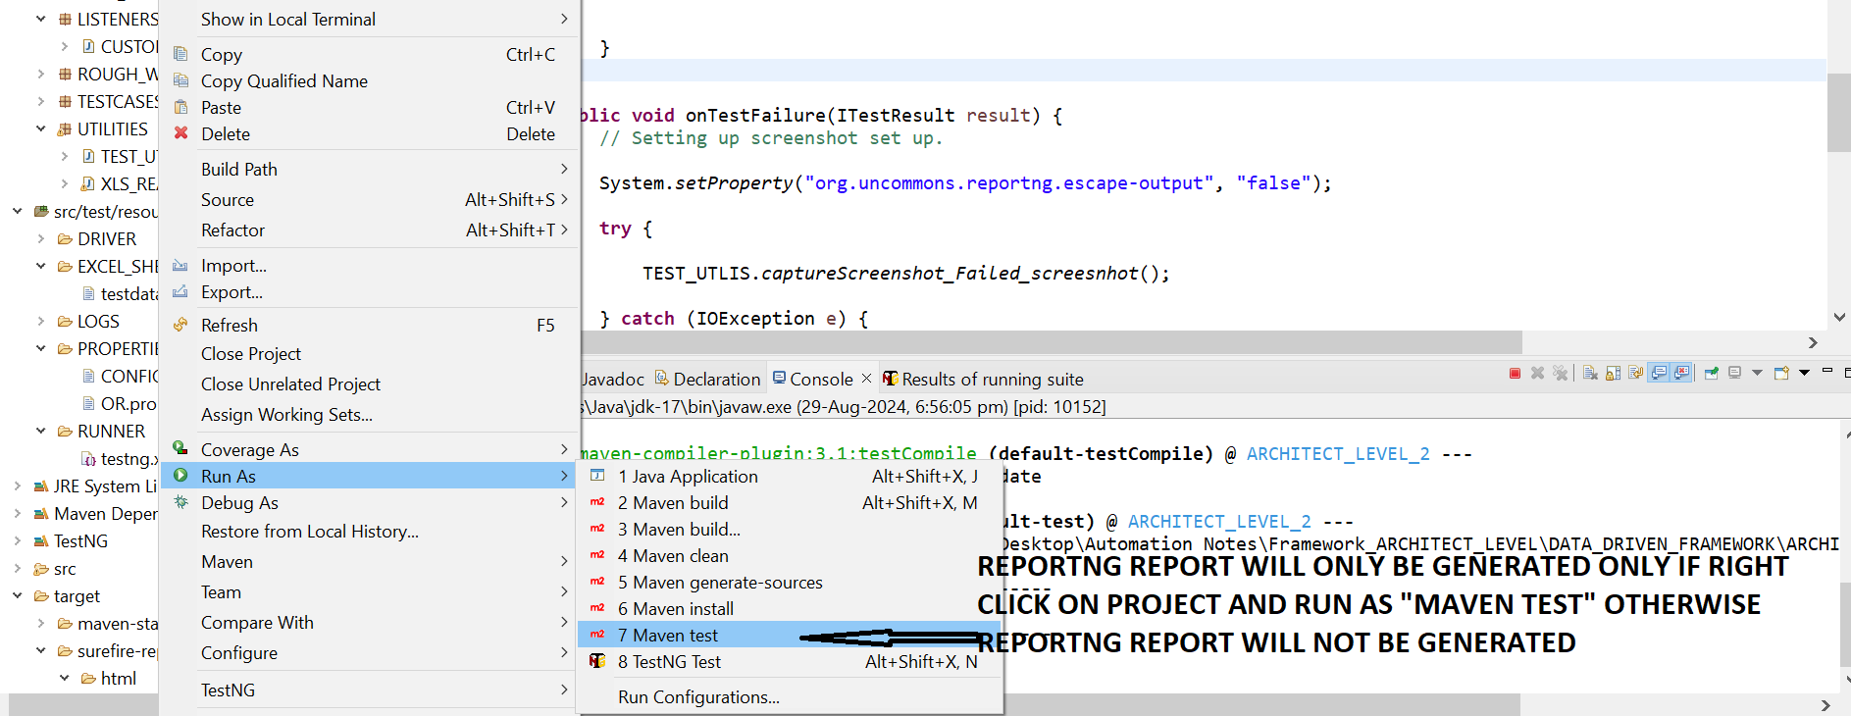

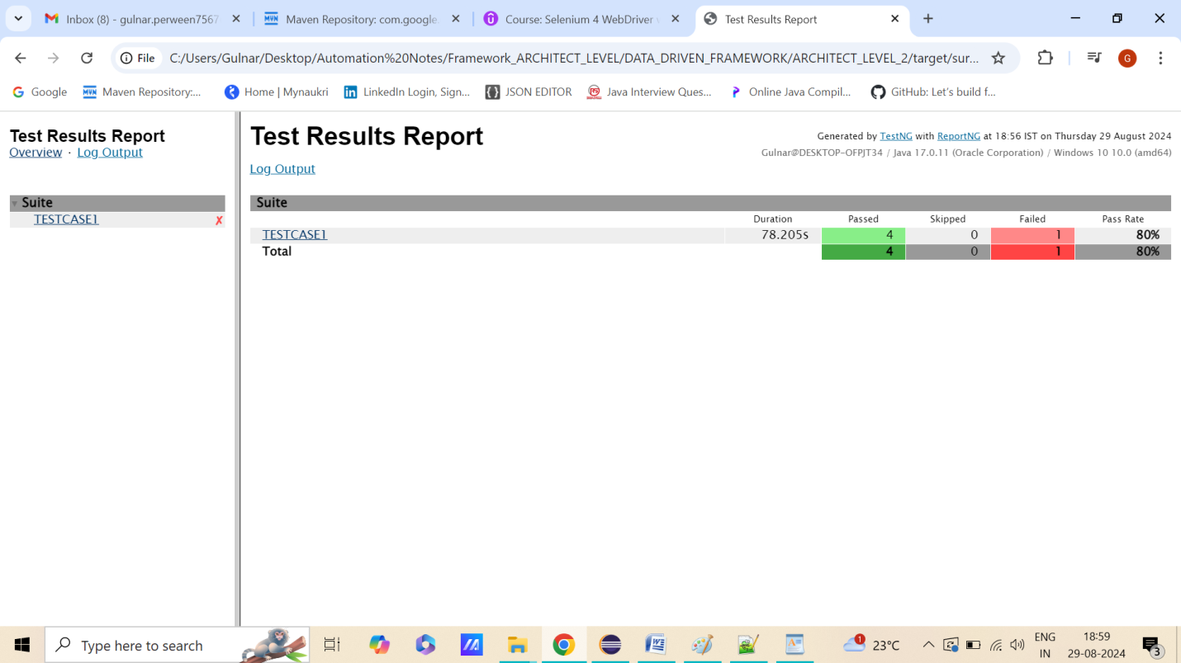

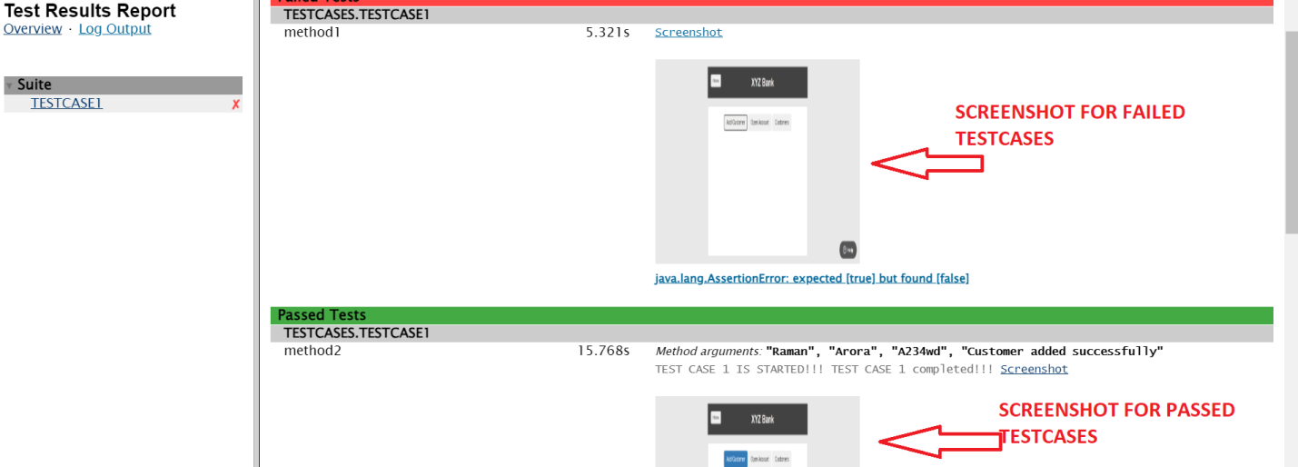



**STEP 24=> HOW TO CREATE TEST CASE 2 ?AND HOW TO DO TESTING USING KEYWORD DRIVEN FRAMEWORK ?**

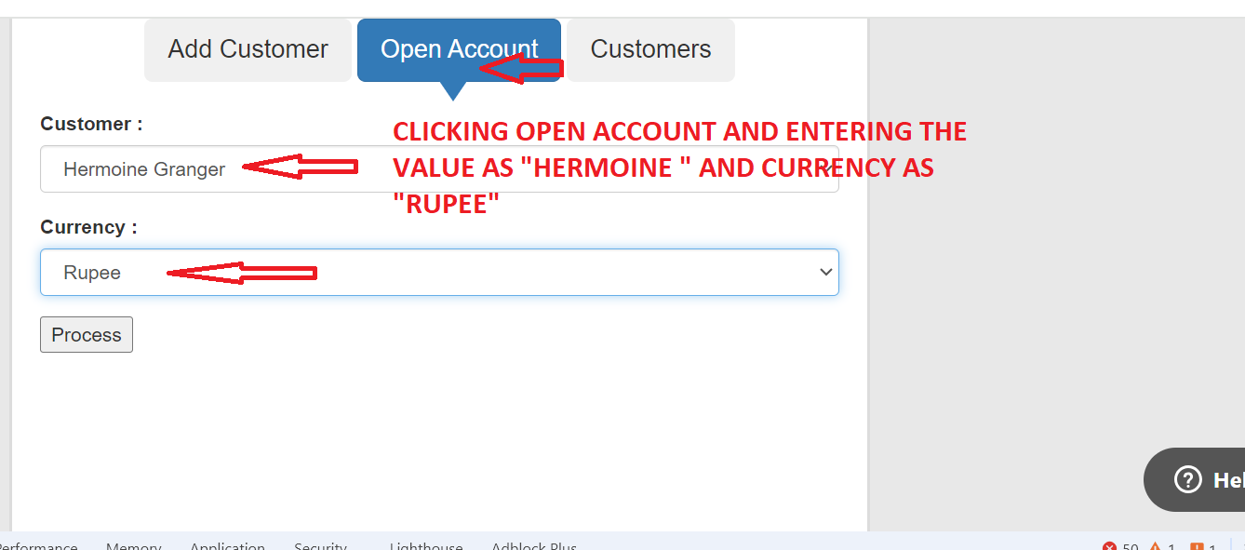

**STEPS 1=>CREATE METHOD IN BASE CLASS SUCH AS “CLICK” METHOD FOR CLICK EVENT ,”TYPEVALUE”METHOD FOR “SEND KEYS “ ETC AND STATE THAT IF LOCATOR “NAME “ IN “OR PROPERTIES” ENDSWITH XPATH ,CSS SELECTOR THEN FETCH THE XPATH NAME FROM LOCATOR_XPATH FROM “OR PROPERTIES”**

**XPATH WRITTEN IN SUCH A WAY THAT NAME ENDSWITH"_XPATH" OR" _CSS"IN “OR PROPERTY”**

**BASE CLASS.JAVA**

**package** BASE_CLASS;

**import** java.io.FileInputStream;

**import** java.io.IOException;

**import** java.time.Duration;

**import** java.util.Date;

**import** java.util.NoSuchElementException;

**import** java.util.Properties;

**import** org.apache.log4j.Logger;

**import** org.apache.log4j.PropertyConfigurator;

**import** org.openqa.selenium.By;

**import** org.openqa.selenium.WebDriver;

**import** org.openqa.selenium.WebElement;

**import** org.openqa.selenium.chrome.ChromeDriver;

**import** org.openqa.selenium.chrome.ChromeOptions;

**import** org.openqa.selenium.edge.EdgeDriver;

**import** org.openqa.selenium.edge.EdgeOptions;

**import** org.openqa.selenium.firefox.FirefoxDriver;

**import** org.openqa.selenium.firefox.FirefoxOptions;

**import** org.openqa.selenium.support.ui.Select;

**import** org.openqa.selenium.support.ui.WebDriverWait;

**import** org.testng.Assert;

**import** org.testng.Reporter;

**import** org.testng.annotations.AfterSuite;

**import** org.testng.annotations.BeforeSuite;

**import** com.aventstack.extentreports.MediaEntityBuilder;

**import** com.aventstack.extentreports.Status;

**import** LISTENERS.CUSTOM_LSITENER;

**import** UTILITIES.TEST_UTLIS;

**import** UTILITIES.XLS_READER;

**import** io.github.bonigarcia.wdm.WebDriverManager;

**public** **class** BASE_CLASS {

**public** **static** WebDriver *driver*;

**public** **static** Properties *config* = **new** Properties();

**public** **static** Properties *OR* = **new** Properties();

**public** **static** WebDriverWait *waits* ;

**public** **static** Logger *log* = Logger.*getLogger*(BASE_CLASS.**class**.getName());

**public** **static** XLS_READER *excel* = **new** XLS_READER(

System.*getProperty*("user.dir") + "\\src\\test\\resources\\EXCEL_SHEET\\testdata.xlsx");

@BeforeSuite

**public** **void** setup() **throws** IOException, InterruptedException

{

Date d = **new** Date();

System.*setProperty*("current.date", d.toString().replace(":", "_").replace(" ", "_"));

PropertyConfigurator.*configure*("C:\\Users\\Gulnar\\Desktop\\Automation Notes\\Framework_ARCHITECT_LEVEL\\DATA_DRIVEN_FRAMEWORK\\ARCHITECT_LEVEL_2\\src\\test\\resources\\LOGS\\log4j.properties");

**if** (*driver* == **null**)

{

FileInputStream fis = **new** FileInputStream(

System.*getProperty*("user.dir") + "\\src\\test\\resources\\PROPERTIES\\CONFIG.properties");

*config*.load(fis);

fis = **new** FileInputStream(

System.*getProperty*("user.dir") + "\\src\\test\\resources\\PROPERTIES\\OR.properties");

*OR*.load(fis);

**if**(*config*.getProperty("BROWSER").equals("CHROME"))

{

System.*setProperty*("Webdriver.chrome.driver",*config*.getProperty("chromepath"));

ChromeOptions option = **new** ChromeOptions();

option.addArguments("--remote-allow-origins=*");

WebDriverManager.*chromedriver*().setup();

*driver* = **new** ChromeDriver(option);

*log*.info("chrome driver is Excueted");

}

**else** **if**(*config*.getProperty("BROWSER").equals("firefox"))

{

System.*setProperty*("Webdriver.gecko.driver",*config*.getProperty("geckodriverpath"));

FirefoxOptions option = **new** FirefoxOptions();

//option.addArguments("--remote-allow-origins=*");

WebDriverManager.*firefoxdriver*().setup();

*driver* = **new** FirefoxDriver(option);

*log*.info("firefox driver is Excueted");

}

**else** **if**(*config*.getProperty("BROWSER").equals("ie"))

{

System.*setProperty*("Webdriver.edge.driver",*config*.getProperty("ie_driverpath"));

EdgeOptions option = **new** EdgeOptions ();

option.addArguments("--remote-allow-origins=*");

WebDriverManager.*edgedriver*().setup();

*driver* =**new** EdgeDriver(option);

*log*.info("edge driver is Excueted");

}

*driver*.get(*config*.getProperty("TESTSITEURL"));

Thread.*sleep*(3000);

*driver*.manage().window().maximize();

*driver*.manage().deleteAllCookies();

*driver*.manage().timeouts().implicitlyWait(Duration.*ofHours*(2));

*waits* = **new** WebDriverWait(*driver*, Duration.*ofHours*(2));

*log*.info("TESTSITEURL is Excueted");

}

}

**public** **boolean** IsElementPresent(By by)

{

**try**

{

*driver*.findElement(by);

**return** **true**;

}

**catch**(NoSuchElementException e)

{

**return** **false**;

}

}

@AfterSuite

**public** **void** Tearup() {

**if**(*driver*!=**null**)

{

*driver*.quit();

}

*log*.info("close Browser is Excueted");

}

**public** **void** click(String locator) {

**if** (locator.endsWith("_CSS")) {

*driver*.findElement(By.*cssSelector*(*OR*.getProperty(locator))).click();

} **else** **if** (locator.endsWith("_XPATH")) {

*driver*.findElement(By.*xpath*(*OR*.getProperty(locator))).click();

} **else** **if** (locator.endsWith("_className")) {

*driver*.findElement(By.*className*(*OR*.getProperty(locator))).click();

}

}

**public** **void** type_value(String locator, String value) {

**if** (locator.endsWith("_CSS")) {

*driver*.findElement(By.*cssSelector*(*OR*.getProperty(locator))).sendKeys(value);

} **else** **if** (locator.endsWith("_XPATH")) {

*driver*.findElement(By.*xpath*(*OR*.getProperty(locator))).sendKeys(value);

} **else** **if** (locator.endsWith("_ID")) {

*driver*.findElement(By.*id*(*OR*.getProperty(locator))).sendKeys(value);

}

}

**static** WebElement *dropdown*;

**public** **void** select(String locator, String value) {

**if** (locator.endsWith("_CSS")) {

*dropdown* = *driver*.findElement(By.*cssSelector*(*OR*.getProperty(locator)));

} **else** **if** (locator.endsWith("_XPATH")) {

*dropdown* = *driver*.findElement(By.*xpath*(*OR*.getProperty(locator)));

} **else** **if** (locator.endsWith("_ID")) {

*dropdown* = *driver*.findElement(By.*id*(*OR*.getProperty(locator)));

}

Select select = **new** Select(*dropdown*);

select.selectByVisibleText(value);

**public** **static** **void** verifyEquals(String expected, String actual) **throws** IOException {

**try** {

Assert.*assertEquals*(actual, expected);

} **catch** (Throwable t) {

TEST_UTLIS.*captureScreenshot_Failed_screesnhot*();

// ReportNG

Reporter.*log*("<br>" + "Verification failure : " + t.getMessage() + "<br>");

Reporter.*log*("<a target=\"_blank\" href=" + TEST_UTLIS.*screenshotName* + "><img src=" + TEST_UTLIS.*screenshotName*

+ " height=200 width=200></img></a>");

Reporter.*log*("<br>");

Reporter.*log*("<br>");

}

}

}

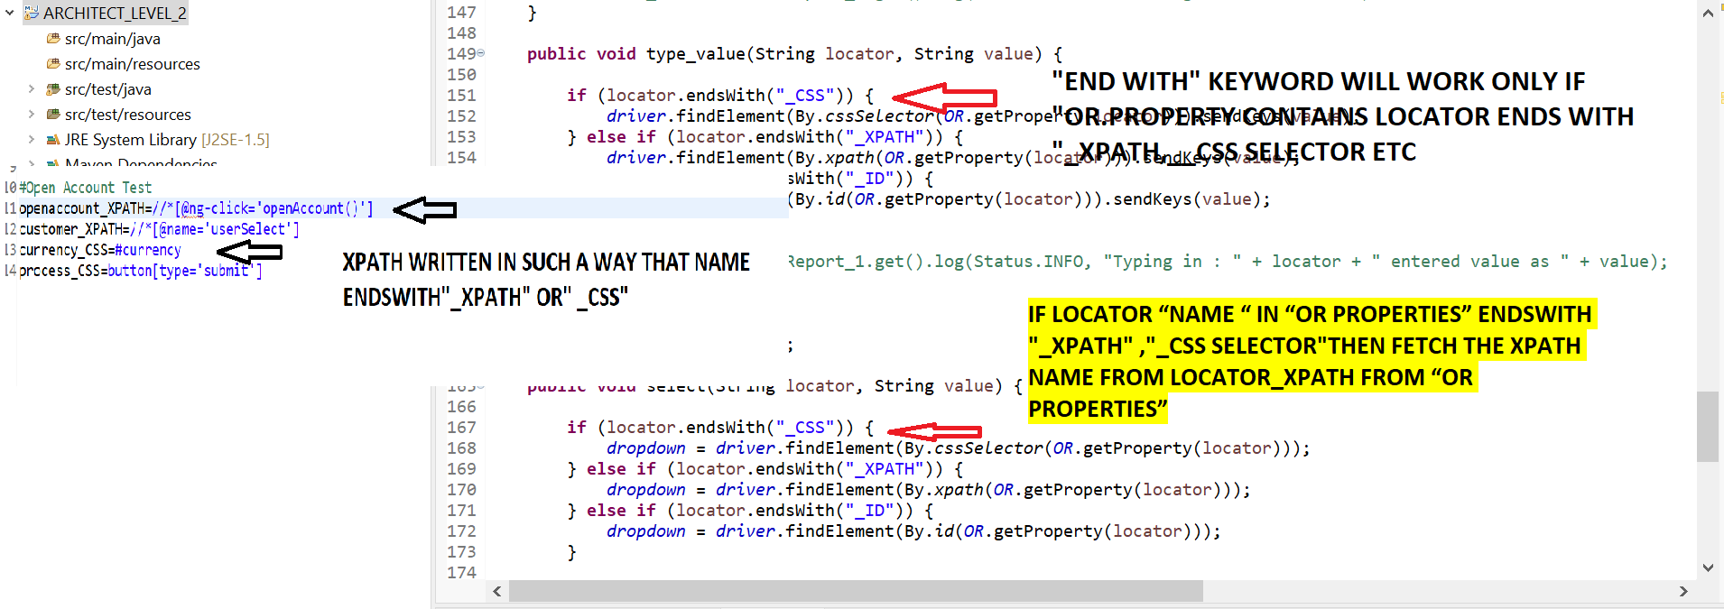

**STEPS 2=>IN “OR.PROPERTIES” ,EDIT EACH XPATH NAME WITH ENDS WITH “_XPATH” FOR XPATH LOCATOR, EDIT EACH CSS NAME WITH ENDS WITH “_CSS” FOR CSS SELECTOR, ETC**

#BankLogins

customer_login_XPATH=(//*[@class='btn btn-primary btn-lg'])[2]

Addcusotmer_XPATH=//*[@ng-class='btnClass1']

firstname_XPATH=//*[@ng-model='fName']

lastname_XPATH=//*[@ng-model='lName']

postalcode_XPATH=//*[@ng-model='postCd']

add_cusomter_button_XPATH=//*[@class='btn btn-default']

#Open Account Test

openaccount_XPATH=//*[@ng-click='openAccount()']

customer_XPATH=//*[@name='userSelect']

currency_CSS=#currency

process_CSS=button[type='submit']

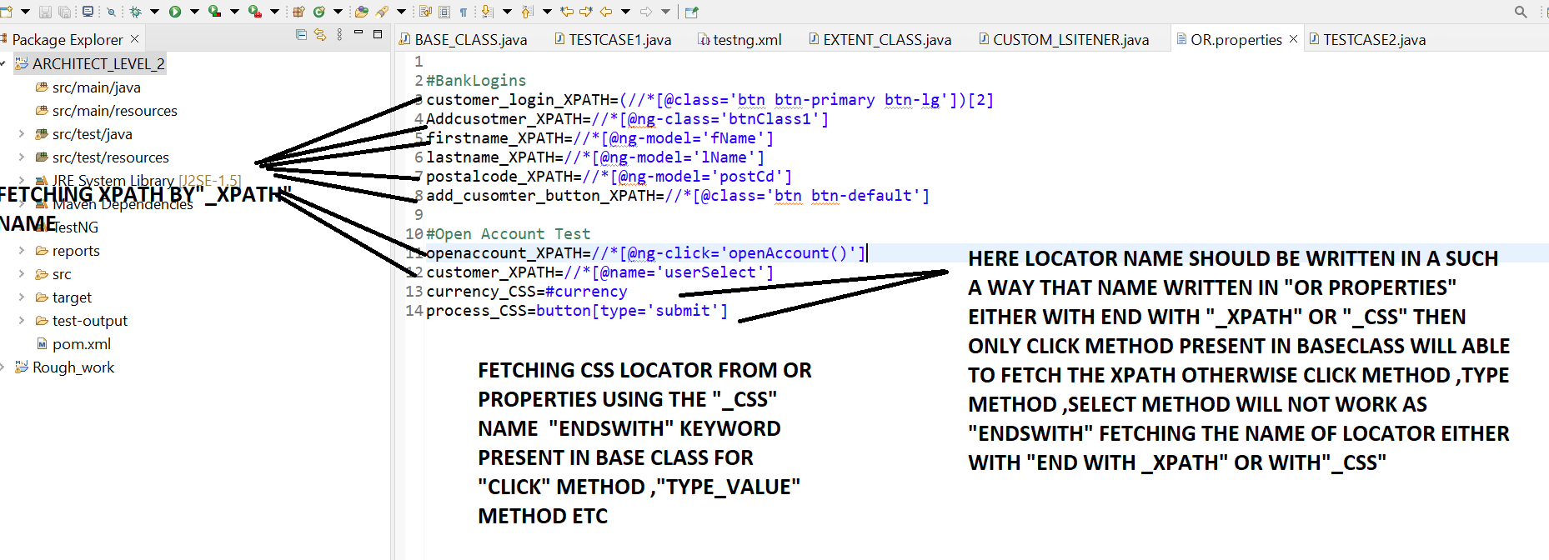

**STEPS 3=>CALL THE METHOD WITH LOCATOR NAME IN RESPECTIVE “TESTCASE”**

**TESTCASE1.JAVA**

**package** TESTCASES;

**import** java.io.IOException;

**import** org.openqa.selenium.Alert;

**import** org.openqa.selenium.By;

**import** org.openqa.selenium.support.ui.ExpectedConditions;

**import** org.testng.Assert;

**import** org.testng.Reporter;

**import** org.testng.annotations.DataProvider;

**import** org.testng.annotations.Test;

**import** BASE_CLASS.BASE_CLASS;

**import** UTILITIES.XLS_READER;

**public** **class** TESTCASE1 **extends** BASE_CLASS

{

@Test

**public** **void** method1() **throws** InterruptedException, IOException

{

*log*.info("Method 1 of Test Case 1 is Excueted");

Thread.*sleep*(3000);

click("customer_login_XPATH");

Thread.*sleep*(2000);

*verifyEquals*(*driver*.getTitle(),"Protractor practice website - Banking Aps");

Thread.*sleep*(2000);

click("Addcusotmer_XPATH");

*log*.info("Method 1 of Test Case 1 is completed");

}

@Test(dataProvider="DataProvide_4")

**public** **void** method2(String firstname,String lastname,String postcode,String alerttext) **throws** Throwable

{

Reporter.*log*("TEST CASE 1 IS STARTED!!!");

*log*.info("Method 2 of Test Case 1 is Excueted");

Thread.*sleep*(3000);

type_value("firstname_XPATH",firstname);

Thread.*sleep*(2000);

type_value("lastname_XPATH",lastname);

Thread.*sleep*(2000);

type_value("postalcode_XPATH",postcode);

Thread.*sleep*(2000);

Assert.*assertTrue*(IsElementPresent

(By.*xpath*(*OR*.getProperty("add_cusomter_button_XPATH"))),"Login not successful");

Thread.*sleep*(2000);

click("add_cusomter_button_XPATH");

//Wait for the alert to be displayed and store it in a variable

Alert alert = *waits*.until(ExpectedConditions.*alertIsPresent*());

Thread.*sleep*(2000);

//Store the alert text in a variable

String text = alert.getText();

System.***out***.println("Text is "+text);

//Press the OK button

Assert.*assertTrue*(alert.getText().contains(alerttext));

//Thread.sleep(2000);

alert.accept();

*log*.info("Method 2 of Test Case 1 is completed");

Reporter.*log*("TEST CASE 1 completed!!!");

}

@DataProvider(name="DataProvide_4")

**public** Object[][] getData() {

**if** (*excel* == **null**) {

*excel* = **new** XLS_READER("C:\\Users\\Gulnar\\Desktop\\Automation Notes\\Framework_ARCHITECT_LEVEL\\DATA_DRIVEN_FRAMEWORK\\ARCHITECT_LEVEL_2\\src\\test\\resources\\EXCEL_SHEET\\testdata.xlsx");

}

String sheetName = "SHEET1";

**int** rows = *excel*.getRowCount(sheetName);

**int** cols = *excel*.getColumnCount(sheetName);

Object[][] data = **new** Object[rows-1][cols];

**for** (**int** rowNum = 2; rowNum <= rows; rowNum++) {

**for** (**int** colNum = 0; colNum < cols; colNum++) {

data[rowNum - 2][colNum] = *excel*.getCellData(sheetName, colNum, rowNum);

}

}

**return** data;

}

}

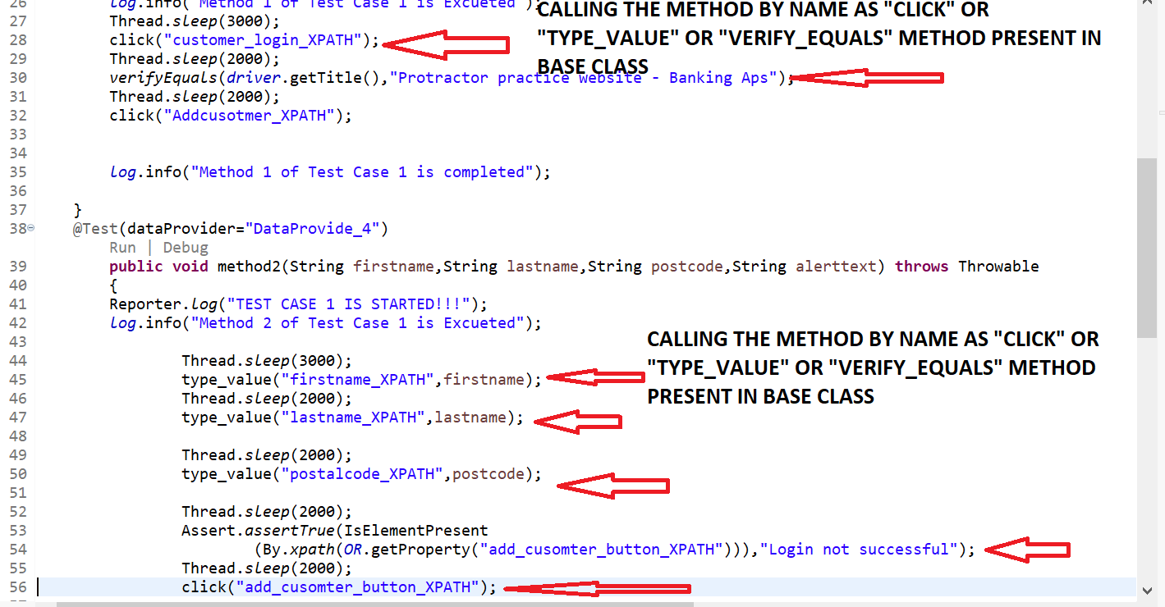

**TESTCASE2.JAVA**

**package** TESTCASES;

**import** org.openqa.selenium.Alert;

**import** org.openqa.selenium.support.ui.ExpectedConditions;

**import** org.testng.annotations.Test;

**import** BASE_CLASS.BASE_CLASS;

**public** **class** TESTCASE2 **extends** BASE_CLASS

{

@Test

**public** **void** openAccountTest() **throws** InterruptedException {

*log*.info(" Test Case 2 is STARTED");

Thread.*sleep*(3000);

click("openaccount_XPATH");

Thread.*sleep*(2000);

select("customer_XPATH", "Hermoine Granger");

Thread.*sleep*(2000);

select("currency_CSS", "Rupee");

Thread.*sleep*(2000);

click("process_CSS");

Thread.*sleep*(2000);

Alert alert = *waits*.until(ExpectedConditions.*alertIsPresent*());

Thread.*sleep*(2000);

alert.accept();

*log*.info(" Test Case 2 is Excueted");

}

}

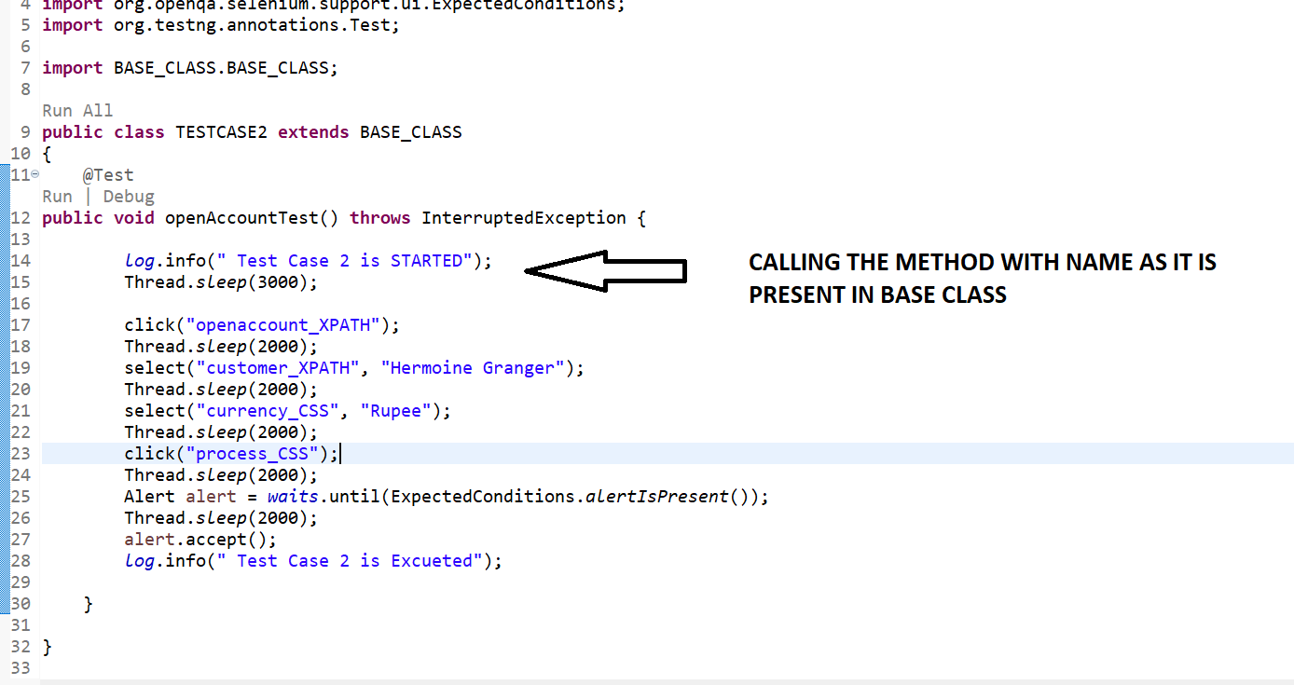

**STEPS 4=>CALL THE TESTCASE 2 IN “TESTNG.XML “ AND RIGHT CLICK AND RIGHT CLICK RUN AS “MAVEN TEST”.REPORT WILL ONLY BE GENERATED IF WE RIGHT CLICK AND PROJECT AND RUN AS “MAVEN TEST” OTHERWISE REPORT WILL NOT GENERATE**

<?xml version="1.0" encoding="UTF-8"?>

<!DOCTYPE suite SYSTEM "http://testng.org/testng-1.0.dtd" >

<suite name="Suite">

<listeners>

<listener class-name="org.uncommons.reportng.HTMLReporter"/>

<listener class-name="org.uncommons.reportng.JUnitXMLReporter"/>

<listener class-name="LISTENERS.CUSTOM_LSITENER"/>

</listeners>

<test name="TESTCASE1">

<classes>

<class name="TESTCASES.TESTCASE1"/>

</classes>

</test> <!-- Test -->

<test name="TESTCASE2">

<classes>

<class name="TESTCASES.TESTCASE2"/>

</classes>

</test> <!-- Test -->

</suite> <!-- Suite -->

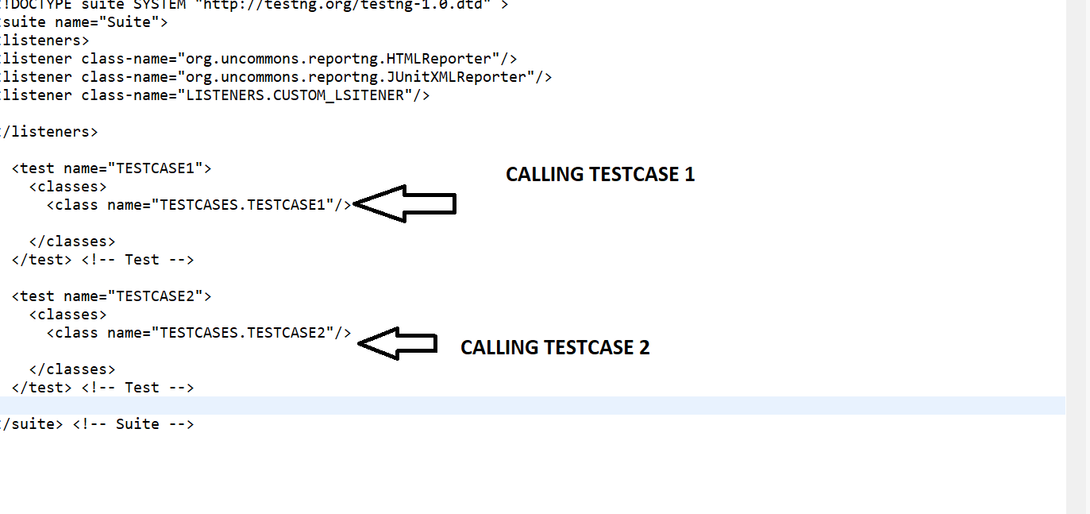

**Output=>**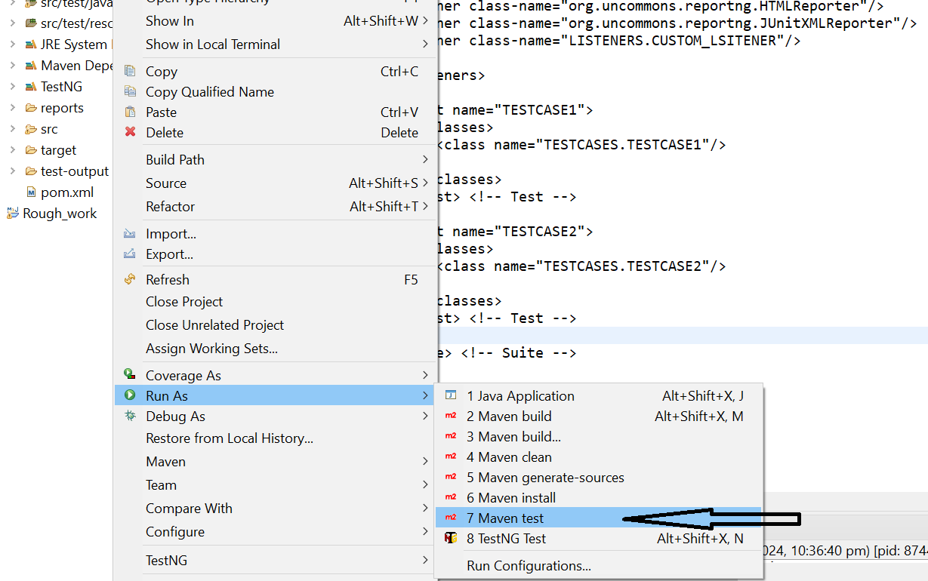

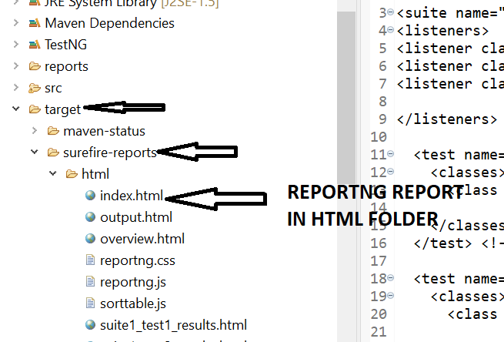

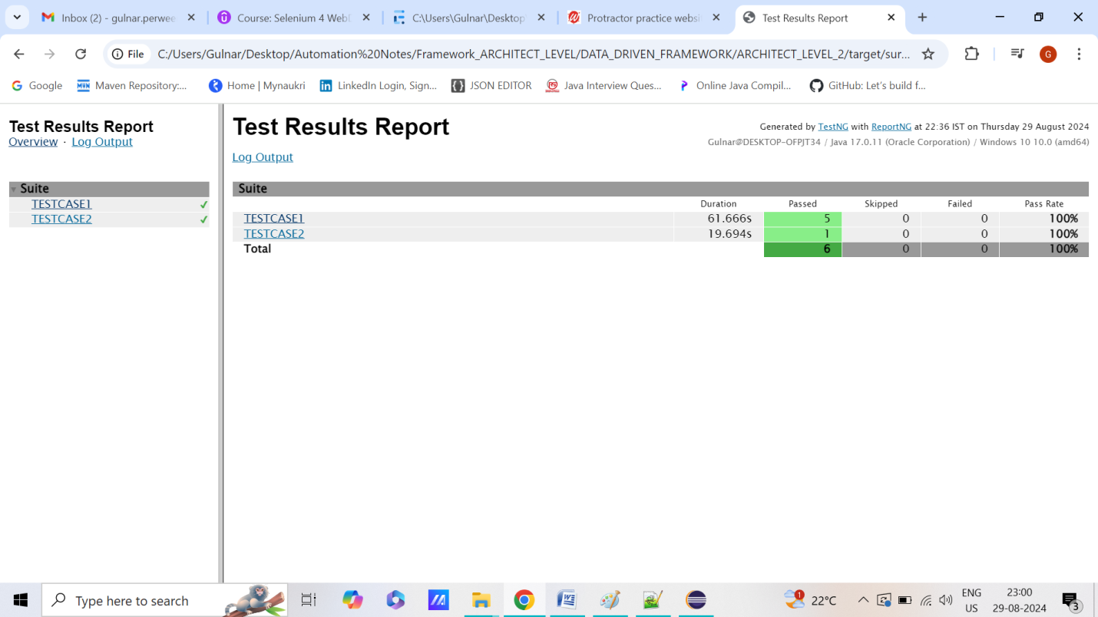

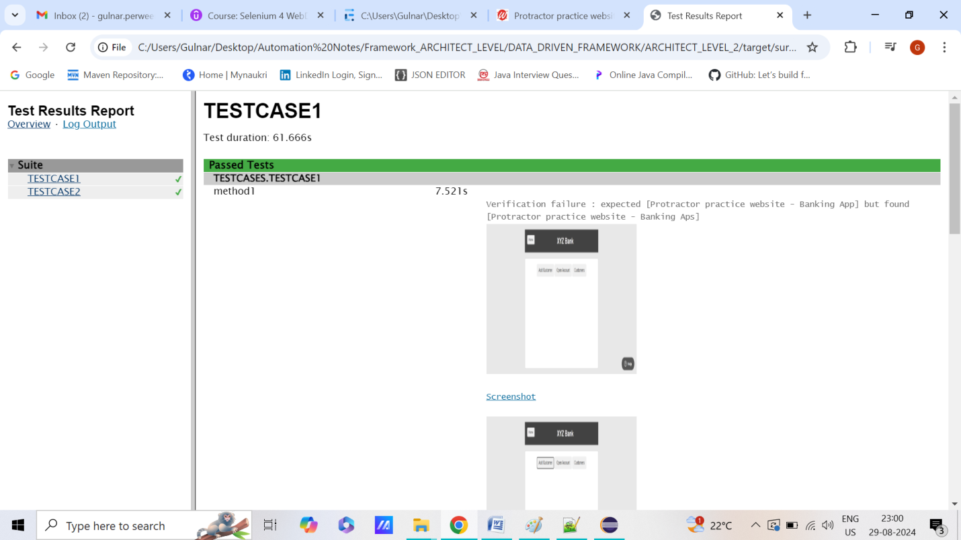

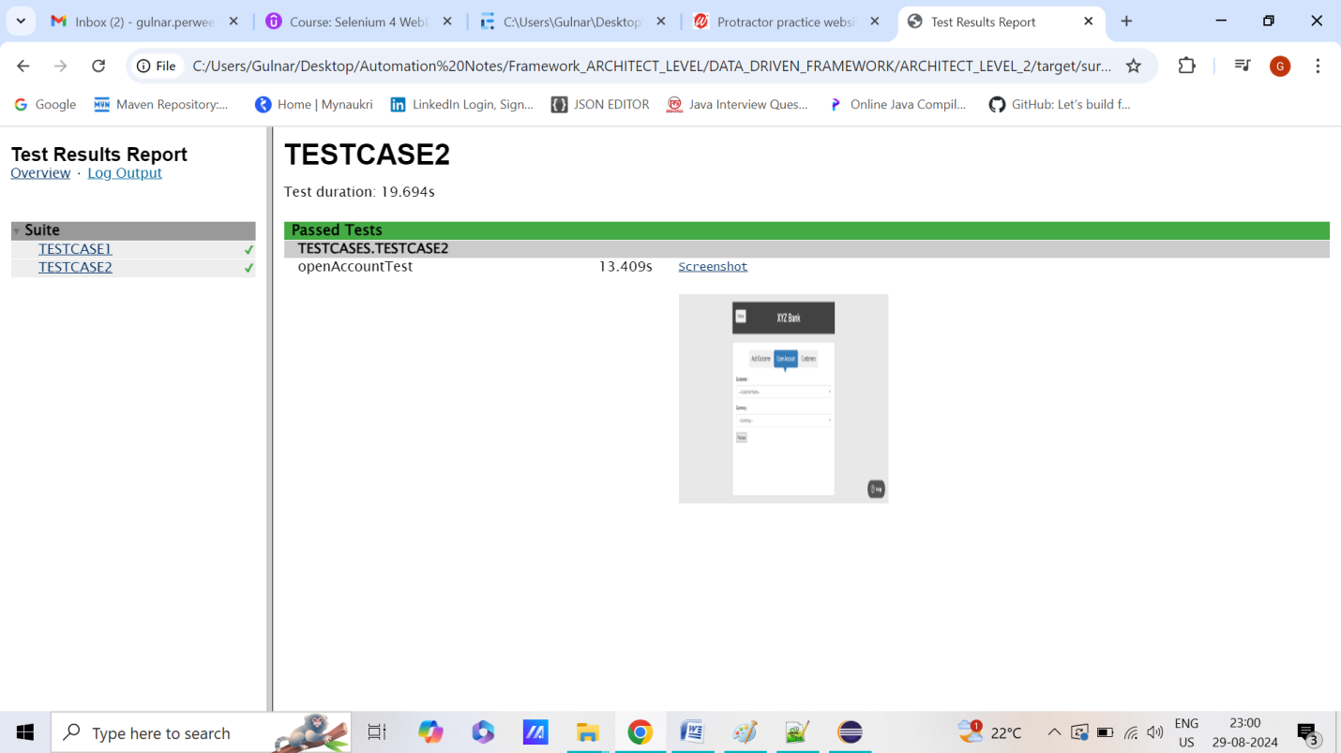

**STEP 23=> WHAT ARE EXTENT REPORTS?HOW TO USE THEM IN APPLICATION?**

**STEPS 1=> ADD ONE DEPENDENCIES IN POM.XML SUCHAS “EXTENT REPORT”**

**STEPS 2=>CREATE “EXTENT” FOLDER IN “SRC/TEST/RESOURCE” AND ADD “REPORT.HTML” TO SET BACKGROUND,TITLE COLOR ETC USING THE REPORT.HTML FILE.THE BELOW CODE FOR “REPORT.HTML” IS WRITTEN**

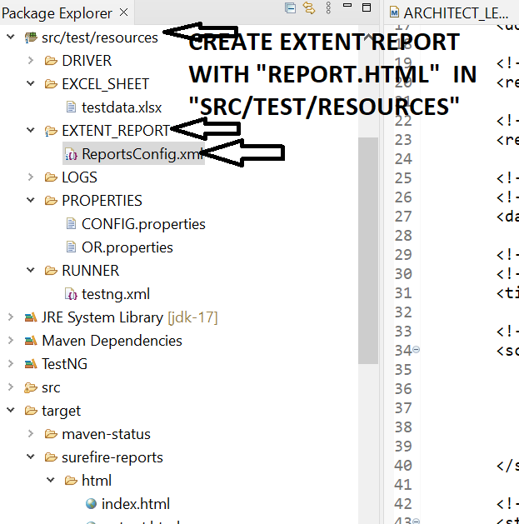

**<?xml version="1.0" encoding="UTF-8"?>**

**<extentreports>**

**<configuration>**

**<!-- report theme -->**

**<!-- standard, dark -->**

**<theme>standard</theme>**

**<!-- document encoding -->**

**<!-- defaults to UTF-8 -->**

**<encoding>UTF-8</encoding>**

**<!-- protocol for script and stylesheets -->**

**<!-- defaults to https -->**

**<protocol>https</protocol>**

**<!-- title of the document -->**

**<documentTitle>W2A Automation Reports</documentTitle>**

**<!-- report name - displayed at top-nav -->**

**<reportName>Automation Report for</reportName>**

**<!-- report headline - displayed at top-nav, after reportHeadline -->**

**<reportHeadline>Data Driven Framework</reportHeadline>**

**<!-- global date format override -->**

**<!-- defaults to yyyy-MM-dd -->**

**<dateFormat>yyyy-MM-dd</dateFormat>**

**<!-- global time format override -->**

**<!-- defaults to HH:mm:ss -->**

**<timeFormat>HH:mm:ss</timeFormat>**

**<!-- custom javascript -->**

**<scripts>**

**<![CDATA[**

**$(document).ready(function() {**

**});**

**]]>**

**</scripts>**

**<!-- custom styles -->**

**<styles>**

**<![CDATA[**

**]]>**

**</styles>**

**</configuration>**

**</extentreports>**

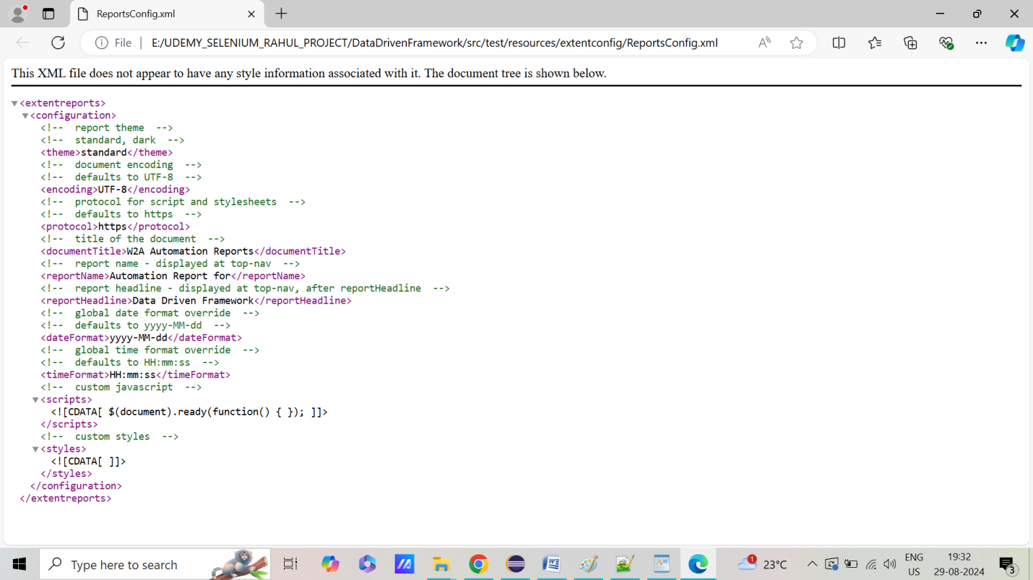

**STEPS 3=> CREATE NEW CLASS “EXTENT_MANAGER” .JAVA INSIDE “UTLIS PACKAGE” IN “SRC/TEST/JAVA”AND WRITE BELOW CODE NEED TO WRITE “EXTENT.START” TO START THE EXTENT REPORT AND “EXTENT.FLUSH” TO CLOSE THE EXTENT REPORTS**

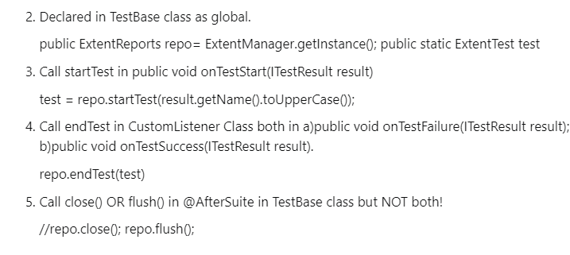

**import** java.io.File;

**import** com.aventstack.extentreports.ExtentReports;

**import** com.aventstack.extentreports.reporter.ExtentSparkReporter;

**import** com.aventstack.extentreports.reporter.configuration.Theme;

**public** **class** EXTENT_CLASS {

**private** **static** ExtentReports *extent*;

**public** **static** ExtentReports createInstance(String fileName)

{

ExtentSparkReporter htmlReporter = **new** ExtentSparkReporter(fileName);

htmlReporter.config().setTheme(Theme.***DARK***);

htmlReporter.config().setDocumentTitle(fileName);

htmlReporter.config().setEncoding("utf-8");

htmlReporter.config().setReportName(fileName);

*extent* = **new** ExtentReports();

*extent*.attachReporter(htmlReporter);

*extent*.setSystemInfo("Automation Tester", "G Perween");

*extent*.setSystemInfo("Organization", "Way2Automation");

*extent*.setSystemInfo("Build no", "W2A-1234");

**return** *extent*;

}

}

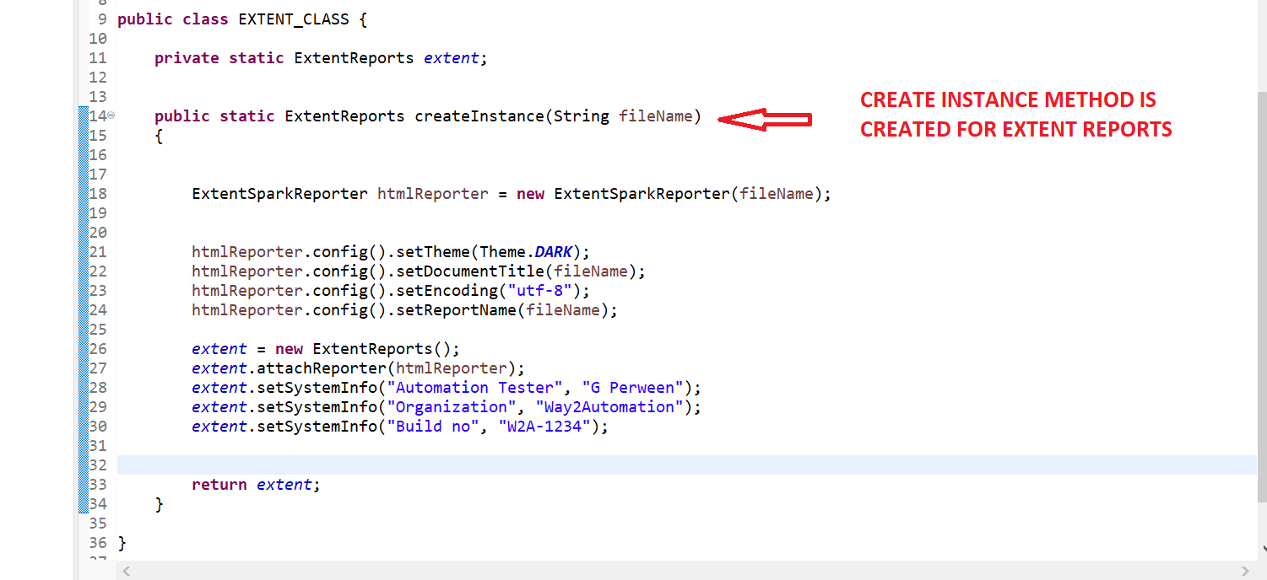

**STEPS 4=> UPDATE BASE CLASS WITH BELOW CODE MEANS IN “EVERY METHOD PRESENT IN BASE CLASS**

**BASECLASS.JAVA**

**package** BASE_CLASS;

**import** java.io.FileInputStream;

**import** java.io.IOException;

**import** java.time.Duration;

**import** java.util.Date;

**import** java.util.NoSuchElementException;

**import** java.util.Properties;

**import** org.apache.log4j.Logger;

**import** org.apache.log4j.PropertyConfigurator;

**import** org.openqa.selenium.By;

**import** org.openqa.selenium.WebDriver;

**import** org.openqa.selenium.WebElement;

**import** org.openqa.selenium.chrome.ChromeDriver;

**import** org.openqa.selenium.chrome.ChromeOptions;

**import** org.openqa.selenium.edge.EdgeDriver;

**import** org.openqa.selenium.edge.EdgeOptions;

**import** org.openqa.selenium.firefox.FirefoxDriver;

**import** org.openqa.selenium.firefox.FirefoxOptions;

**import** org.openqa.selenium.support.ui.Select;

**import** org.openqa.selenium.support.ui.WebDriverWait;

**import** org.testng.Assert;

**import** org.testng.Reporter;

**import** org.testng.annotations.AfterSuite;

**import** org.testng.annotations.BeforeSuite;

**import** com.aventstack.extentreports.MediaEntityBuilder;

**import** com.aventstack.extentreports.Status;

**import** LISTENERS.CUSTOM_LSITENER;

**import** UTILITIES.TEST_UTLIS;

**import** UTILITIES.XLS_READER;

**import** io.github.bonigarcia.wdm.WebDriverManager;

**public** **class** BASE_CLASS {

**public** **static** WebDriver *driver*;

**public** **static** Properties *config* = **new** Properties();

**public** **static** Properties *OR* = **new** Properties();

**public** **static** WebDriverWait *waits* ;

**public** **static** Logger *log* = Logger.*getLogger*(BASE_CLASS.**class**.getName());

**public** **static** XLS_READER *excel* = **new** XLS_READER(

System.*getProperty*("user.dir") + "\\src\\test\\resources\\EXCEL_SHEET\\testdata.xlsx");

@BeforeSuite

**public** **void** setup() **throws** IOException, InterruptedException

{

Date d = **new** Date();

System.*setProperty*("current.date", d.toString().replace(":", "_").replace(" ", "_"));

PropertyConfigurator.*configure*("C:\\Users\\Gulnar\\Desktop\\Automation Notes\\Framework_ARCHITECT_LEVEL\\DATA_DRIVEN_FRAMEWORK\\ARCHITECT_LEVEL_2\\src\\test\\resources\\LOGS\\log4j.properties");

**if** (*driver* == **null**)

{

FileInputStream fis = **new** FileInputStream(

System.*getProperty*("user.dir") + "\\src\\test\\resources\\PROPERTIES\\CONFIG.properties");

*config*.load(fis);

fis = **new** FileInputStream(

System.*getProperty*("user.dir") + "\\src\\test\\resources\\PROPERTIES\\OR.properties");

*OR*.load(fis);

**if**(*config*.getProperty("BROWSER").equals("CHROME"))

{

System.*setProperty*("Webdriver.chrome.driver",*config*.getProperty("chromepath"));

ChromeOptions option = **new** ChromeOptions();

option.addArguments("--remote-allow-origins=*");

WebDriverManager.*chromedriver*().setup();

*driver* = **new** ChromeDriver(option);

*log*.info("chrome driver is Excueted");

}

**else** **if**(*config*.getProperty("BROWSER").equals("firefox"))

{

System.*setProperty*("Webdriver.gecko.driver",*config*.getProperty("geckodriverpath"));

FirefoxOptions option = **new** FirefoxOptions();

//option.addArguments("--remote-allow-origins=*");

WebDriverManager.*firefoxdriver*().setup();

*driver* = **new** FirefoxDriver(option);

*log*.info("firefox driver is Excueted");

}

**else** **if**(*config*.getProperty("BROWSER").equals("ie"))

{

System.*setProperty*("Webdriver.edge.driver",*config*.getProperty("ie_driverpath"));

EdgeOptions option = **new** EdgeOptions ();

option.addArguments("--remote-allow-origins=*");

WebDriverManager.*edgedriver*().setup();

*driver* =**new** EdgeDriver(option);

*log*.info("edge driver is Excueted");

}

*driver*.get(*config*.getProperty("TESTSITEURL"));

Thread.*sleep*(3000);

*driver*.manage().window().maximize();

*driver*.manage().deleteAllCookies();

*driver*.manage().timeouts().implicitlyWait(Duration.*ofHours*(2));

*waits* = **new** WebDriverWait(*driver*, Duration.*ofHours*(2));

*log*.info("TESTSITEURL is Excueted");

}

}

**public** **boolean** IsElementPresent(By by)

{

**try**

{

*driver*.findElement(by);

**return** **true**;

}

**catch**(NoSuchElementException e)

{

**return** **false**;

}

}

@AfterSuite

**public** **void** Tearup() {

**if**(*driver*!=**null**)

{

*driver*.quit();

}

*log*.info("close Browser is Excueted");

}

**public** **void** click(String locator) {

**if** (locator.endsWith("_CSS")) {

*driver*.findElement(By.*cssSelector*(*OR*.getProperty(locator))).click();

} **else** **if** (locator.endsWith("_XPATH")) {

*driver*.findElement(By.*xpath*(*OR*.getProperty(locator))).click();

} **else** **if** (locator.endsWith("_className")) {

*driver*.findElement(By.*className*(*OR*.getProperty(locator))).click();

}

CUSTOM_LSITENER.*testReport_1*.get().log(Status.***INFO***, "Clicking on : " + locator);

}

**public** **void** type_value(String locator, String value) {

**if** (locator.endsWith("_CSS")) {

*driver*.findElement(By.*cssSelector*(*OR*.getProperty(locator))).sendKeys(value);

} **else** **if** (locator.endsWith("_XPATH")) {

*driver*.findElement(By.*xpath*(*OR*.getProperty(locator))).sendKeys(value);

} **else** **if** (locator.endsWith("_ID")) {

*driver*.findElement(By.*id*(*OR*.getProperty(locator))).sendKeys(value);

}

CUSTOM_LSITENER.*testReport_1*.get().log(Status.***INFO***, "Typing in : " + locator + " entered value as " + value);

}

**static** WebElement *dropdown*;

**public** **void** select(String locator, String value) {

**if** (locator.endsWith("_CSS")) {

*dropdown* = *driver*.findElement(By.*cssSelector*(*OR*.getProperty(locator)));

} **else** **if** (locator.endsWith("_XPATH")) {

*dropdown* = *driver*.findElement(By.*xpath*(*OR*.getProperty(locator)));

} **else** **if** (locator.endsWith("_ID")) {

*dropdown* = *driver*.findElement(By.*id*(*OR*.getProperty(locator)));

}

Select select = **new** Select(*dropdown*);

select.selectByVisibleText(value);

CUSTOM_LSITENER.*testReport_1*.get().log(Status.***INFO***, "Selecting from dropdown : " + locator + " value as " + value);

}

**public** **static** **void** verifyEquals(String expected, String actual) **throws** IOException {

**try** {

Assert.*assertEquals*(actual, expected);

} **catch** (Throwable t) {

TEST_UTLIS.*captureScreenshot_Failed_screesnhot*();

// ReportNG

Reporter.*log*("<br>" + "Verification failure : " + t.getMessage() + "<br>");

Reporter.*log*("<a target=\"_blank\" href=" + TEST_UTLIS.*screenshotName* + "><img src=" + TEST_UTLIS.*screenshotName*

+ " height=200 width=200></img></a>");

Reporter.*log*("<br>");

Reporter.*log*("<br>");

// Extent Reports for generating Reports

CUSTOM_LSITENER.*testReport_1*.get().log(Status.***FAIL***, " Verification failed with exception : " + t.getMessage());

CUSTOM_LSITENER.*testReport_1*.get().fail("<b>" + "<font color=" + "red>" + "Screenshot of failure" + "</font>" + "</b>",

MediaEntityBuilder.*createScreenCaptureFromPath*(TEST_UTLIS.*screenshotName*)

.build());

}

}

}

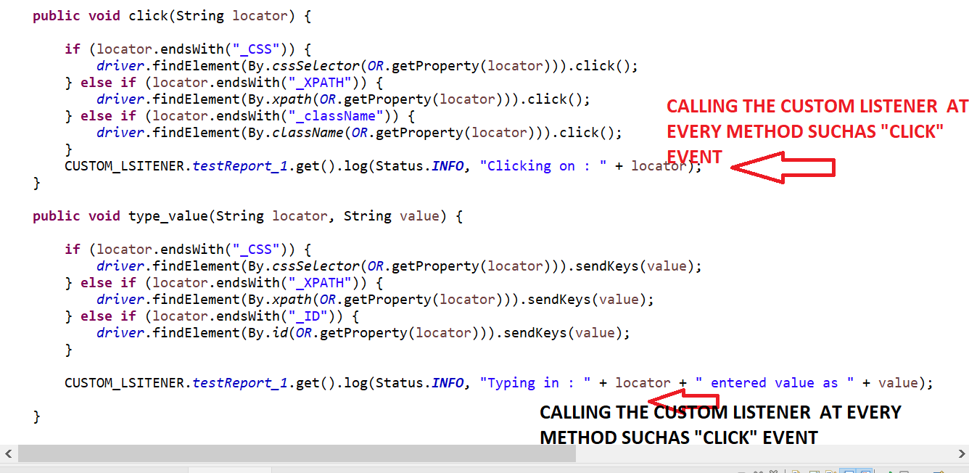

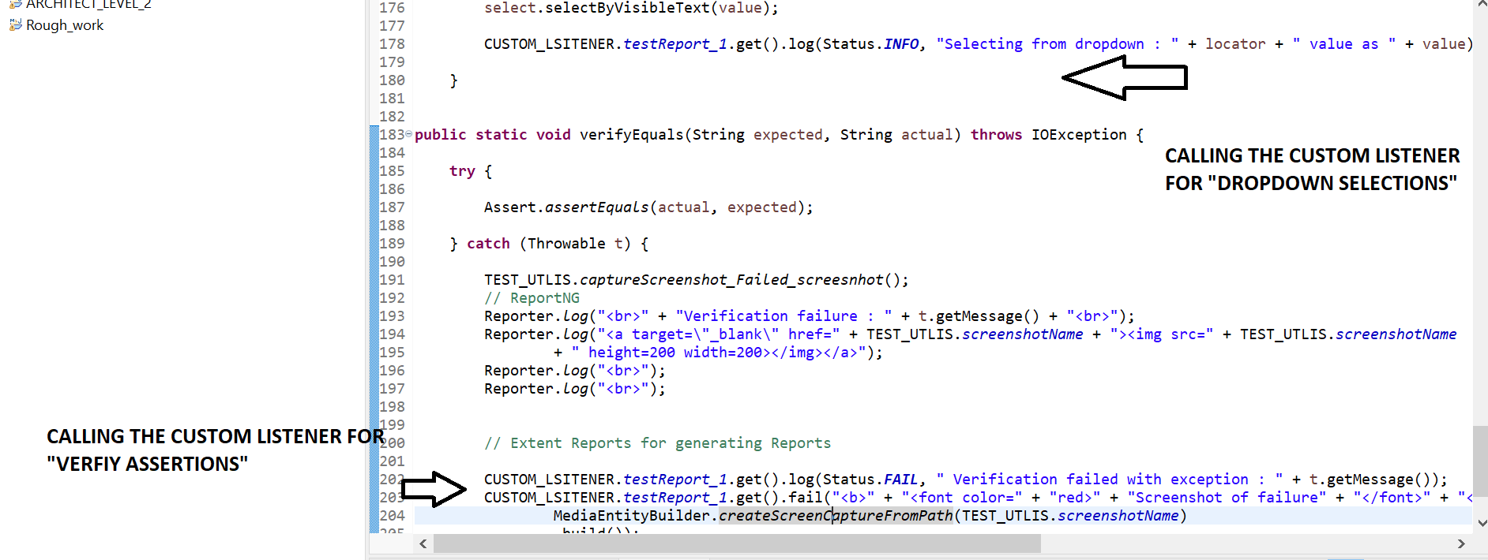

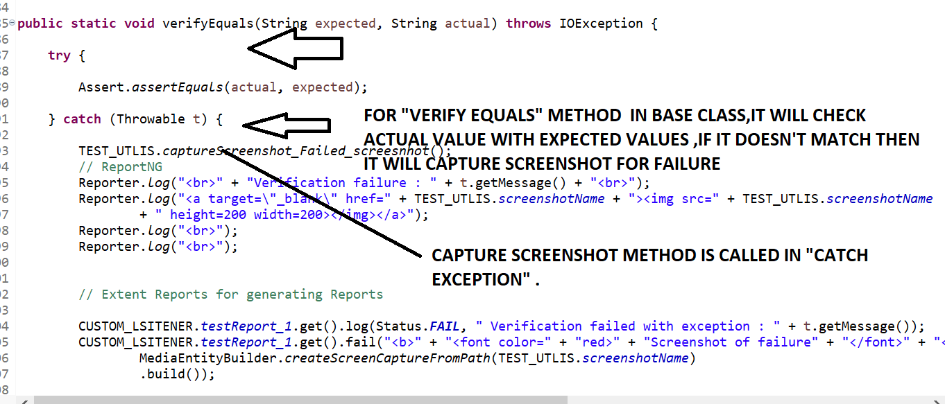

**STEPS 5=>WRITE BELOW CODE FOR GENERATING REPORT IN “LISTENER CLASS” FOR GENERATING REPORTS “ON METHOD SUCCESS “AND “ON METHOD FAILURES” AND “ON METHOD SKIPS” AND “ON METHOD START” ,”ON METHOD FINISH”.The black Text method is more important as extent report will work becoz of that method only=> HERE IN CUSTOM LISTENER ,NEED TO PROVIDE THE PATH WHERE SCREENSHOT IS CAPTURED THAT IS INSIDE TARGET FOLDER,INSISE SUREFIRE THEN INSIDE HTML FOLDER ONLY AS “SCREENSHOT PATH” OTHERWISE REPORT WILL NOT GENERATE THE SCREENSHOT FOR FAILED TESTCASES**

**CUSTOMS LISTENER .JAVA**

**package** LISTENERS;

**import** java.io.IOException;

**import** java.util.Arrays;

**import** java.util.Date;

**import** org.testng.ISuite;

**import** org.testng.ISuiteListener;

**import** org.testng.ITestContext;

**import** org.testng.ITestListener;

**import** org.testng.ITestResult;

**import** org.testng.Reporter;

**import** com.aventstack.extentreports.ExtentReports;

**import** com.aventstack.extentreports.ExtentTest;

**import** com.aventstack.extentreports.MediaEntityBuilder;

**import** com.aventstack.extentreports.Status;

**import** com.aventstack.extentreports.markuputils.ExtentColor;

**import** com.aventstack.extentreports.markuputils.Markup;

**import** com.aventstack.extentreports.markuputils.MarkupHelper;

**import** BASE_CLASS.BASE_CLASS;

**import** UTILITIES.EXTENT_CLASS;

**import** UTILITIES.TEST_UTLIS;

**public** **class** CUSTOM_LSITENER **extends** BASE_CLASS **implements** ITestListener,ISuiteListener

{

**static** Date *d* = **new** Date();

**static** String *fileName1* = "Extent_" + *d*.toString().replace(":", "_").replace(" ", "_") + ".html";

**private** **static** ExtentReports *extent* =

EXTENT_CLASS.*createInstance*(System.*getProperty*("user.dir")+"\\target\\surefire-reports\\html\\"+*fileName1*);

**public** **static** ThreadLocal<ExtentTest> *testReport_1* = **new** ThreadLocal<ExtentTest>();

**public** **void** onStart(ISuite suite) {

// **TODO** Auto-generated method stub

}

**public** **void** onFinish(ISuite suite) {

// **TODO** Auto-generated method stub

}

**public** **void** onTestStart(ITestResult result)

{

//Inorder to start Extent Report to work ,below code is given for extent reports

ExtentTest test = *extent*.createTest(result.getTestClass()

.getName()+" @TestCase : "+result.getMethod().getMethodName());

*testReport_1*.set(test);

}

**public** **void** onTestSuccess(ITestResult result) {

System.*setProperty*("org.uncommons.reportng.escape-output", "false");

**try** {

TEST_UTLIS.*captureScreenshot_Failed_screesnhot*();

} **catch** (IOException e) {

e.printStackTrace();

}

Reporter.*log*("<a target=\"_blank\" href="+ TEST_UTLIS.*screenshotName* +">Screenshot</a>");

Reporter.*log*("<br>");

Reporter.*log*("<br>");

Reporter.*log*("<a target=\"_blank\" href="+ TEST_UTLIS.*screenshotName* +"><img src="+ TEST_UTLIS.*screenshotName* +" height=200 width=200></img></a>" );

//below Exend Report for Success

String methodName=result.getMethod().getMethodName();

String logText="<b>"+"TEST CASE:- "+ methodName.toUpperCase()+ " PASSED"+"</b>";

Markup m=MarkupHelper.*createLabel*(logText, ExtentColor.***GREEN***);

*testReport_1*.get().pass(m);

// EXTEND REPORT FOR CAPTURING THE SCREENSHOT FOR PASSED TESTCASES

}

**public** **void** onTestFailure(ITestResult result) {

// Setting up screenshot set up.

System.*setProperty*("org.uncommons.reportng.escape-output", "false");

**try** {

TEST_UTLIS.*captureScreenshot_Failed_screesnhot*();

} **catch** (IOException e) {

e.printStackTrace();

}

Reporter.*log*("<a target=\"_blank\" href="+ TEST_UTLIS.*screenshotName* +">Screenshot</a>");

Reporter.*log*("<br>");

Reporter.*log*("<br>");

Reporter.*log*("<a target=\"_blank\" href="+ TEST_UTLIS.*screenshotName* +"><img src="+ TEST_UTLIS.*screenshotName* +" height=200 width=200></img></a>" );

// Below is code for Extend Reports

String excepionMessage=Arrays.*toString*(result.getThrowable().getStackTrace());

*testReport_1*.get().fail("<details>" + "<summary>" + "<b>" + "<font color=" + "red>" + "Exception Occured:Click to see"

+ "</font>" + "</b >" + "</summary>" +excepionMessage.replaceAll(",", "<br>")+"</details>"+" \n");

**try** {

TEST_UTLIS.*captureScreenshot_Failed_screesnhot*();

*testReport_1*.get().fail("<b>" + "<font color=" + "red>" + "Screenshot of failure" + "</font>" + "</b>",

MediaEntityBuilder.*createScreenCaptureFromPath*(TEST_UTLIS.*screenshotName*)

.build());

} **catch** (IOException e) {

}

String failureLogg="TEST CASE FAILED";

Markup m = MarkupHelper.*createLabel*(failureLogg, ExtentColor.***RED***);

*testReport_1*.get().log(Status.***FAIL***, m);

}

**public** **void** onTestSkipped(ITestResult result) {

// **TODO** Auto-generated method stub

//Extent Report code are as below

String methodName=result.getMethod().getMethodName();

String logText="<b>"+"Test Case:- "+ methodName+ " Skipped"+"</b>";

Markup m=MarkupHelper.*createLabel*(logText, ExtentColor.***YELLOW***);

*testReport_1*.get().skip(m);

}

**public** **void** onTestFailedButWithinSuccessPercentage(ITestResult result) {

// **TODO** Auto-generated method stub

}

**public** **void** onStart(ITestContext context) {

// **TODO** Auto-generated method stub

}

**public** **void** onFinish(ITestContext context) {

// **TODO** Auto-generated method stub

//Need to flush the extend reports

**if** (*extent* != **null**) {

*extent*.flush();

}

}

}

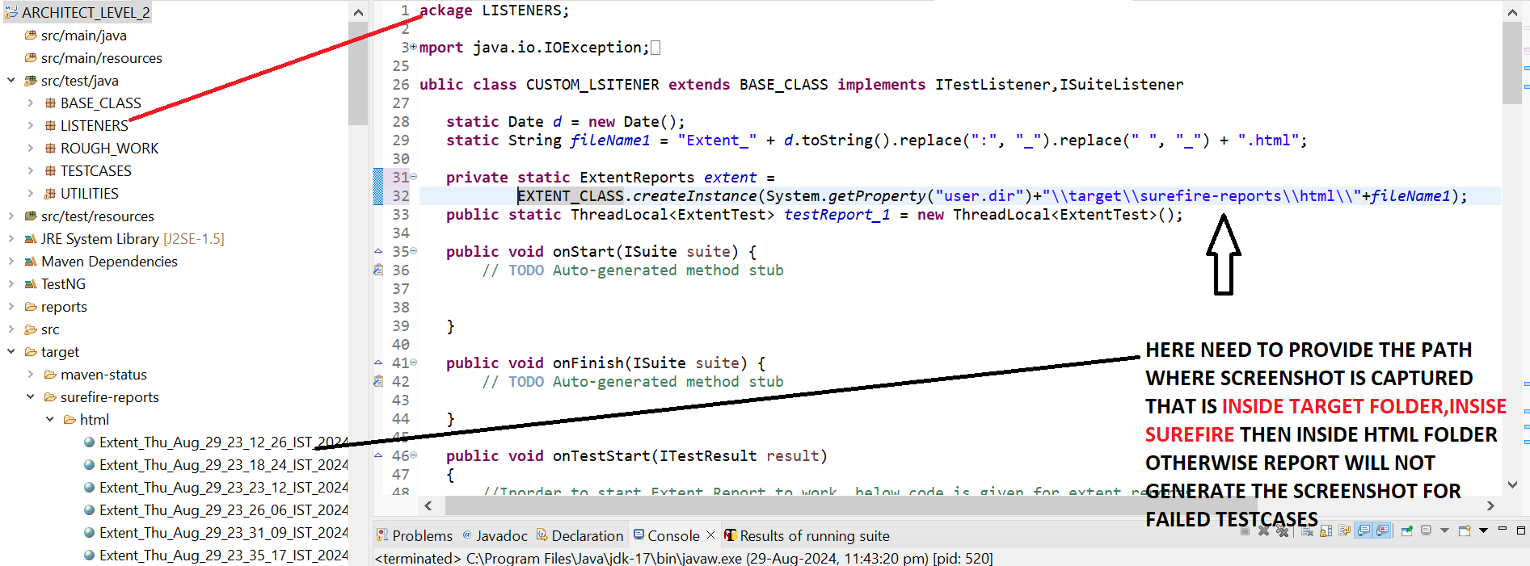

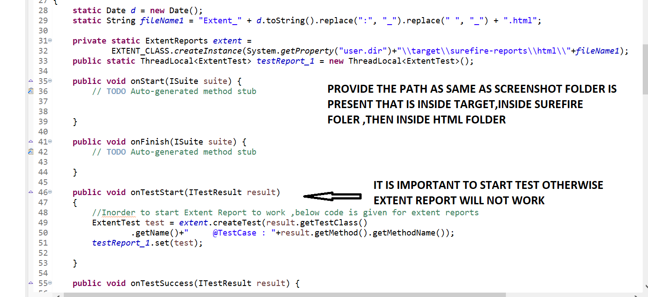

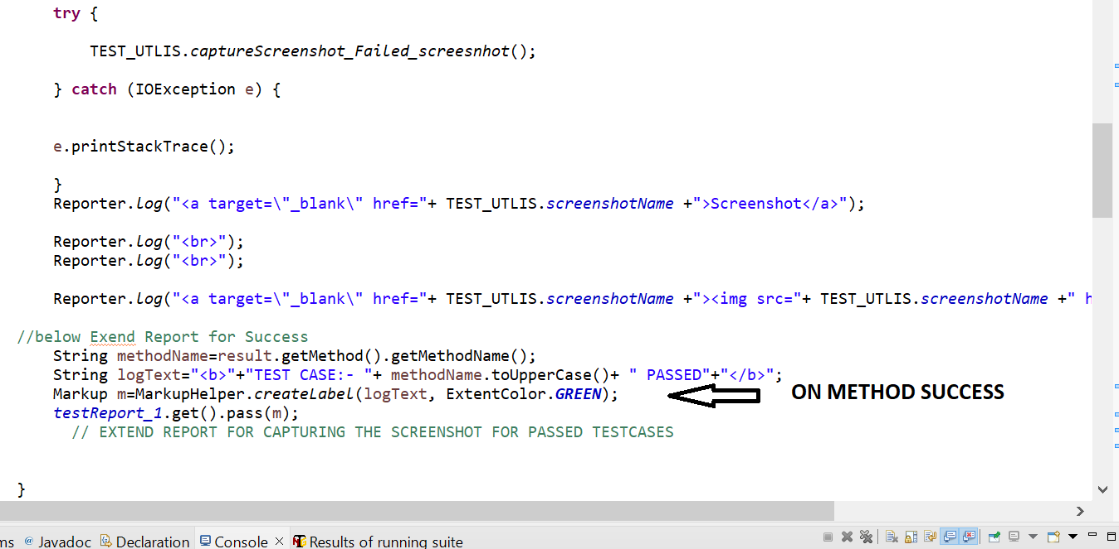

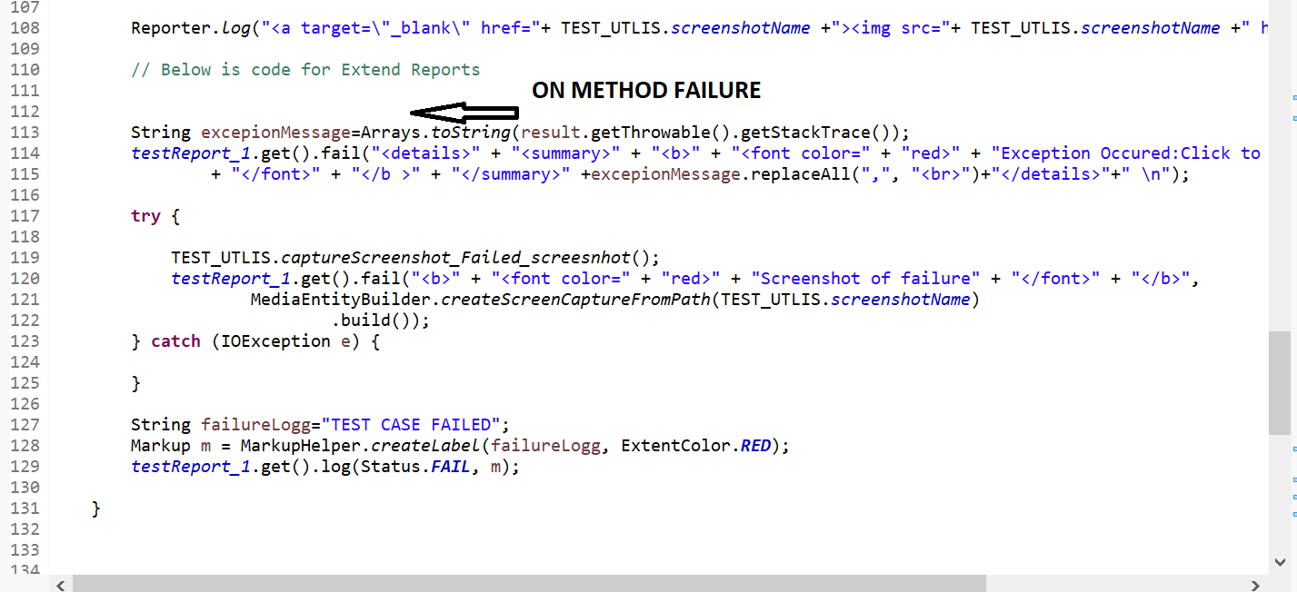

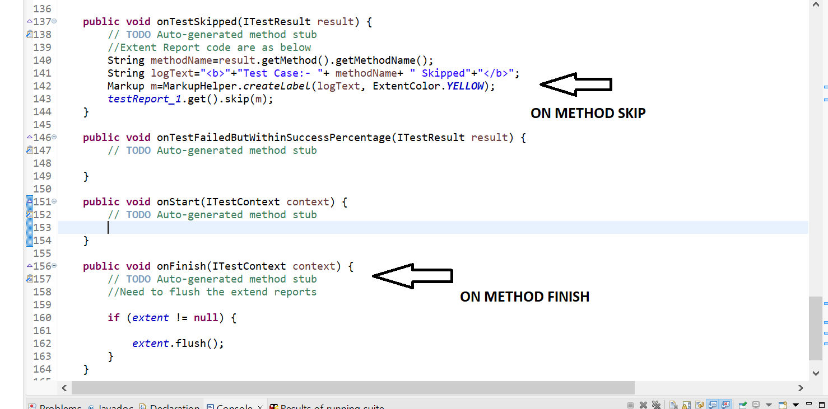

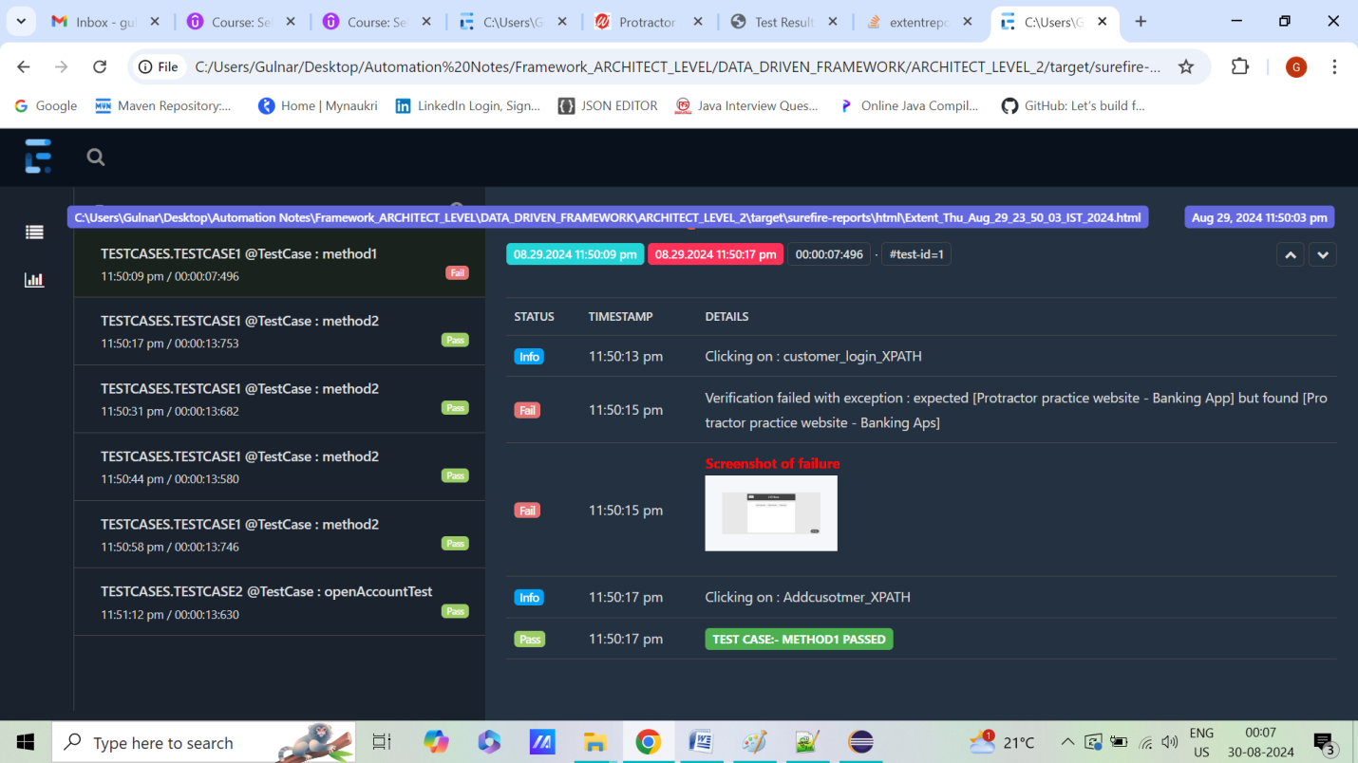

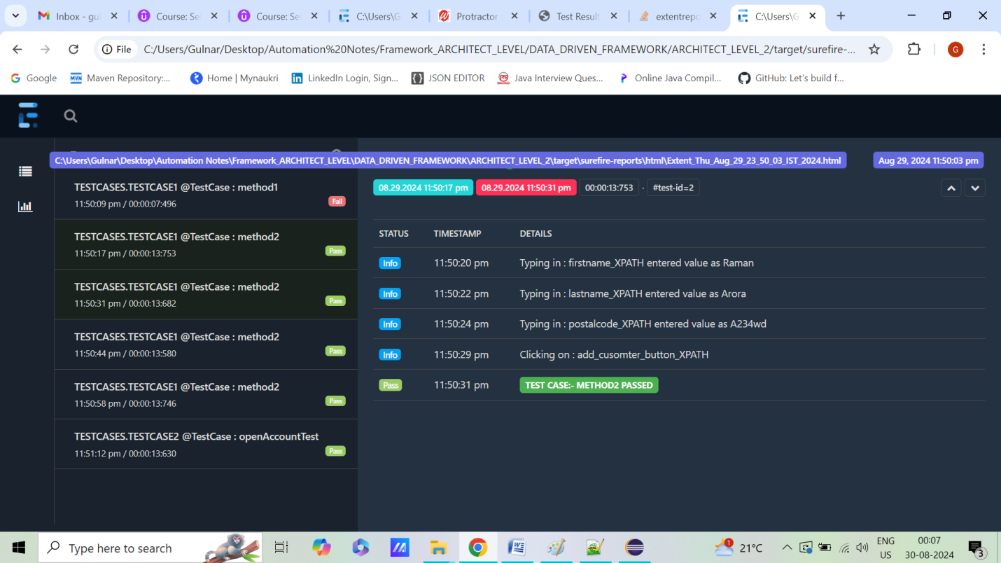

**STEPS 6=> ALWAYS RIGHT CLICK ON PROJECT AND RUN AS “MAVEN TEST”**

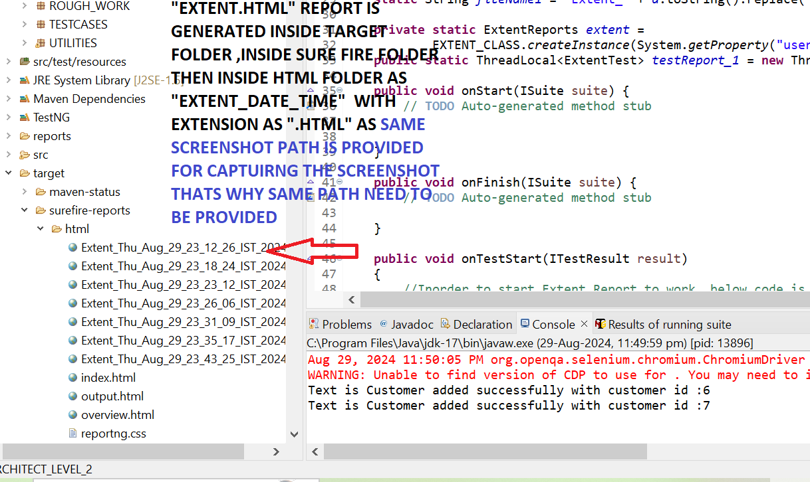

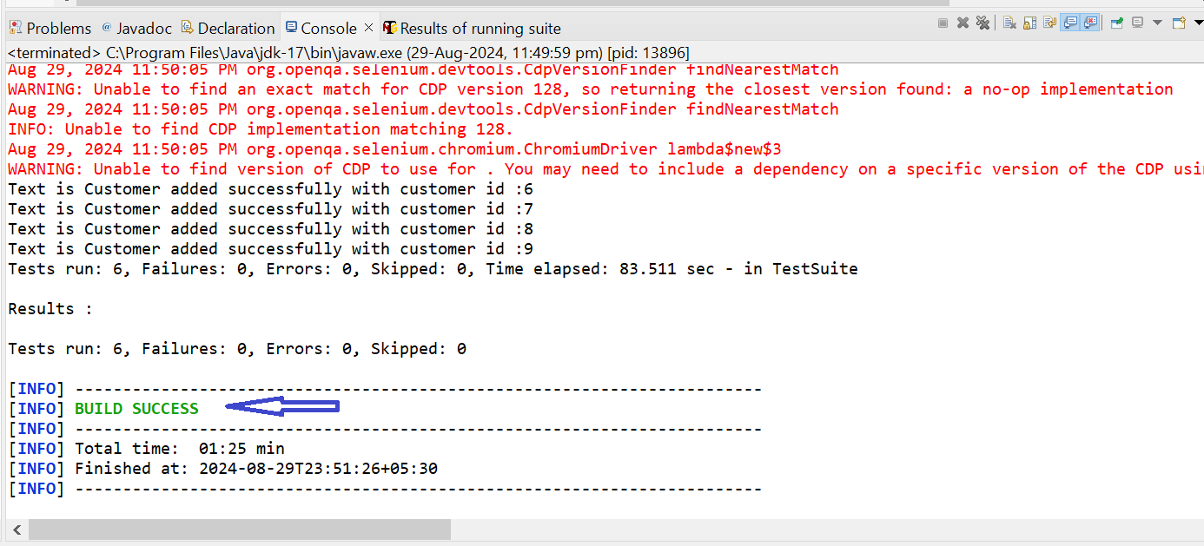

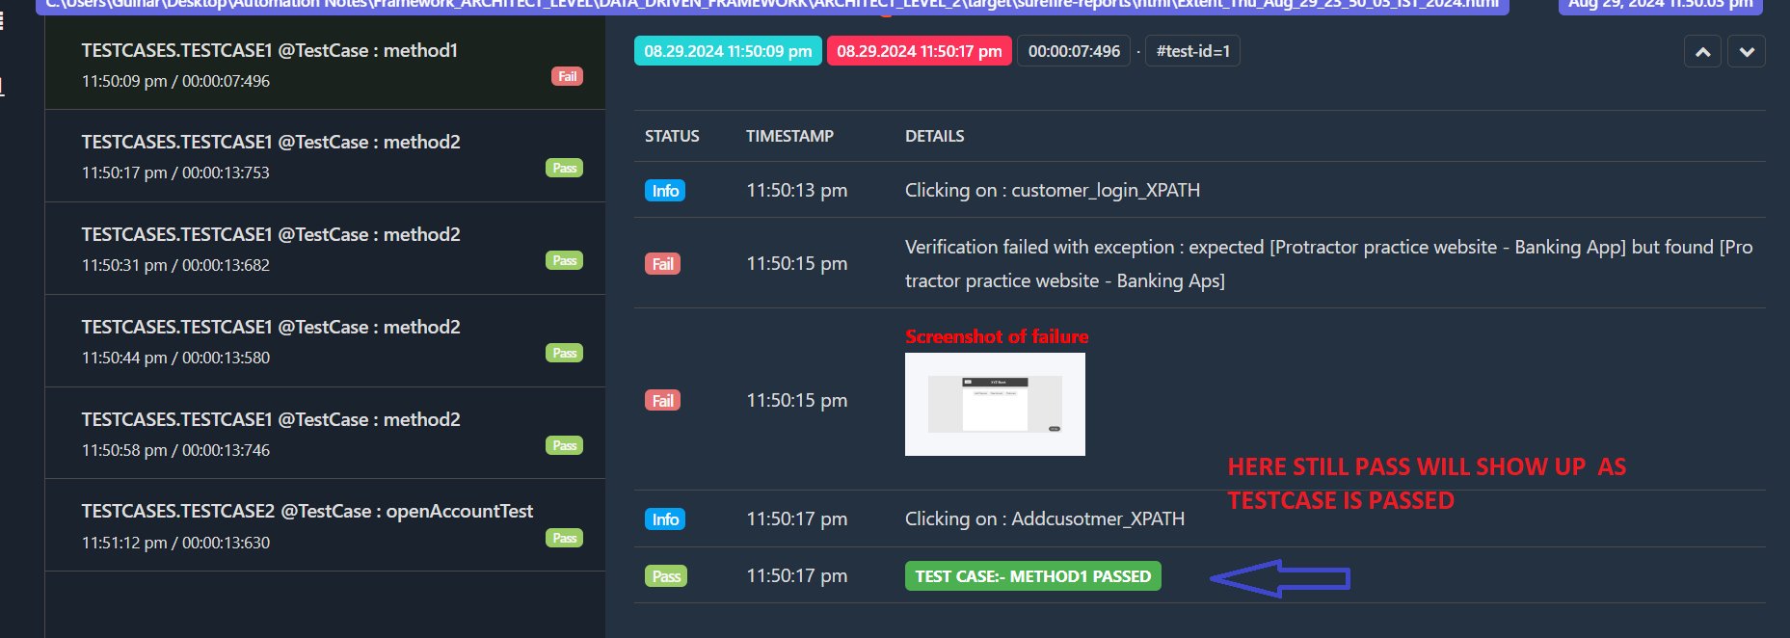

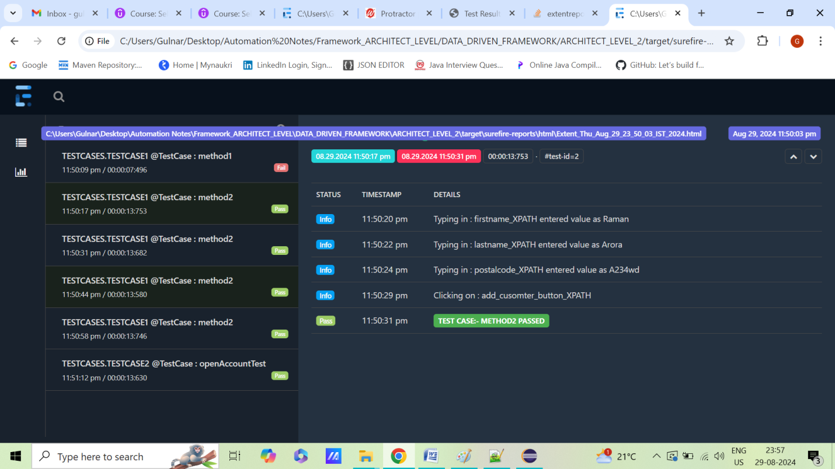

**STEP 25=>HOW TO CREATE COMMON DATA PROVIDER MEANS USING SAME DATA PROVIDER WITH DIFFERENT SHEET NAME ?**

**STEPS 1=> ADD ONE MORE EXCEL SHEET FOR “OPEN ACCOUNT” in “SHEET2”& ALSO GIVING THE SHEETNAME SAME AS CLASSNAME PRESENT IN TESTCASE1 AND TESTCASE 2**

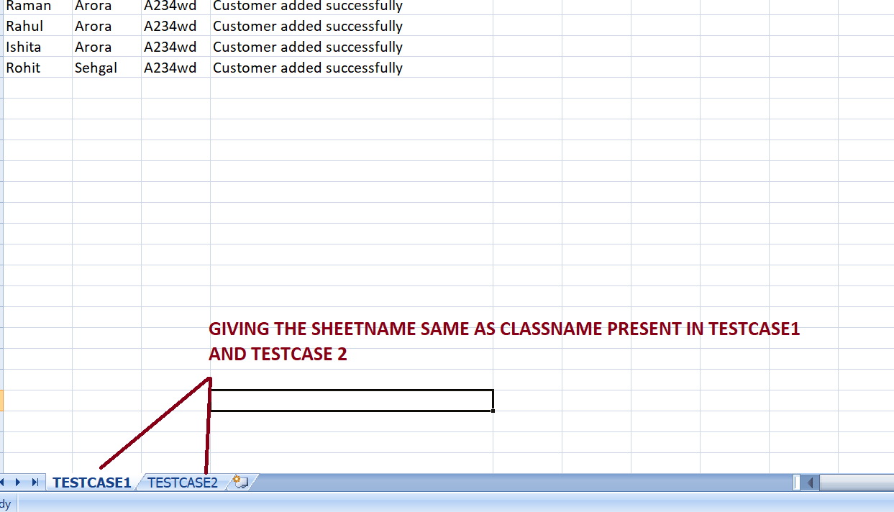

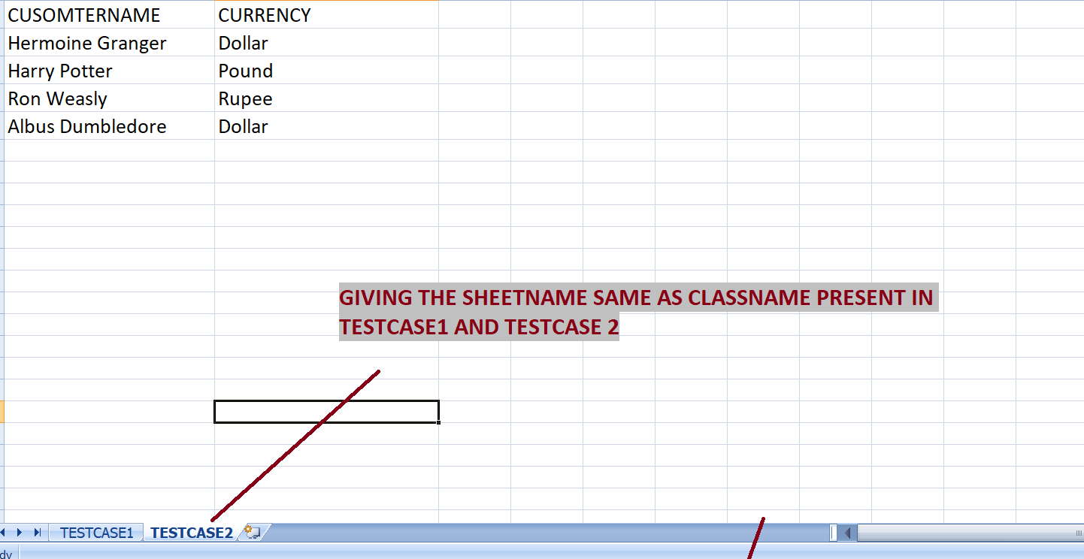

**STEPS 2=> GIVE THE METHOD WITH SAME NAME AS CLASS NAME FOR BOTH TESTCASE 1 AND TESTCASE 2 and PROVIDE SHEETNAME IN EXCEL SHEET WITH SAME NAME AS CLASS NAME THEN IT WILL FETCH THE METHOD NAME AS “SHEETNAME” IN DATA PROVIDER”**

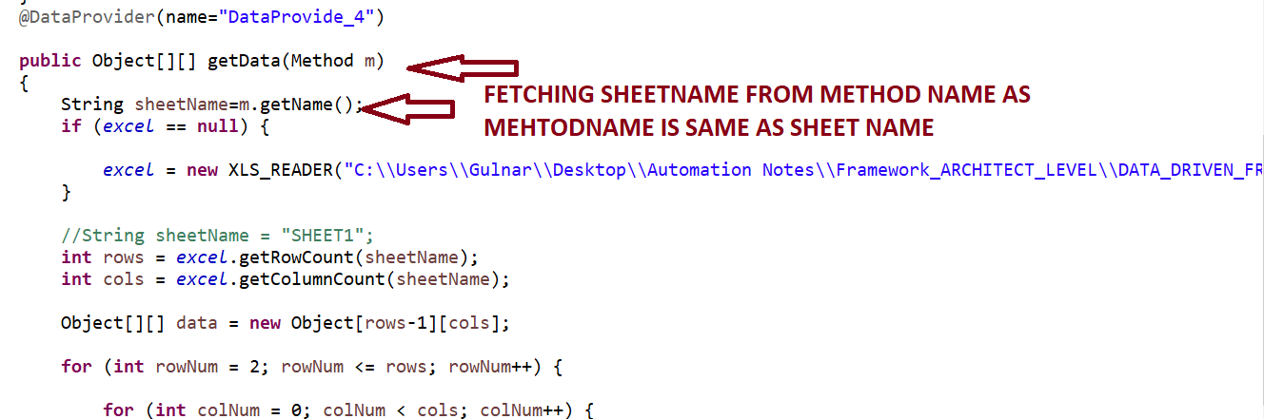

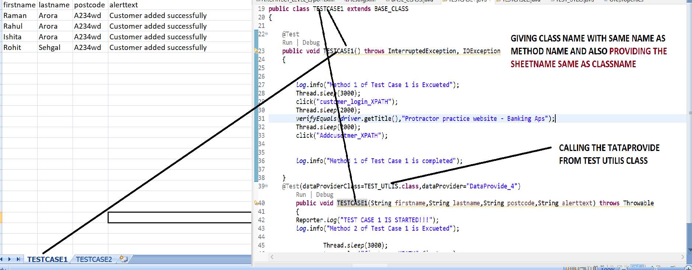

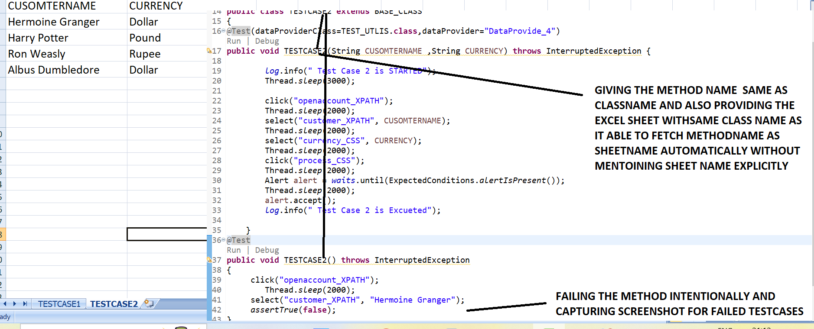

**STEPS 3=> REMOVING DATA PROVIDER CODE FROM TESTCASES 1 AND PLACING IN “TEST UTILS CLASS”**

**TESTUTLIS.JAVA**

**package** UTILITIES;

**import** java.io.File;

**import** java.io.IOException;

**import** java.lang.reflect.Method;

**import** java.util.Date;

**import** org.apache.commons.io.FileUtils;

**import** org.openqa.selenium.OutputType;

**import** org.openqa.selenium.TakesScreenshot;

**import** org.testng.annotations.DataProvider;

**import** BASE_CLASS.BASE_CLASS;

**public** **class** TEST_UTLIS **extends** BASE_CLASS

{

**public** **static** String *screenshotPath*;

**public** **static** String *screenshotName*;

**public** **static** **void** captureScreenshot_Failed_screesnhot() **throws** IOException

{

File scrFile = ((TakesScreenshot) *driver*).getScreenshotAs(OutputType.***FILE***);

Date d = **new** Date();

*screenshotName* = d.toString().replace(":", "_").replace(" ", "_") + ".jpg";

File destFile=**new** File(System.*getProperty*("user.dir") + "\\target\\surefire-reports\\html\\" + *screenshotName*);

FileUtils.*copyFile*(scrFile,destFile);

}

@DataProvider(name="DataProvide_4")

**public** Object[][] getData(Method m)

{

String sheetName=m.getName();

**if** (*excel* == **null**) {

*excel* = **new** XLS_READER("C:\\Users\\Gulnar\\Desktop\\Automation Notes\\Framework_ARCHITECT_LEVEL\\DATA_DRIVEN_FRAMEWORK\\ARCHITECT_LEVEL_2\\src\\test\\resources\\EXCEL_SHEET\\testdata.xlsx");

}

//String sheetName = "SHEET1";

**int** rows = *excel*.getRowCount(sheetName);

**int** cols = *excel*.getColumnCount(sheetName);

Object[][] data = **new** Object[rows-1][cols];

**for** (**int** rowNum = 2; rowNum <= rows; rowNum++) {

**for** (**int** colNum = 0; colNum < cols; colNum++) {

data[rowNum - 2][colNum] = *excel*.getCellData(sheetName, colNum, rowNum);

}

}

**return** data;

}

}

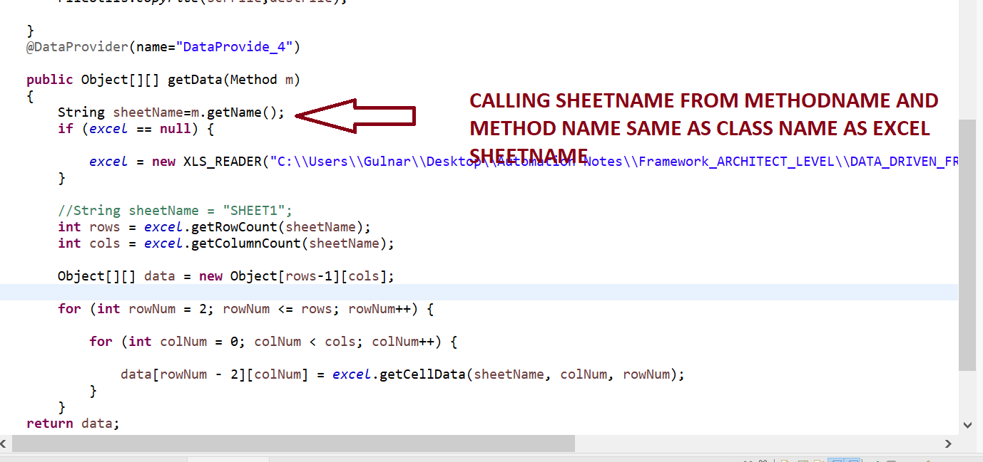

**STEPS 4=> CALLING THE TESTUTILS CLASS DATA PROVIDER IN TESTCASE AS “**@Test(dataProviderClass=TEST_UTLIS.**class**,dataProvider="DataProvide_4")

**TESTCASE1.JAVA**

**package** TESTCASES;

**import** java.io.IOException;

**import** org.openqa.selenium.Alert;

**import** org.openqa.selenium.By;

**import** org.openqa.selenium.support.ui.ExpectedConditions;

**import** org.testng.Assert;

**import** org.testng.Reporter;

**import** org.testng.annotations.DataProvider;

**import** org.testng.annotations.Test;

**import** BASE_CLASS.BASE_CLASS;

**import** UTILITIES.TEST_UTLIS;

**import** UTILITIES.XLS_READER;

**public** **class** TESTCASE1 **extends** BASE_CLASS

{

@Test

**public** **void** TESTCASE1() **throws** InterruptedException, IOException

{

*log*.info("Method 1 of Test Case 1 is Excueted");

Thread.*sleep*(3000);

click("customer_login_XPATH");

Thread.*sleep*(2000);

*verifyEquals*(*driver*.getTitle(),"Protractor practice website - Banking Aps");

Thread.*sleep*(2000);

click("Addcusotmer_XPATH");

*log*.info("Method 1 of Test Case 1 is completed");

}

@Test(dataProviderClass=TEST_UTLIS.**class**,dataProvider="DataProvide_4")

**public** **void** TESTCASE1(String firstname,String lastname,String postcode,String alerttext) **throws** Throwable

{

Reporter.*log*("TEST CASE 1 IS STARTED!!!");

*log*.info("Method 2 of Test Case 1 is Excueted");

Thread.*sleep*(3000);

type_value("firstname_XPATH",firstname);

Thread.*sleep*(2000);

type_value("lastname_XPATH",lastname);

Thread.*sleep*(2000);

type_value("postalcode_XPATH",postcode);

Thread.*sleep*(2000);

Assert.*assertTrue*(IsElementPresent

(By.*xpath*(*OR*.getProperty("add_cusomter_button_XPATH"))),"Login not successful");

Thread.*sleep*(2000);

click("add_cusomter_button_XPATH");

//Wait for the alert to be displayed and store it in a variable

Alert alert = *waits*.until(ExpectedConditions.*alertIsPresent*());

Thread.*sleep*(2000);

//Store the alert text in a variable

String text = alert.getText();

System.***out***.println("Text is "+text);

//Press the OK button

Assert.*assertTrue*(alert.getText().contains(alerttext));

//Thread.sleep(2000);

alert.accept();

*log*.info("Method 2 of Test Case 1 is completed");

Reporter.*log*("TEST CASE 1 completed!!!");

}

}

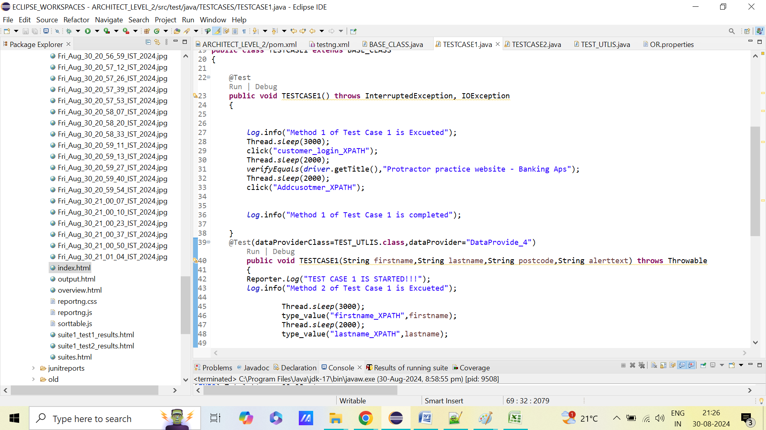

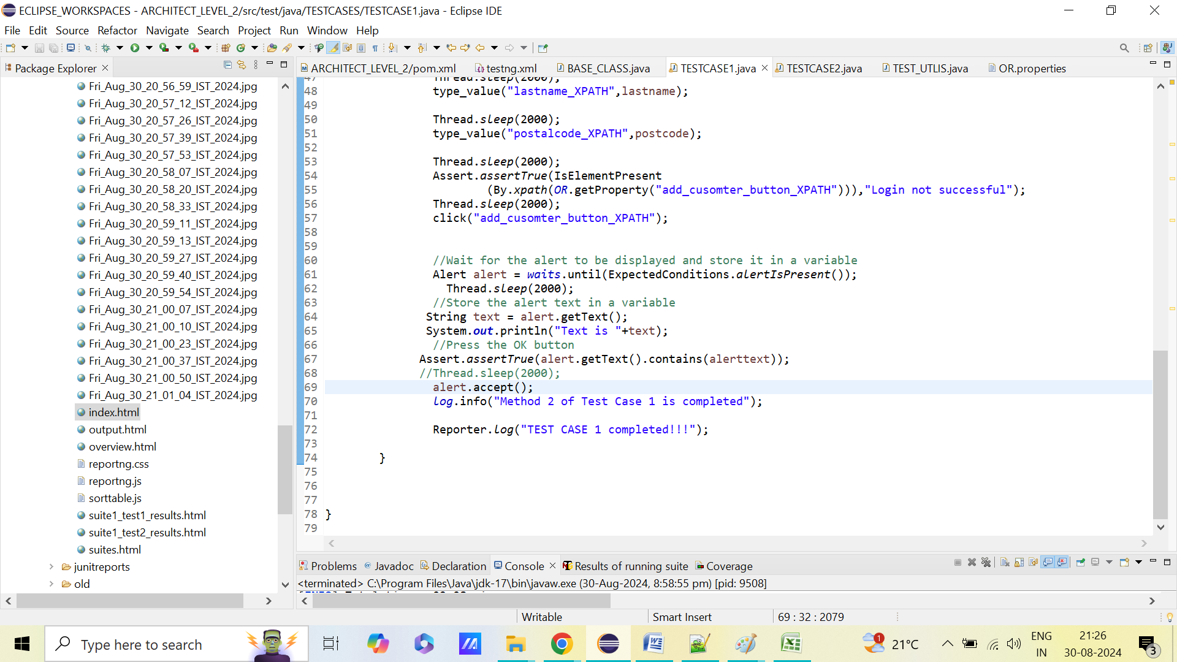

**TESTCASE2.JAVA**

**package** TESTCASES;

**import** **static** org.testng.Assert.*assertTrue*;

**import** org.openqa.selenium.Alert;

**import** org.openqa.selenium.support.ui.ExpectedConditions;

**import** org.testng.annotations.Test;

**import** com.aventstack.extentreports.util.Assert;

**import** BASE_CLASS.BASE_CLASS;

**import** UTILITIES.TEST_UTLIS;

**public** **class** TESTCASE2 **extends** BASE_CLASS

{

@Test(dataProviderClass=TEST_UTLIS.**class**,dataProvider="DataProvide_4")

**public** **void** TESTCASE2(String CUSOMTERNAME ,String CURRENCY) **throws** InterruptedException {

*log*.info(" Test Case 2 is STARTED");

Thread.*sleep*(3000);

click("openaccount_XPATH");

Thread.*sleep*(2000);

select("customer_XPATH", CUSOMTERNAME);

Thread.*sleep*(2000);

select("currency_CSS", CURRENCY);

Thread.*sleep*(2000);

click("process_CSS");

Thread.*sleep*(2000);

Alert alert = *waits*.until(ExpectedConditions.*alertIsPresent*());

Thread.*sleep*(2000);

alert.accept();

*log*.info(" Test Case 2 is Excueted");

}

@Test

**public** **void** TESTCASE2() **throws** InterruptedException

{

click("openaccount_XPATH");

Thread.*sleep*(2000);

select("customer_XPATH", "Hermoine Granger");

*assertTrue*(**false**);

}

}

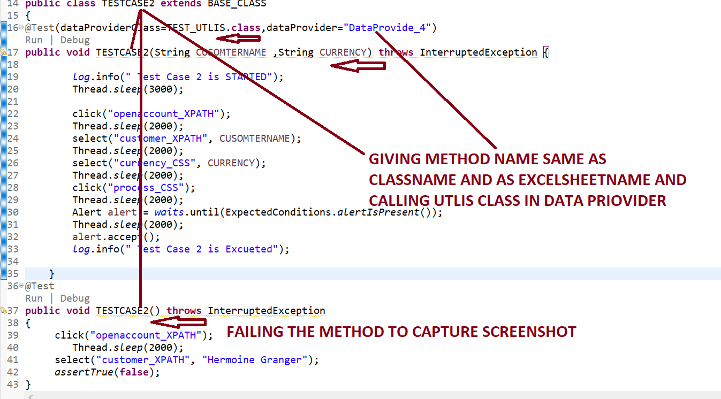

**STEPS 5=>RIGHT CLICK AND RUN AS MAVEN TEST .IT WILL CAPTURE SCREENSHOT FOR FAILED TESTCASES AS WELL AS “verifyEquals “AS IT WILL VALIDATE ACTUAL AND EXPECTED VALUE METHOD “ AS IT WILL “CAPTURE SCREENSHOT” IS CALLED FOR THAT METHOD IN “CATCH EXCEPTIONS PRESENT IN BASE CLASS**

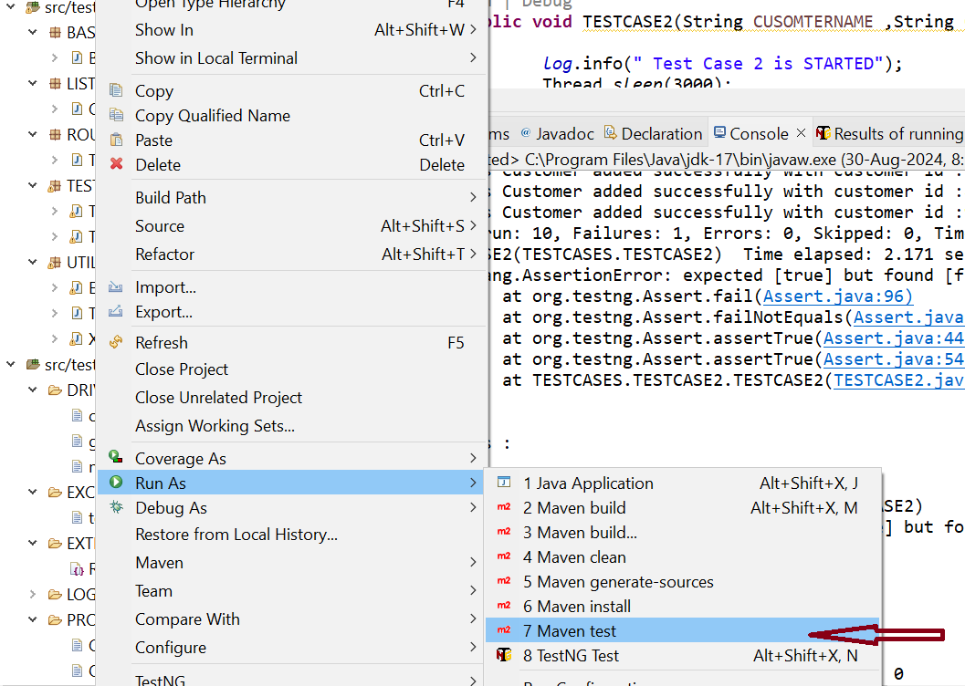

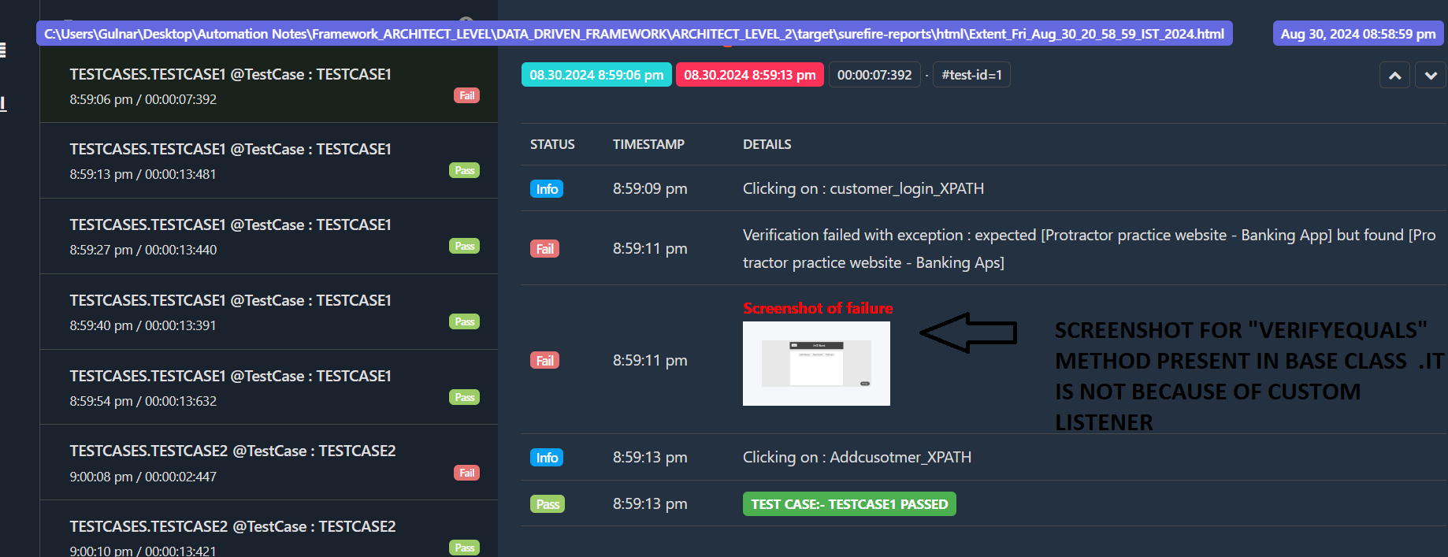

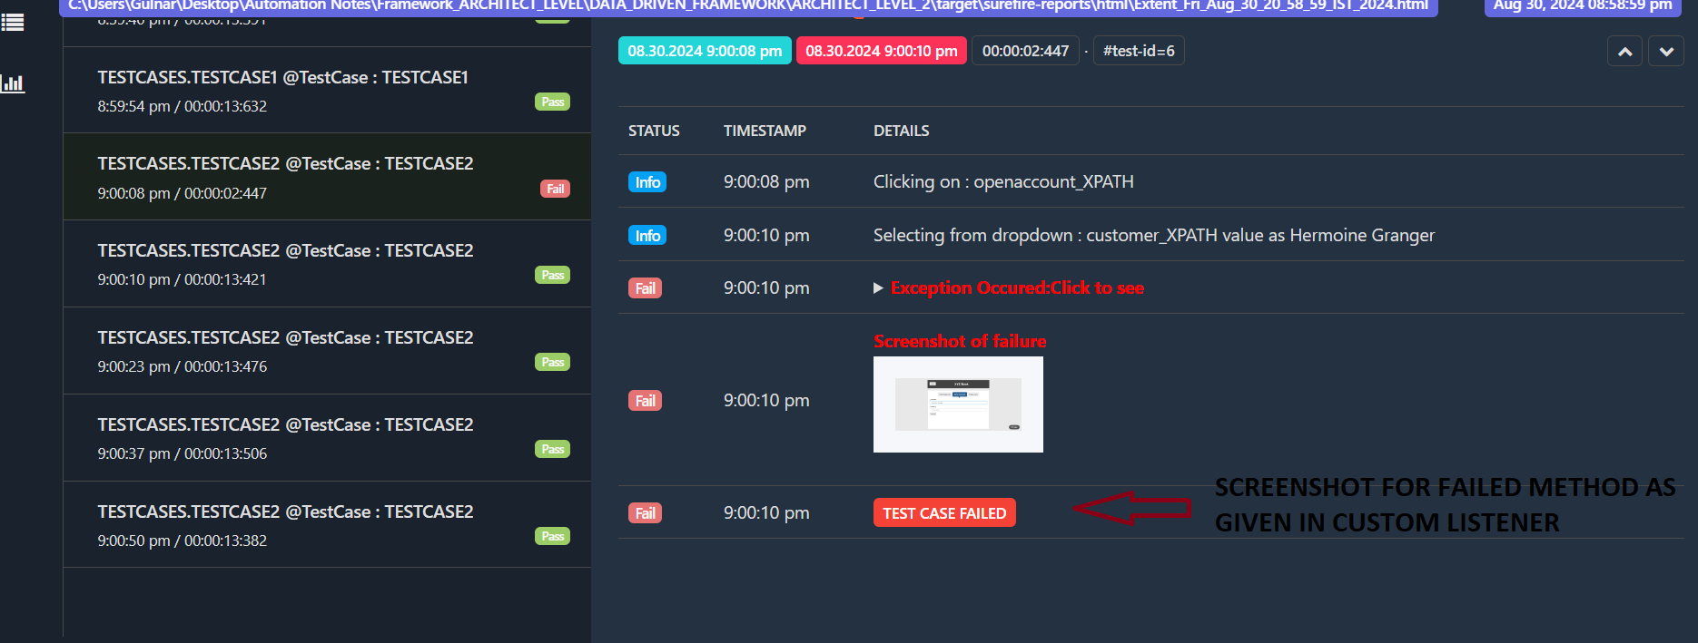

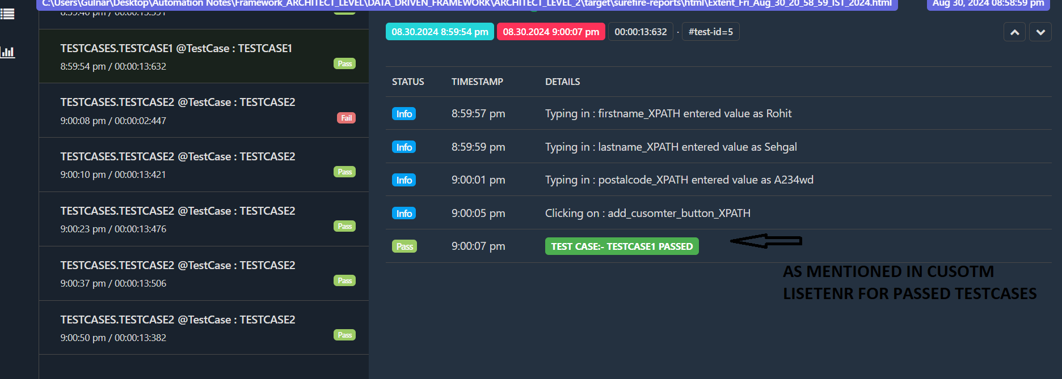

**STEP 26=>FOR EXAMPLE , WE HAVE 100 TESTCASES ,NEED TO RUN THE ONLY FEW TESTCASES ,FOR THAT WE CAN USE “GROUPS” OR SET RUN MODE FOR TEST CASES SO HOW TO SET RUN MODE FOR TESTCASES?**

**=>MEANS IT WILL SKIP THOSE TESTCASE WHOSE RUNMODE IS “NO” IN EXCEL SHEET**

**STEPS 1=> CREATE NEW SHEET IN “EXCEL SHEET “ AND CALLING THE SHEETNAME OR CLASSNAME OF EACH TESTCASE HERE IN “EXCEL SHEET FIRST ROW” WHICH IS SAME PRESENT AS CLASSNAME OF EACH TESTCASES**

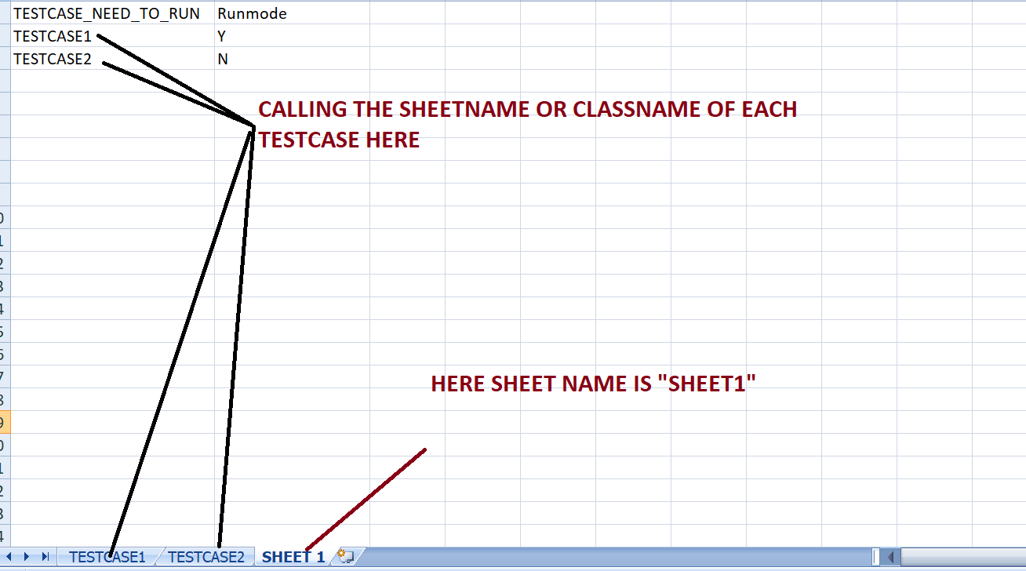

**STEPS 2=> WRITE BELOW CODE IN “TESTUTLIS CLASS “ FOR “SETTING RUNNING MODE” AND CALLING THAT METHOD IN RESPECTIVE “TESTCASE “ FOR SKIPPING THE TESTCASES**

**TESTUTLIS.JAVA=>HERE PROVIDE COLUMN NAME WHICH IS SAME AS GIVEN IN “EXCEL SHEET” FOR “COLUMN 1 AND COLUMN2”**

**package** UTILITIES;

**import** java.io.File;

**import** java.io.IOException;

**import** java.lang.reflect.Method;

**import** java.util.Date;

**import** org.apache.commons.io.FileUtils;

**import** org.openqa.selenium.OutputType;

**import** org.openqa.selenium.TakesScreenshot;

**import** org.testng.annotations.DataProvider;

**import** BASE_CLASS.BASE_CLASS;

**public** **class** TEST_UTLIS **extends** BASE_CLASS

{

**public** **static** String *screenshotPath*;

**public** **static** String *screenshotName*;

**public** **static** **void** captureScreenshot_Failed_screesnhot() **throws** IOException

{

File scrFile = ((TakesScreenshot) *driver*).getScreenshotAs(OutputType.***FILE***);

Date d = **new** Date();

*screenshotName* = d.toString().replace(":", "_").replace(" ", "_") + ".jpg";

File destFile=**new** File(System.*getProperty*("user.dir") + "\\target\\surefire-reports\\html\\" + *screenshotName*);

FileUtils.*copyFile*(scrFile,destFile);

}

@DataProvider(name="DataProvide_4")

**public** Object[][] getData(Method m)

{

String sheetName=m.getName();

**if** (*excel* == **null**) {

*excel* = **new** XLS_READER("C:\\Users\\Gulnar\\Desktop\\Automation Notes\\Framework_ARCHITECT_LEVEL\\DATA_DRIVEN_FRAMEWORK\\ARCHITECT_LEVEL_2\\src\\test\\resources\\EXCEL_SHEET\\testdata.xlsx");

}

//String sheetName = "SHEET1";

**int** rows = *excel*.getRowCount(sheetName);

**int** cols = *excel*.getColumnCount(sheetName);

Object[][] data = **new** Object[rows-1][cols];

**for** (**int** rowNum = 2; rowNum <= rows; rowNum++) {

**for** (**int** colNum = 0; colNum < cols; colNum++) {

data[rowNum - 2][colNum] = *excel*.getCellData(sheetName, colNum, rowNum);

}

}

**return** data;

}

**public static boolean Method_to_Skip(String testName, XLS_READER excel){**

**String sheetName="SHEET 1";**

**int rows = excel.getRowCount(sheetName);**

**for(int rNum=2; rNum<=rows; rNum++){**

**String testCase = excel.getCellData(sheetName, "TESTCASE_NEED_TO_RUN", rNum);**

**if(testCase.equalsIgnoreCase(testName)){**

**String runmode = excel.getCellData(sheetName, "Runmode", rNum);**

**if(runmode.equalsIgnoreCase("Y"))**

**return true;**

**else**

**return false;**

**}**

**}**

**return false;**

**}**

**}**

**EXPLANATION**

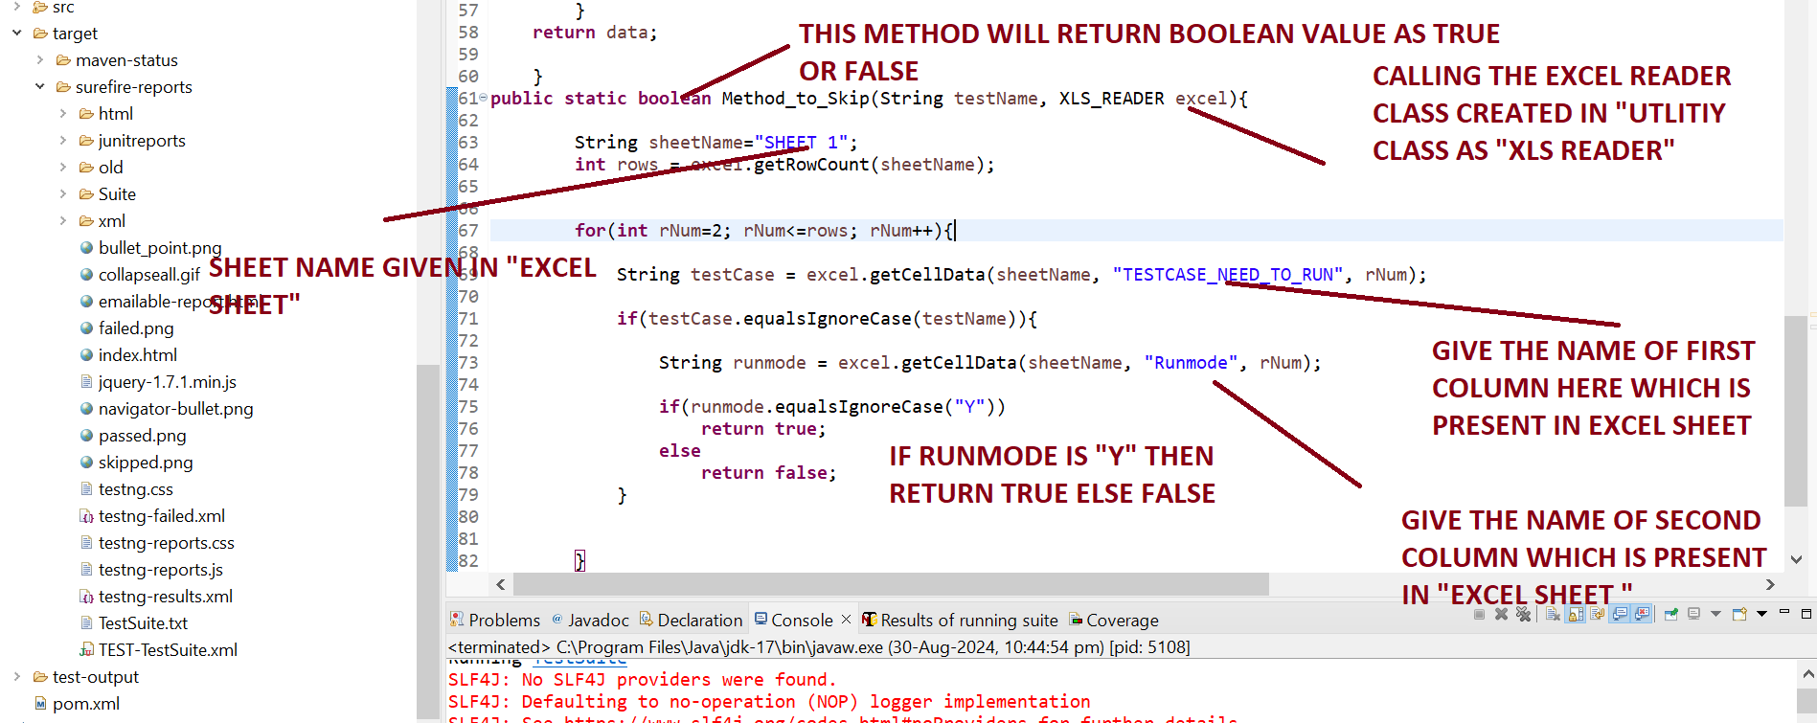

**STEPS 3=> WRITE BELOW CODE IN “TESTCASE” THAT WANT TO SKIPS**

**TESTCASE2.JAVA**

package TESTCASES;

import static org.testng.Assert.*assertTrue*;

import org.openqa.selenium.Alert;

import org.openqa.selenium.support.ui.ExpectedConditions;

import org.testng.SkipException;

import org.testng.annotations.Test;

import com.aventstack.extentreports.util.Assert;

import BASE_CLASS.BASE_CLASS;

import UTILITIES.TEST_UTLIS;

public class TESTCASE2 extends BASE_CLASS

{

@Test(dataProviderClass=TEST_UTLIS.class,dataProvider="DataProvide_4")

public void TESTCASE2(String CUSOMTERNAME ,String CURRENCY) throws InterruptedException {

if(!(TEST_UTLIS.*Method_to_Skip*("TESTCASE2", *excel*)))

{

throw new SkipException("Skipping the test "+"TESTCASE2".toUpperCase()+ "as the Run mode is NO");

}

*log*.info(" Test Case 2 is STARTED");

Thread.*sleep*(3000);

click("openaccount_XPATH");

Thread.*sleep*(2000);

select("customer_XPATH", CUSOMTERNAME);

Thread.*sleep*(2000);

select("currency_CSS", CURRENCY);

Thread.*sleep*(2000);

click("process_CSS");

Thread.*sleep*(2000);

Alert alert = *waits*.until(ExpectedConditions.*alertIsPresent*());

Thread.*sleep*(2000);

alert.accept();

*log*.info(" Test Case 2 is Excueted");

}

@Test

public void TESTCASE2() throws InterruptedException

{

click("openaccount_XPATH");

Thread.*sleep*(2000);

select("customer_XPATH", "Hermoine Granger");

*assertTrue*(false);

}

}

**EXPLANATION=> SYNTAX ARE AS FOLLOW**

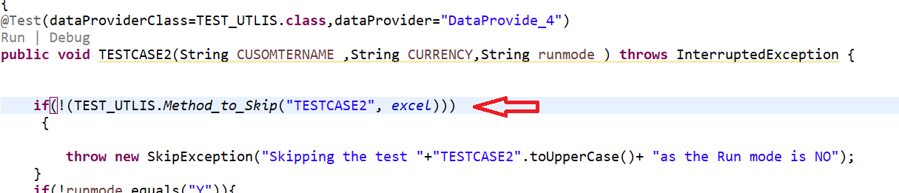

**HERE CALLING THE SAME TESTNAME AS CLASSNAME AND AS SAME EXCEL SHEETNAME IN TESTCASES**

**SYNTAX**

**if**(!(TEST_UTLIS.*Method_to_Skip*("TESTCASE2", *excel*)))

{

**throw** **new** SkipException("Skipping the test "+"TESTCASE2".toUpperCase()+ "as the Run mode is NO");

}

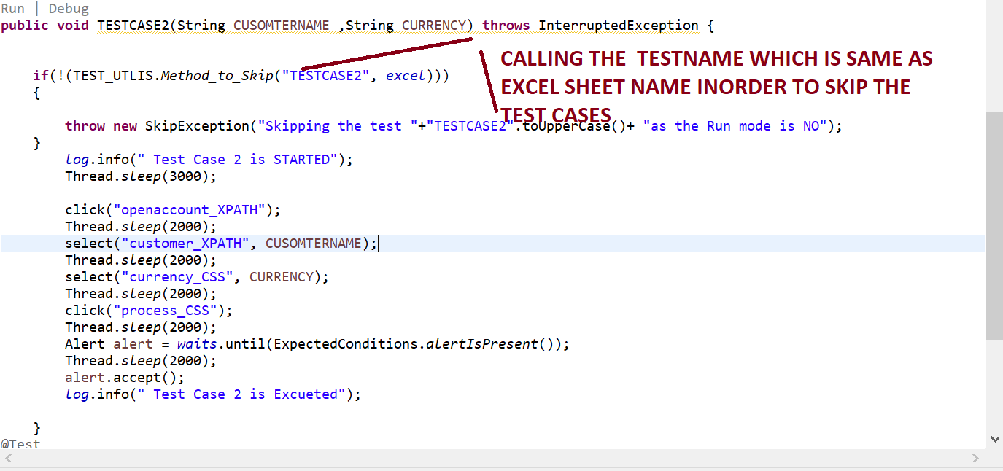

**STEPS 4=> ALSO CHECK “EXTENT REPORT “ CODE IS WRTTIEN IN CUSTOM LISTENERS FOR “SKIPPED TESTCASES” ON “SKIP METHOD” THEN ONLY “EXTENT REPORT” WILL SHOW IN YELLOW COLOUR WITH METHOD NAME FOR “SKIPPED TESTCASES”**

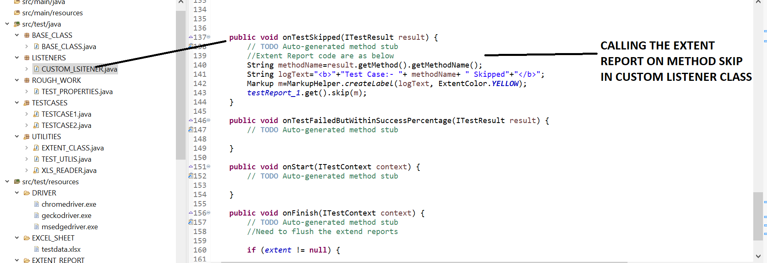

**STEPS 5=> RIGHT CLICK AND RUN AS “MAVEN TEST”, THEN ONLY EXTENT REPORT IS GENERATED WITH “SKIPPED TESTCASES” MEANS IT WILL SKIP THE TESTCASES AS “RUN MODE PRESENT IN EXCEL SHEET IS GIVEN AS “NO” FOR THAT TESTCASES**

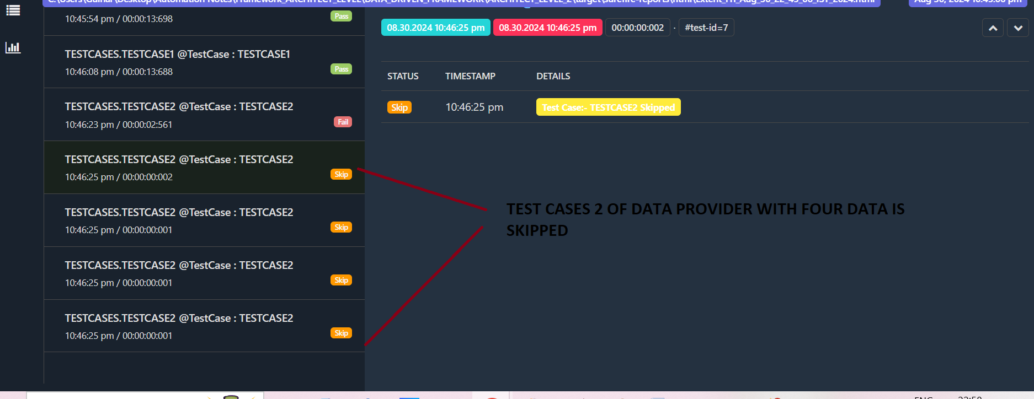

**STEP 27=> HOW TO SET “RUN MODES” FOR “TEST DATA”?**

**MEANS SETTING RUNMODE FOR TEST DATA .IT WILL RUN ONLY ONLY THOSE DATA WHOSE RUN MODE IS YES**

**STEPS 1=> ADD “RUNMODE COLUMN” IN EXCEL SHEET FOR EACH TESTCASE IE “TESTCASE1” AND “TESTCASE2”**

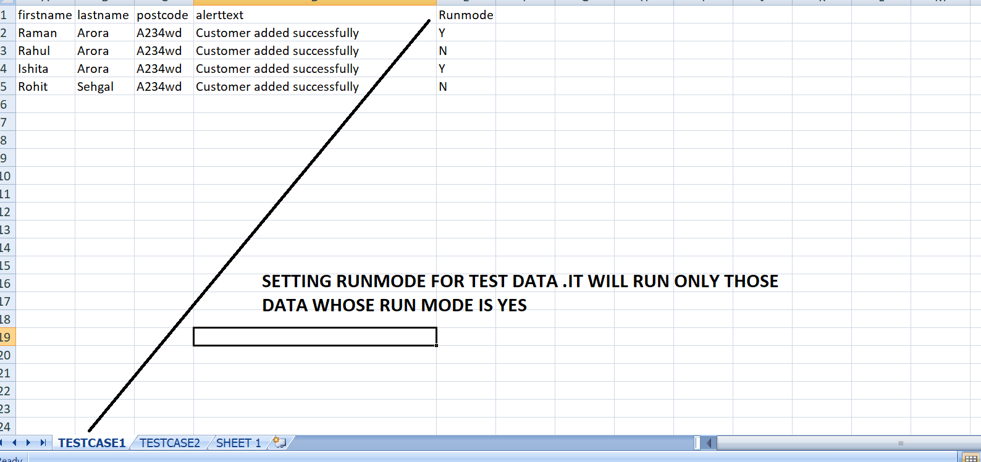

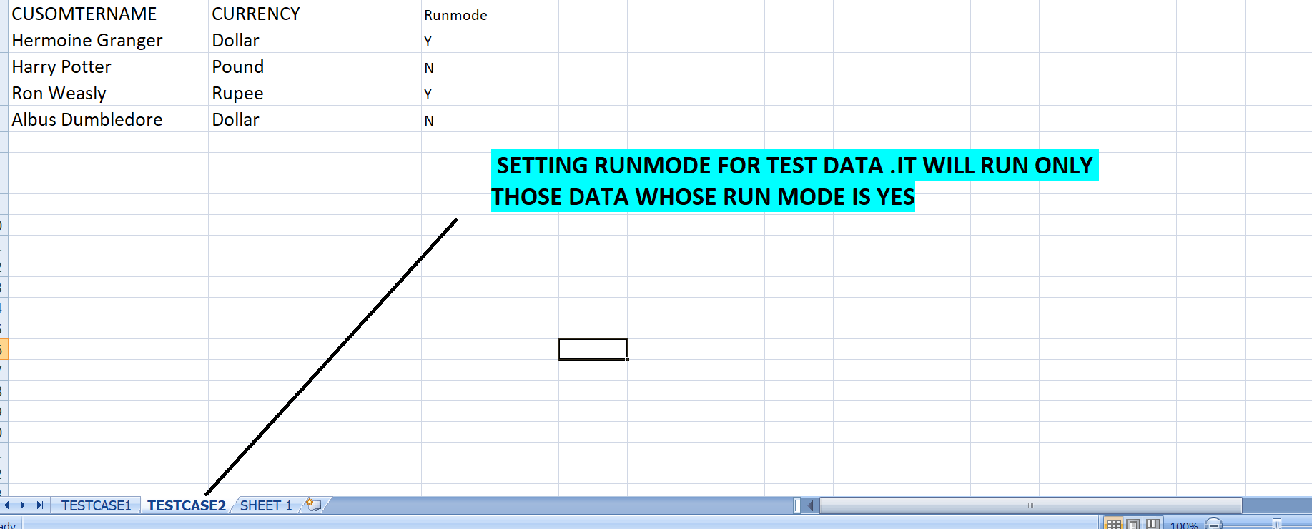

**STEPS 2=> ADD BELOW CODE FOR EACH TEST CASE**

**SYNTAX=>IN DATA PROVIDER METHOD, PROVIDE THE RUNMODE COLUMN AS “STRING” AND SPECIFY CUSTOM EXCEPTION MESSAGE FOR THAT TEST DATA THAT IS SKIPPED**

**if**(!runmode.equals("Y")){

**throw** **new** SkipException("Skipping the test case as the Run mode for data set is NO");

}

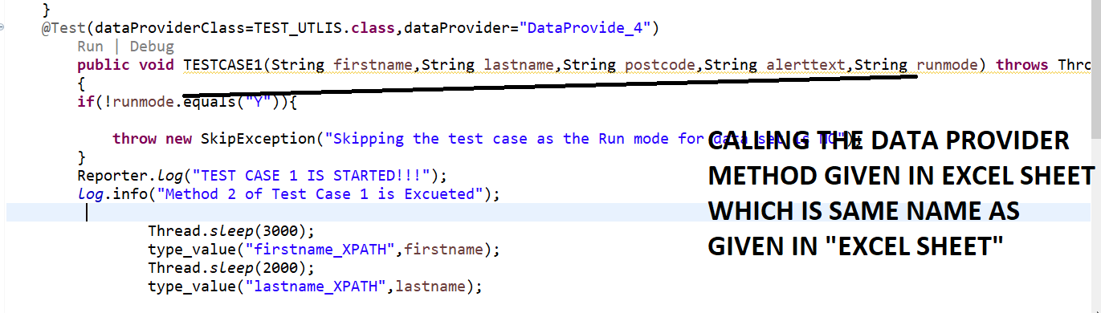

**TEST CASE1.JAVA**

**package** TESTCASES;

**import** java.io.IOException;

**import** org.openqa.selenium.Alert;

**import** org.openqa.selenium.By;

**import** org.openqa.selenium.support.ui.ExpectedConditions;

**import** org.testng.Assert;

**import** org.testng.Reporter;

**import** org.testng.SkipException;

**import** org.testng.annotations.DataProvider;

**import** org.testng.annotations.Test;

**import** BASE_CLASS.BASE_CLASS;

**import** UTILITIES.TEST_UTLIS;

**import** UTILITIES.XLS_READER;

**public** **class** TESTCASE1 **extends** BASE_CLASS

{

@Test

**public** **void** TESTCASE1() **throws** InterruptedException, IOException

{

*log*.info("Method 1 of Test Case 1 is Excueted");

Thread.*sleep*(3000);

click("customer_login_XPATH");

Thread.*sleep*(2000);

*verifyEquals*(*driver*.getTitle(),"Protractor practice website - Banking Aps");

Thread.*sleep*(2000);

click("Addcusotmer_XPATH");

*log*.info("Method 1 of Test Case 1 is completed");

}

@Test(dataProviderClass=TEST_UTLIS.**class**,dataProvider="DataProvide_4")

**public** **void** TESTCASE1(String firstname,String lastname,String postcode,String alerttext,String runmode) **throws** Throwable

{

**if**(!runmode.equals("Y")){

**throw** **new** SkipException("Skipping the test case as the Run mode for data set is NO");

}

Reporter.*log*("TEST CASE 1 IS STARTED!!!");

*log*.info("Method 2 of Test Case 1 is Excueted");

Thread.*sleep*(3000);

type_value("firstname_XPATH",firstname);

Thread.*sleep*(2000);

type_value("lastname_XPATH",lastname);

Thread.*sleep*(2000);

type_value("postalcode_XPATH",postcode);

Thread.*sleep*(2000);

Assert.*assertTrue*(IsElementPresent

(By.*xpath*(*OR*.getProperty("add_cusomter_button_XPATH"))),"Login not successful");

Thread.*sleep*(2000);

click("add_cusomter_button_XPATH");

//Wait for the alert to be displayed and store it in a variable

Alert alert = *waits*.until(ExpectedConditions.*alertIsPresent*());

Thread.*sleep*(2000);

//Store the alert text in a variable

String text = alert.getText();

System.***out***.println("Text is "+text);

//Press the OK button

Assert.*assertTrue*(alert.getText().contains(alerttext));

//Thread.sleep(2000);

alert.accept();

*log*.info("Method 2 of Test Case 1 is completed");

Reporter.*log*("TEST CASE 1 completed!!!");

}

}

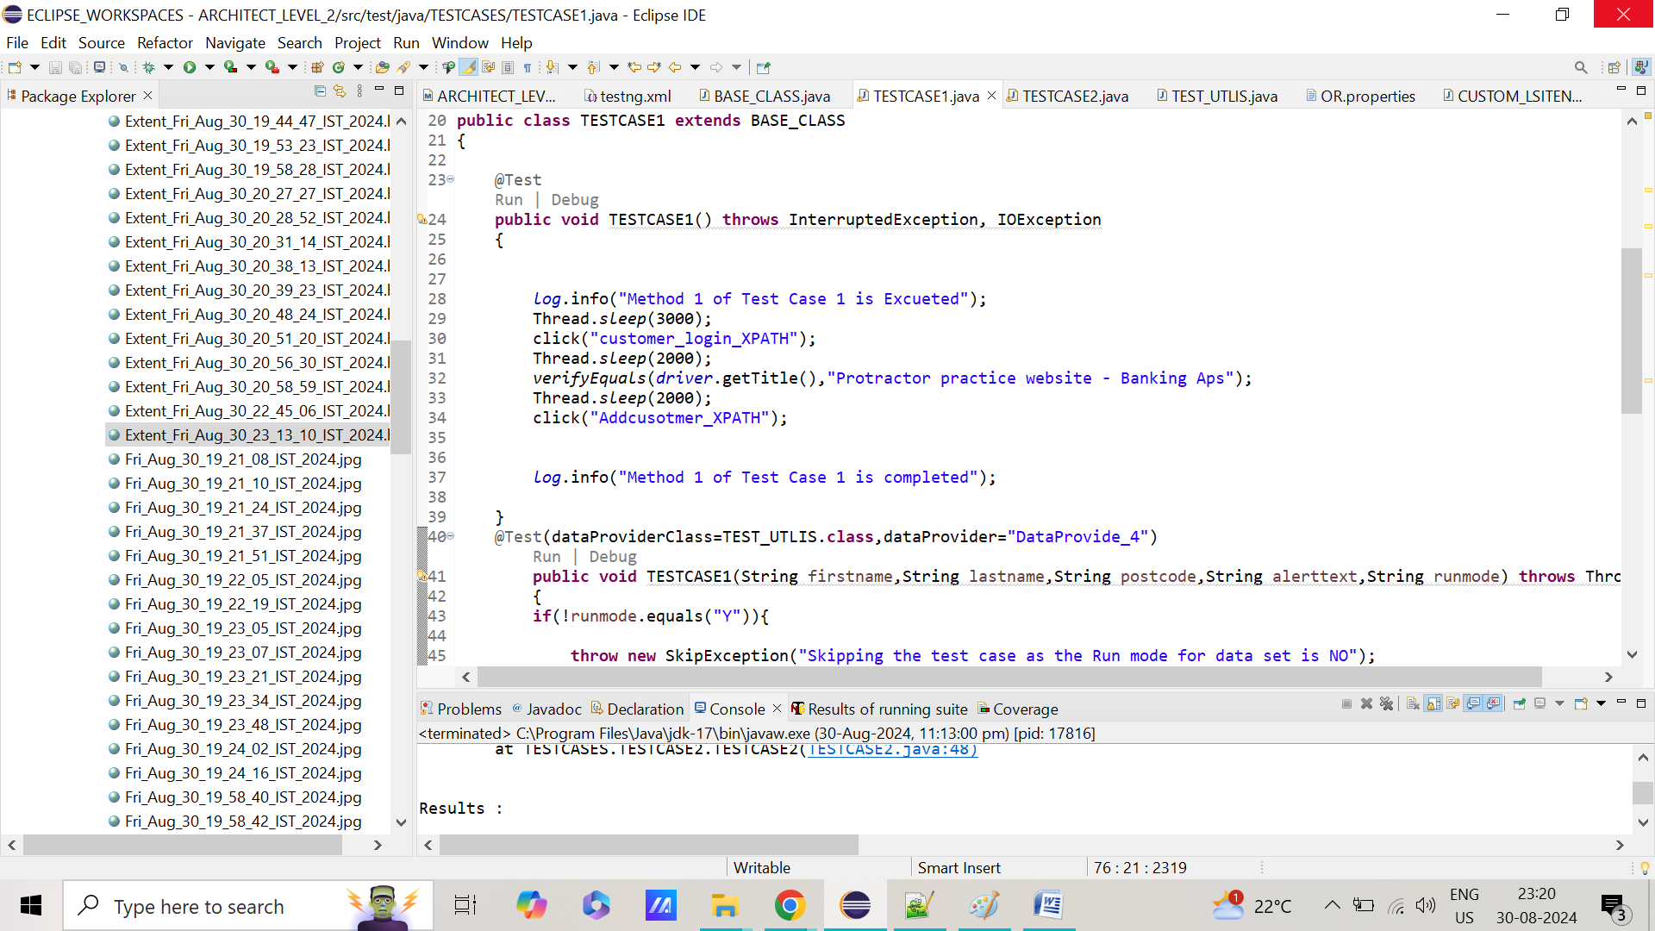

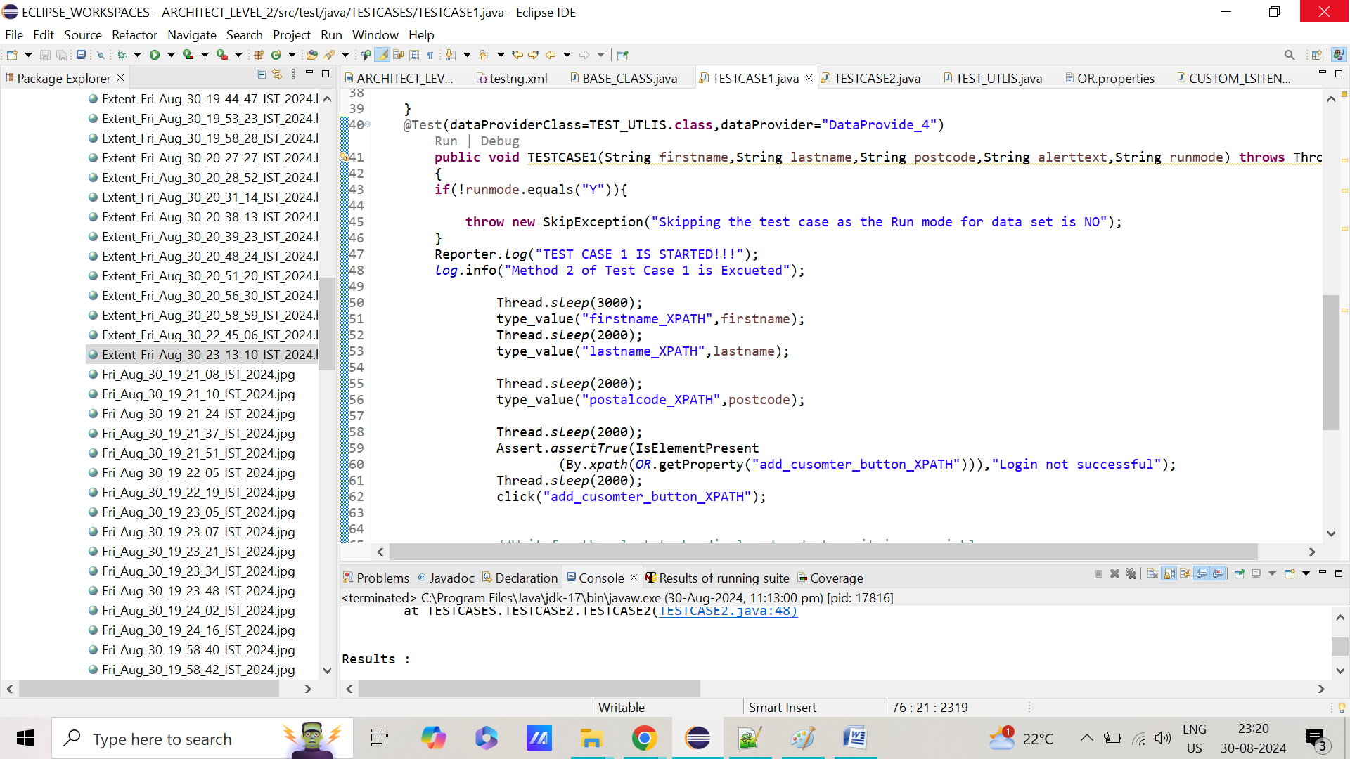

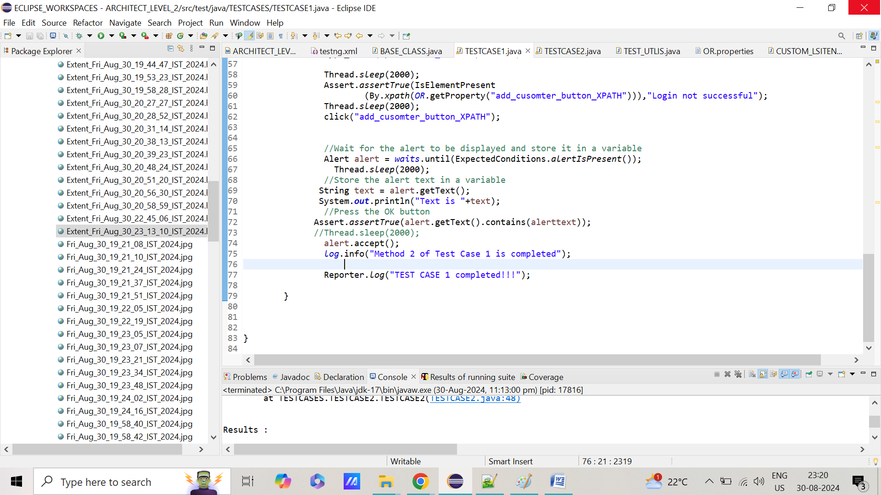

**TESTCASE2.JAVA**

**package** TESTCASES;

**import** **static** org.testng.Assert.*assertTrue*;

**import** org.openqa.selenium.Alert;

**import** org.openqa.selenium.support.ui.ExpectedConditions;

**import** org.testng.SkipException;

**import** org.testng.annotations.Test;

**import** com.aventstack.extentreports.util.Assert;

**import** BASE_CLASS.BASE_CLASS;

**import** UTILITIES.TEST_UTLIS;

**public** **class** TESTCASE2 **extends** BASE_CLASS

{

@Test(dataProviderClass=TEST_UTLIS.**class**,dataProvider="DataProvide_4")

**public** **void** TESTCASE2(String CUSOMTERNAME ,String CURRENCY,String runmode ) **throws** InterruptedException {

**if**(!runmode.equals("Y")){

**throw** **new** SkipException("Skipping the test case as the Run mode for data set is NO");

}

*log*.info(" Test Case 2 is STARTED");

Thread.*sleep*(3000);

click("openaccount_XPATH");

Thread.*sleep*(2000);

select("customer_XPATH", CUSOMTERNAME);

Thread.*sleep*(2000);

select("currency_CSS", CURRENCY);

Thread.*sleep*(2000);

click("process_CSS");

Thread.*sleep*(2000);

Alert alert = *waits*.until(ExpectedConditions.*alertIsPresent*());

Thread.*sleep*(2000);

alert.accept();

*log*.info(" Test Case 2 is Excueted");

}

@Test

**public** **void** TESTCASE2() **throws** InterruptedException

{

click("openaccount_XPATH");

Thread.*sleep*(2000);

select("customer_XPATH", "Hermoine Granger");

*assertTrue*(**false**);

}

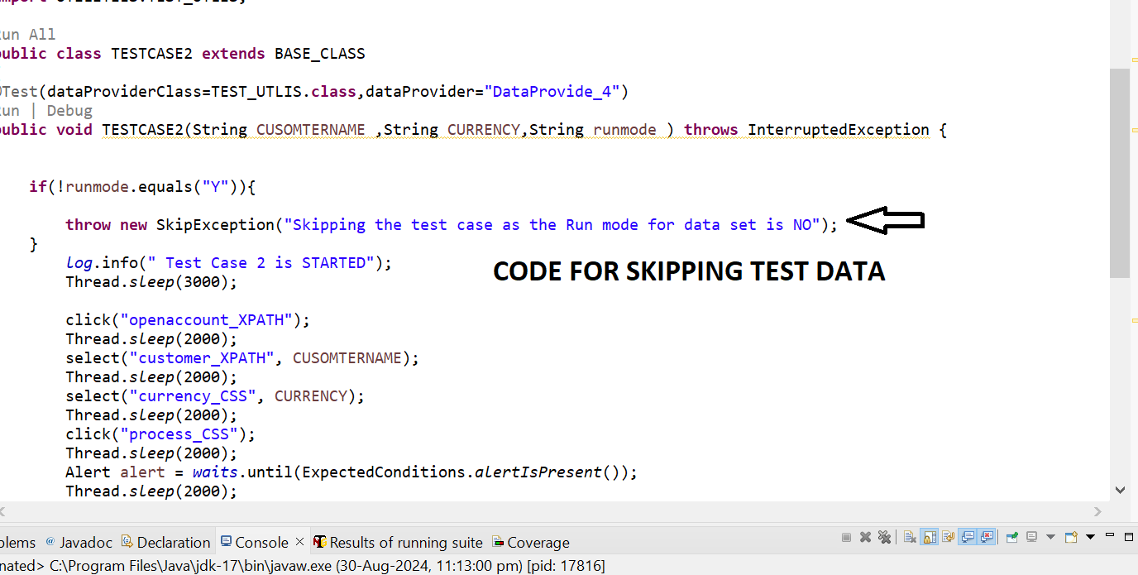

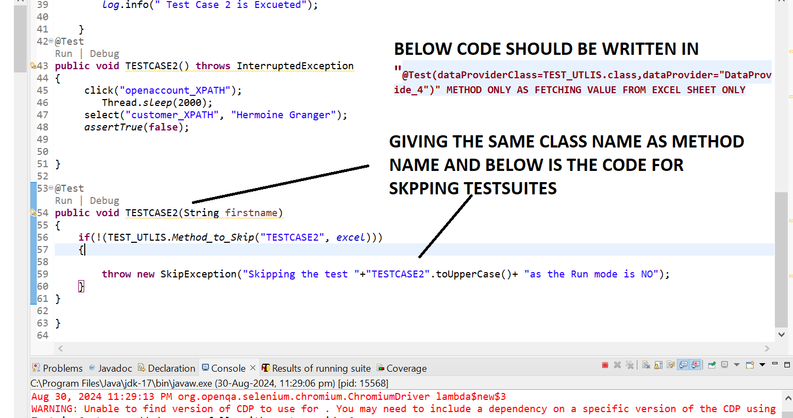

**STEPS 3=> RIGHT CLICK AND RUN AS “MAVEN TEST”.IT WILL SHOW “EXTENT REPORT “ WITH SKIP METHOD WITH CUSTOM MESSAGE GIVEN FOR “SKIPPED TESTDATA”**

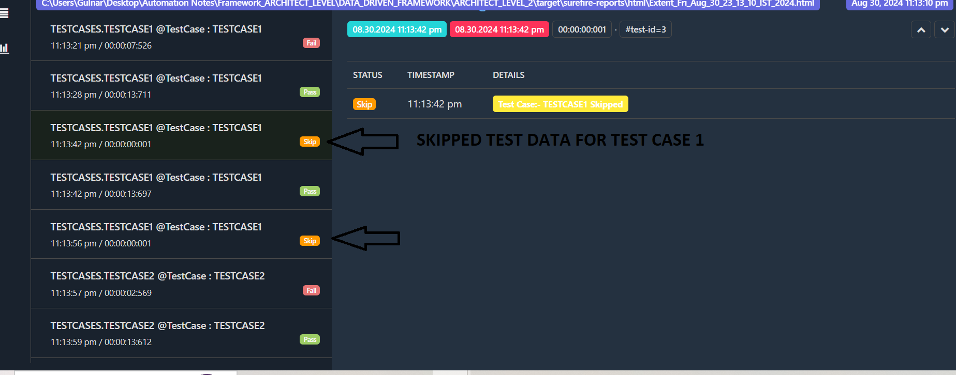

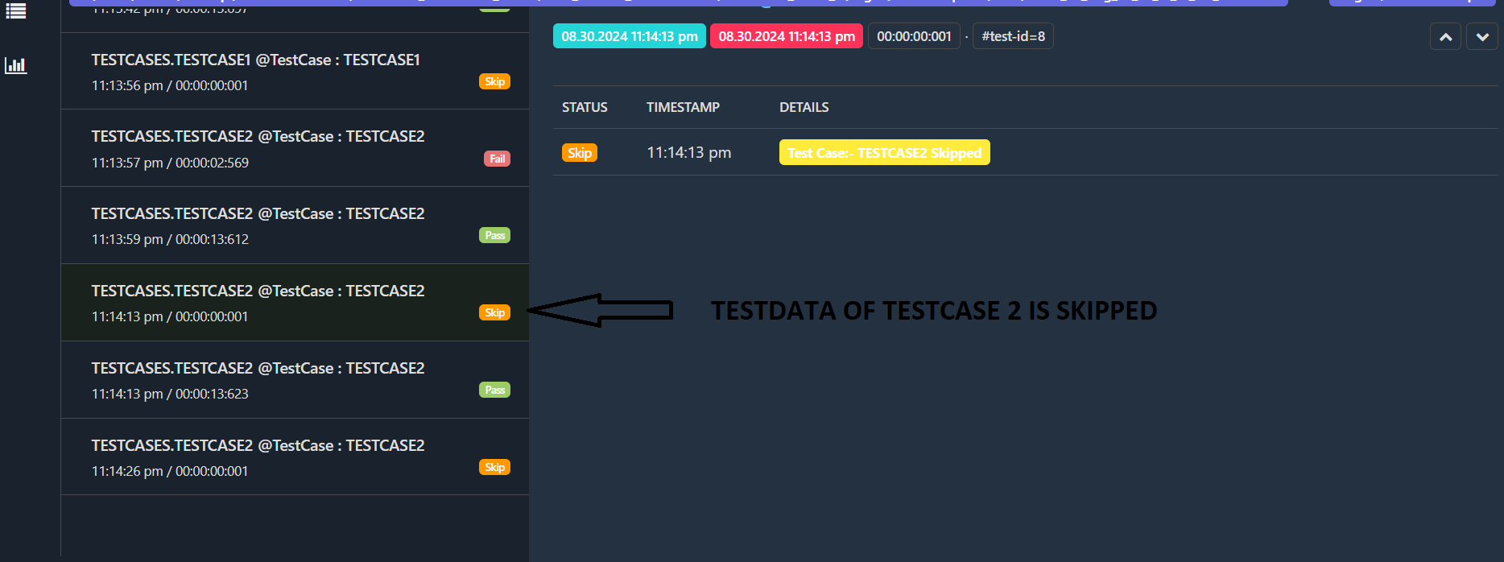

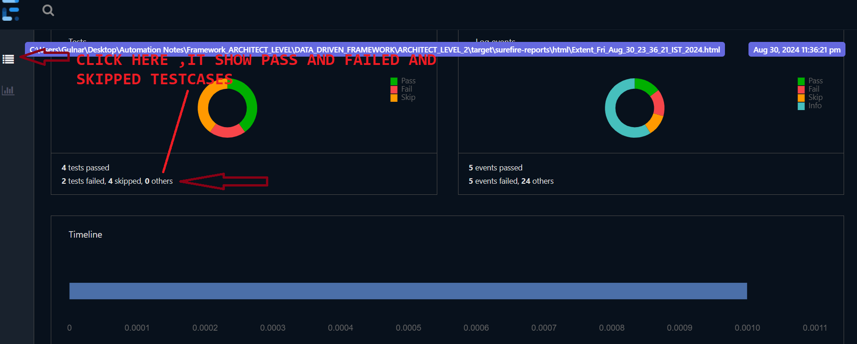

**STEP 28=>HOW TO OPTIMISE THE CODE USING THE HASHTABLES**

**HASHTABLE USE KEY AND VALUE PAIR CONCEPT TO STORE VALUES JUST LIKE “HASHMAP”**

**EXPLANATION**

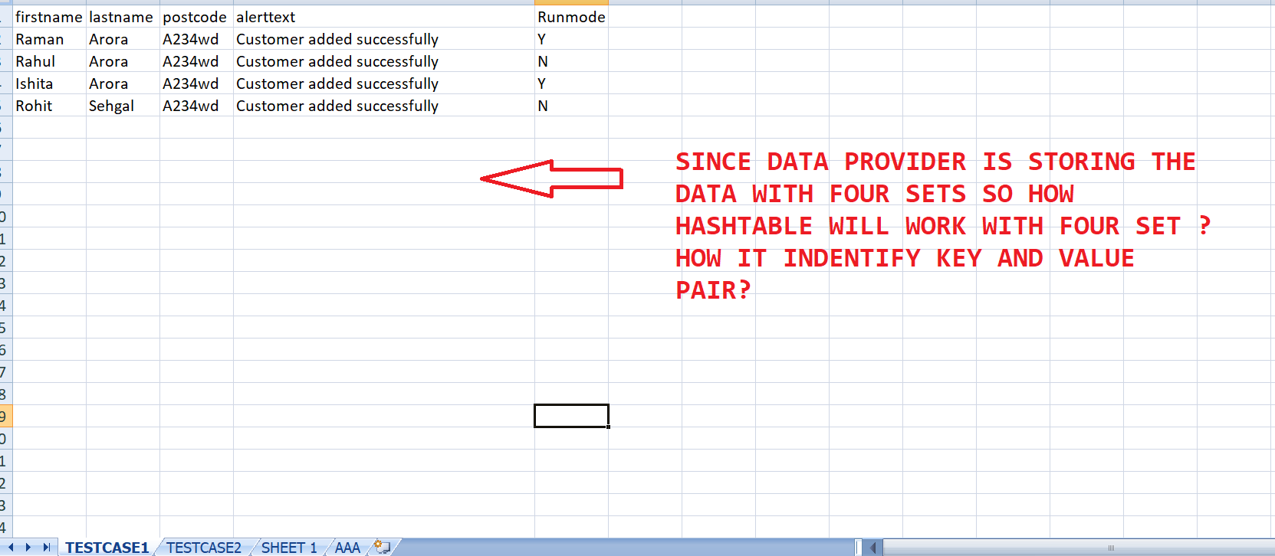

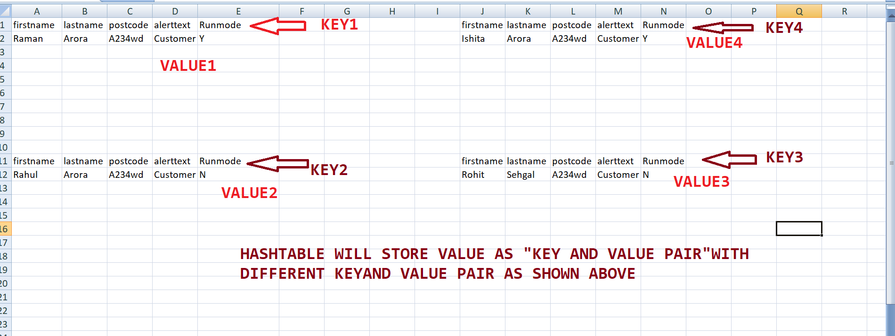

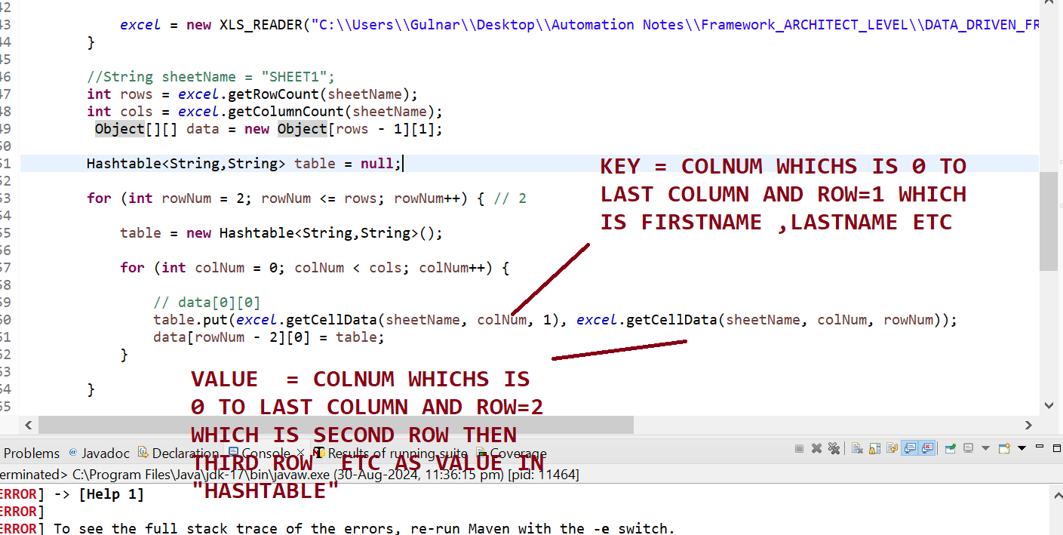

**STEPS 1=> ADD “HASHTABLE CODE FOR “DATA PROVIDER METHOD PRESENT IN “TEST UTLIS CLASS”**

**package** UTILITIES;

**import** java.io.File;

**import** java.io.IOException;

**import** java.lang.reflect.Method;

**import** java.util.Date;

**import** java.util.Hashtable;

**import** org.apache.commons.io.FileUtils;

**import** org.openqa.selenium.OutputType;

**import** org.openqa.selenium.TakesScreenshot;

**import** org.testng.annotations.DataProvider;

**import** BASE_CLASS.BASE_CLASS;

**public** **class** TEST_UTLIS **extends** BASE_CLASS

{

**public** **static** String *screenshotPath*;

**public** **static** String *screenshotName*;

**public** **static** **void** captureScreenshot_Failed_screesnhot() **throws** IOException

{

File scrFile = ((TakesScreenshot) *driver*).getScreenshotAs(OutputType.***FILE***);

Date d = **new** Date();

*screenshotName* = d.toString().replace(":", "_").replace(" ", "_") + ".jpg";

File destFile=**new** File(System.*getProperty*("user.dir") + "\\target\\surefire-reports\\html\\" + *screenshotName*);

FileUtils.*copyFile*(scrFile,destFile);

}

@DataProvider(name="DataProvide_4")

**public** Object[][] getData(Method m)

{

String sheetName=m.getName();

**if** (*excel* == **null**) {

*excel* = **new** XLS_READER("C:\\Users\\Gulnar\\Desktop\\Automation Notes\\Framework_ARCHITECT_LEVEL\\DATA_DRIVEN_FRAMEWORK\\ARCHITECT_LEVEL_2\\src\\test\\resources\\EXCEL_SHEET\\testdata.xlsx");

}

//String sheetName = "SHEET1";

**int** rows = *excel*.getRowCount(sheetName);

**int** cols = *excel*.getColumnCount(sheetName);

Object[][] data = **new** Object[rows - 1][1];

Hashtable<String,String> table = **null**;

**for** (**int** rowNum = 2; rowNum <= rows; rowNum++) { // 2

table = **new** Hashtable<String,String>();

**for** (**int** colNum = 0; colNum < cols; colNum++) {

// data[0][0]

table.put(*excel*.getCellData(sheetName, colNum, 1), *excel*.getCellData(sheetName, colNum, rowNum));

data[rowNum - 2][0] = table;

}

}

**return** data;

}

**public** **static** **boolean** Method_to_Skip(String testName, XLS_READER excel){

String sheetName="SHEET 1";

**int** rows = excel.getRowCount(sheetName);

**for**(**int** rNum=2; rNum<=rows; rNum++){

String testCase = excel.getCellData(sheetName, "TESTCASE_NEED_TO_RUN", rNum);

**if**(testCase.equalsIgnoreCase(testName)){

String runmode = excel.getCellData(sheetName, "Runmode", rNum);

**if**(runmode.equalsIgnoreCase("Y"))

**return** **true**;

**else**

**return** **false**;

}

}

**return** **false**;

}

}

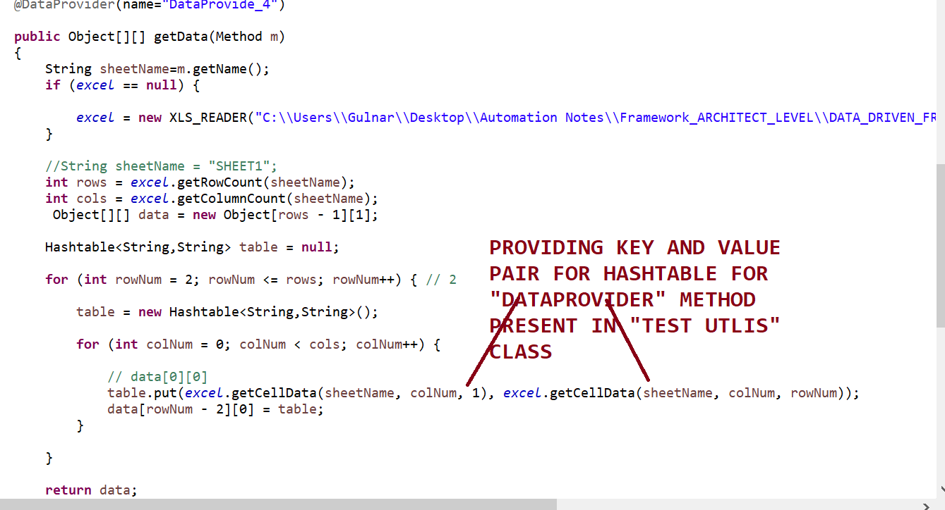

**STEPS 2=> THEN “EACH TEST CASE “ ,IT WILL PASS HASHTABLE METHOD AND WE USE “DATA.GET(LOCATOR NAME)” TO PERFORM CLICK ACTIONS OR SEND KEYS OR SELECT DROPDOWN VALUES ACTIONS IN TESTCASE 1 AND TESTCASE2 RESPECTIVELY**

**TESTCASE 1.JAVA**

**package** TESTCASES;

**import** java.io.IOException;

**import** java.util.Hashtable;

**import** org.openqa.selenium.Alert;

**import** org.openqa.selenium.By;

**import** org.openqa.selenium.support.ui.ExpectedConditions;

**import** org.testng.Assert;

**import** org.testng.Reporter;

**import** org.testng.SkipException;

**import** org.testng.annotations.DataProvider;

**import** org.testng.annotations.Test;

**import** BASE_CLASS.BASE_CLASS;

**import** UTILITIES.TEST_UTLIS;

**import** UTILITIES.XLS_READER;

**public** **class** TESTCASE1 **extends** BASE_CLASS

{

@Test

**public** **void** TESTCASE1() **throws** InterruptedException, IOException

{

*log*.info("Method 1 of Test Case 1 is Excueted");

Thread.*sleep*(3000);

click("customer_login_XPATH");

Thread.*sleep*(2000);

*verifyEquals*(*driver*.getTitle(),"Protractor practice website - Banking Aps");

Thread.*sleep*(2000);

click("Addcusotmer_XPATH");

*log*.info("Method 1 of Test Case 1 is completed");

}

@Test(dataProviderClass=TEST_UTLIS.**class**,dataProvider="DataProvide_4")

**public** **void** TESTCASE1(Hashtable<String,String> data) **throws** Throwable

{

**if**(!data.get("Runmode").equals("Y")){

**throw** **new** SkipException("Skipping the test case as the Run mode for data set is NO");

}

Reporter.*log*("TEST CASE 1 IS STARTED!!!");

*log*.info("Method 2 of Test Case 1 is Excueted");

Thread.*sleep*(3000);

type_value("firstname_XPATH",data.get("firstname"));

Thread.*sleep*(2000);

type_value("lastname_XPATH",data.get("lastname"));

Thread.*sleep*(2000);

type_value("postalcode_XPATH",data.get("postcode"));

Thread.*sleep*(2000);

Assert.*assertTrue*(IsElementPresent

(By.*xpath*(*OR*.getProperty("add_cusomter_button_XPATH"))),"Login not successful");

Thread.*sleep*(2000);

click("add_cusomter_button_XPATH");

//Wait for the alert to be displayed and store it in a variable

Alert alert = *waits*.until(ExpectedConditions.*alertIsPresent*());

Thread.*sleep*(2000);

//Store the alert text in a variable

String text = alert.getText();

System.***out***.println("Text is "+text);

//Press the OK button

Assert.*assertTrue*(alert.getText().contains(data.get("alerttext")));

//Thread.sleep(2000);

alert.accept();

*log*.info("Method 2 of Test Case 1 is completed");

Reporter.*log*("TEST CASE 1 completed!!!");

}

}

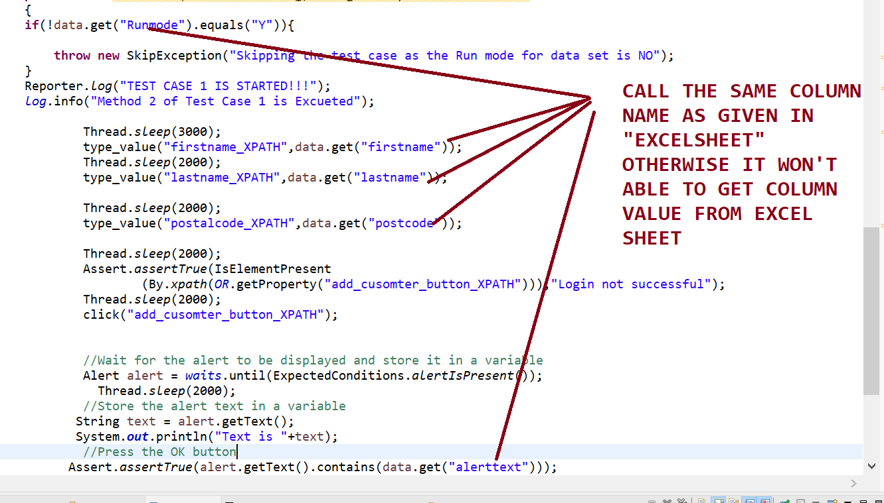

**TESTCASE 2.JAVA**

**package** TESTCASES;

**import** **static** org.testng.Assert.*assertTrue*;

**import** java.util.Hashtable;

**import** org.openqa.selenium.Alert;

**import** org.openqa.selenium.support.ui.ExpectedConditions;

**import** org.testng.SkipException;

**import** org.testng.annotations.Test;

**import** com.aventstack.extentreports.util.Assert;

**import** BASE_CLASS.BASE_CLASS;

**import** UTILITIES.TEST_UTLIS;

**public** **class** TESTCASE2 **extends** BASE_CLASS

{

@Test(dataProviderClass=TEST_UTLIS.**class**,dataProvider="DataProvide_4")

**public** **void** TESTCASE2(Hashtable<String,String> data ) **throws** InterruptedException {

**if**(!data.get("Runmode").equals("Y")){

**throw** **new** SkipException("Skipping the test case as the Run mode for data set is NO");

}

*log*.info(" Test Case 2 is STARTED");

Thread.*sleep*(3000);

click("openaccount_XPATH");

Thread.*sleep*(2000);

select("customer_XPATH", data.get("CUSOMTERNAME "));

Thread.*sleep*(2000);

select("currency_CSS", data.get("CURRENCY"));

Thread.*sleep*(2000);

click("process_CSS");

Thread.*sleep*(2000);

Alert alert = *waits*.until(ExpectedConditions.*alertIsPresent*());

Thread.*sleep*(2000);

alert.accept();

*log*.info(" Test Case 2 is Excueted");

}

@Test

**public** **void** TESTCASE2() **throws** InterruptedException

{

click("openaccount_XPATH");

Thread.*sleep*(2000);

select("customer_XPATH", "Hermoine Granger");

*assertTrue*(**false**);

}

}

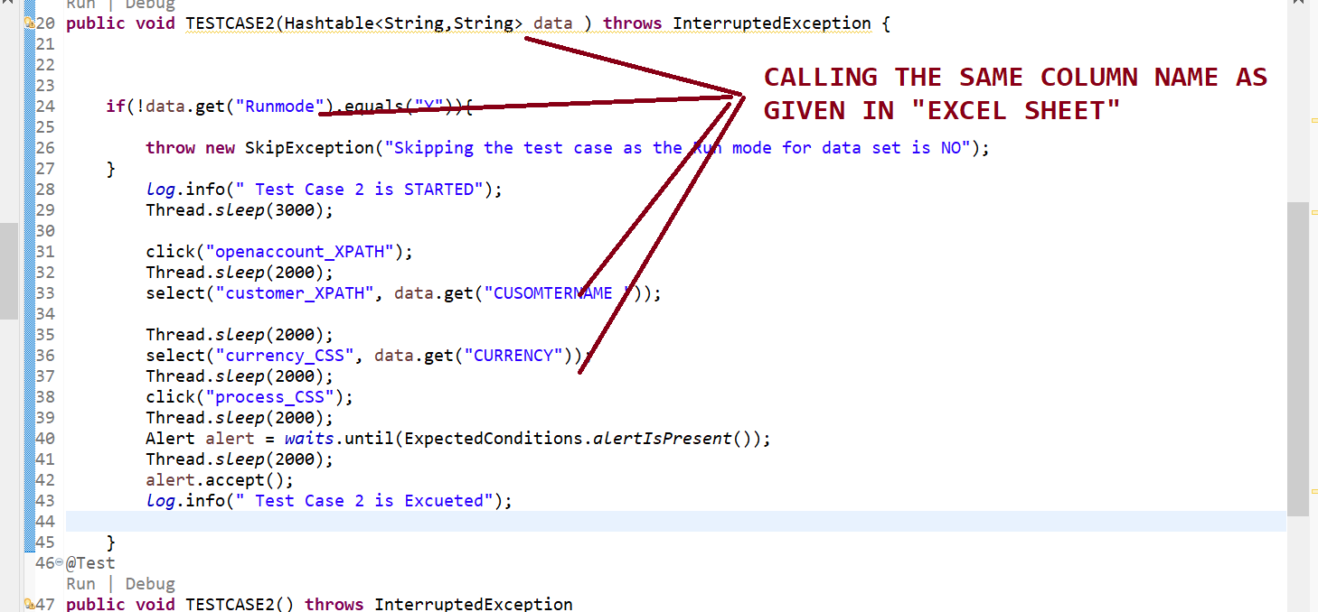

**STEPS 3=> RIGHT CLICK AND RUN AS “MAVEN TEST” THEN EXTENT REPORT WILL BE GENERATED**

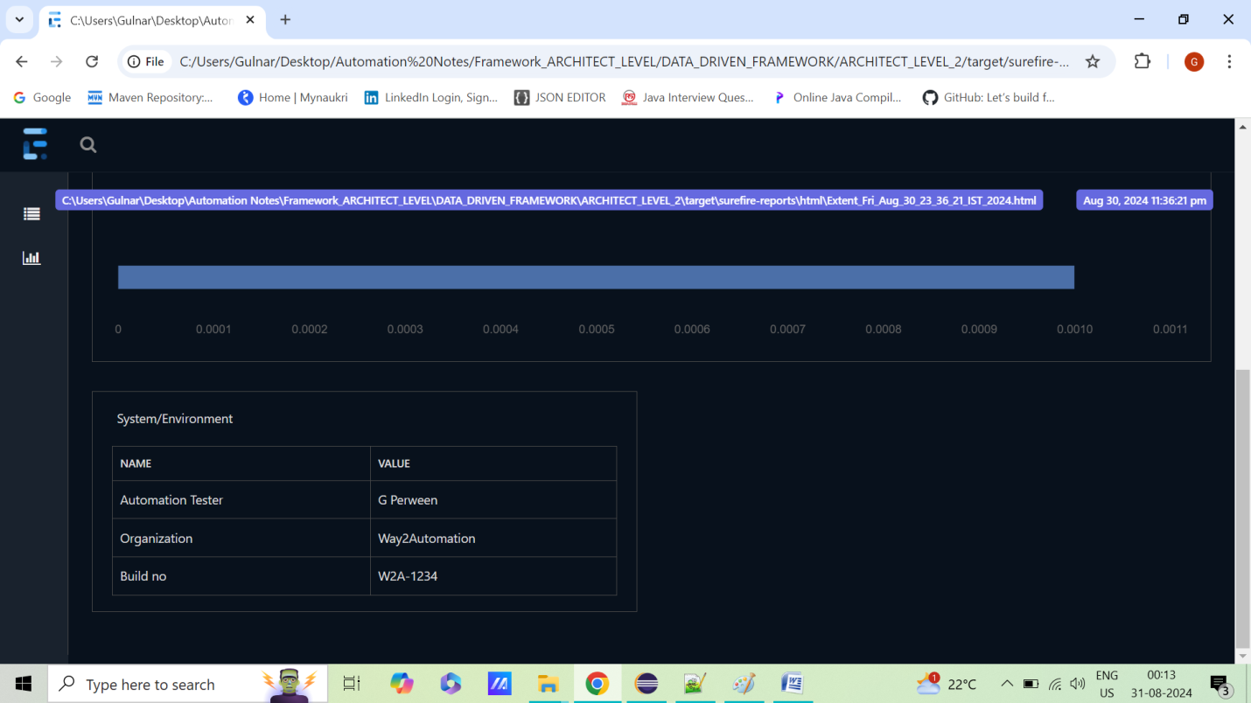

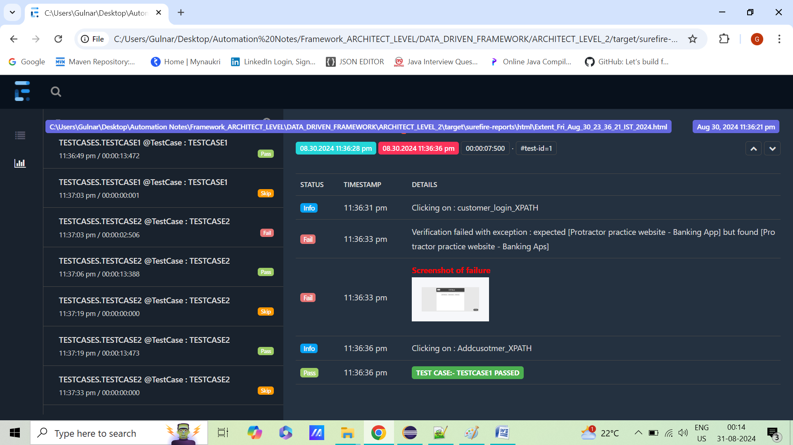

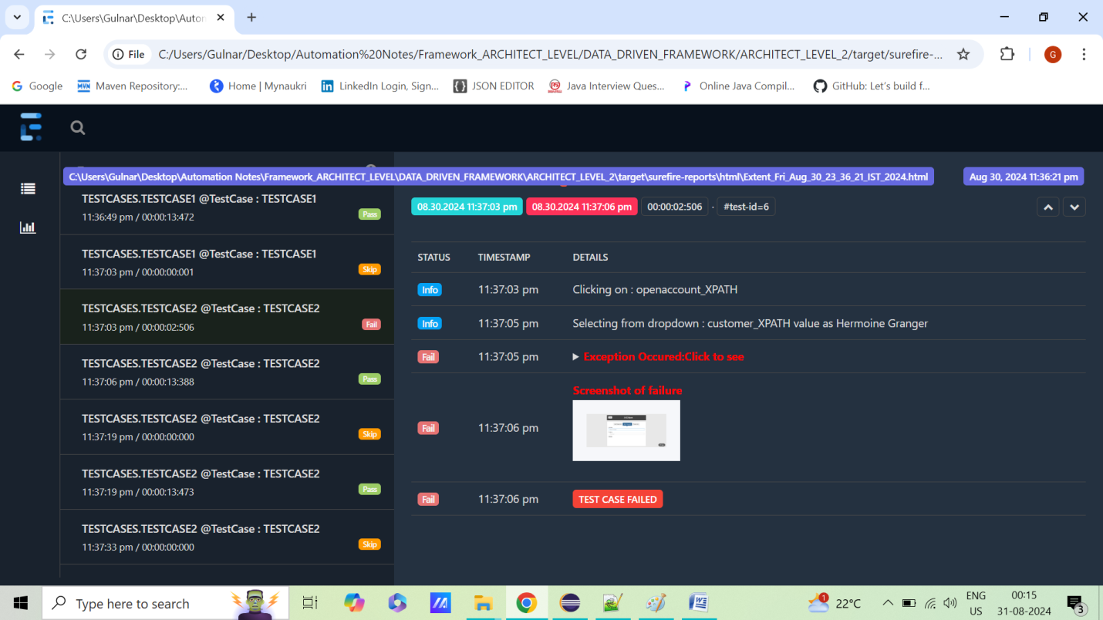

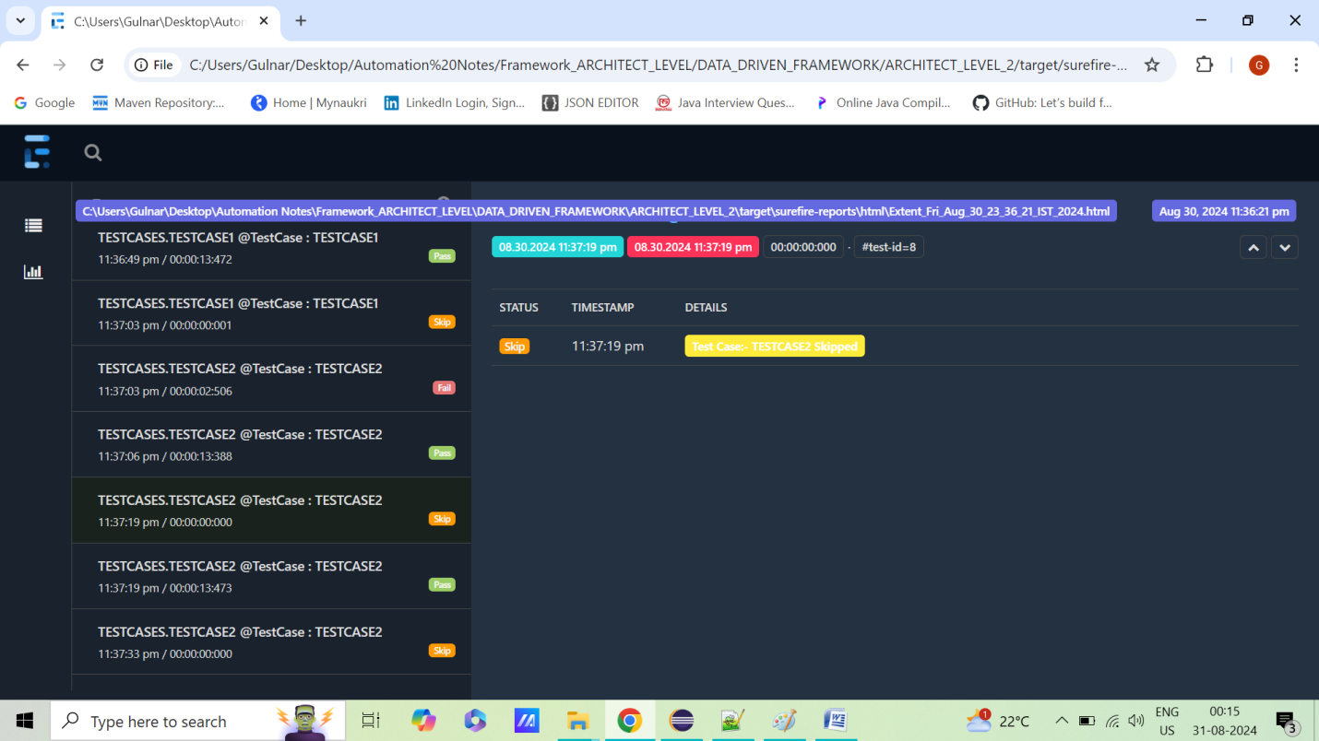

**STEP 28=>HOW TO USE JENKINS IN CURRENT PROJECTS?**

**QUESTION 18=> HOW TO WORK WITH JENKINS**

**STEP 1=>INSTALL JENKINS .WAR FILE**

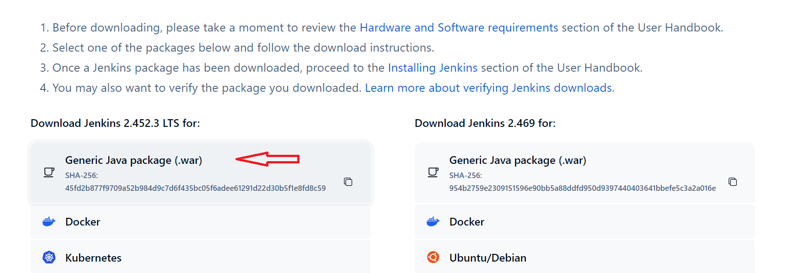

**STEP 2=>GO TO COMMAND PROMPT AND ENTER**

**”cd LOCATION OF JENKINS WAR FILE”**

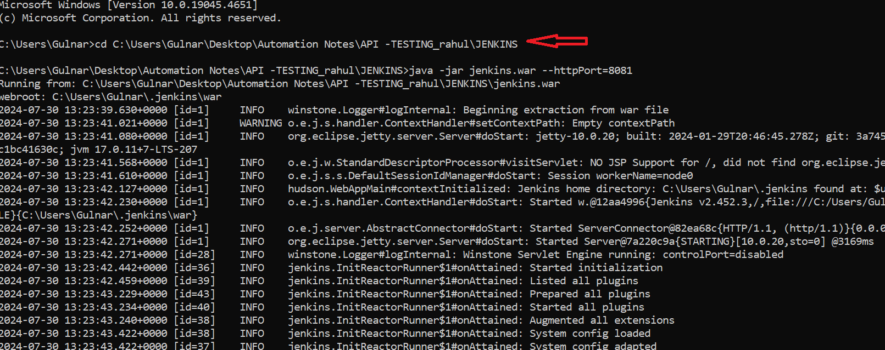

**STEP 3=>GO TO COMMAND PROMPT AND ENTER BELOW COMMAND=>**

**java -jar jenkins.war --httpPort=8081**

**IT MEANS IT WILL INSTALL JENKINS ON LOCAL PORT 8081 SERVER**

**STEP 4=>GO TO CHROME ,ENTER =>** [**http://localhost:8081/**](http://localhost:8081/)

**AND ENTER THE PASSWORD SHOWN IN COMMAND prompt there**

**jenkins =>http://localhost:8081/**

**runthe below command=>java -jar jenkins.war --httpPort=8081**

**username =gulnar_**

**pwd=12345**

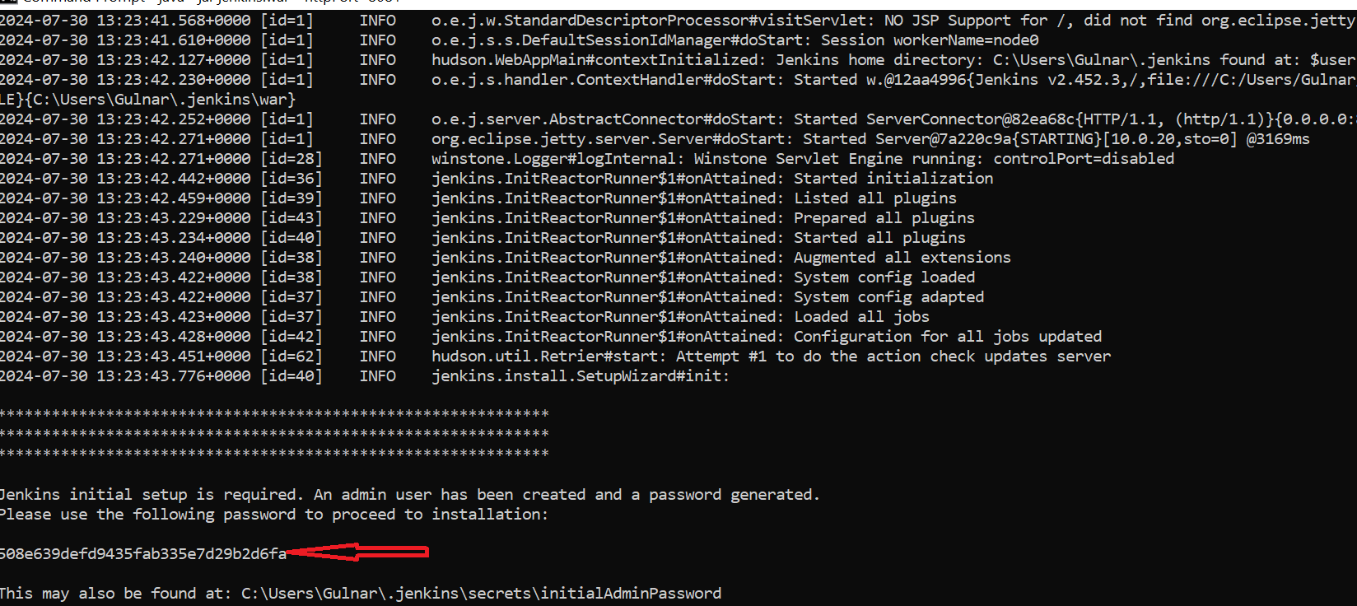

**STEP 5=>PROVIDE USERNAME AND PASSWORD THERE IN LOCAL HOST:8081 SERVER**

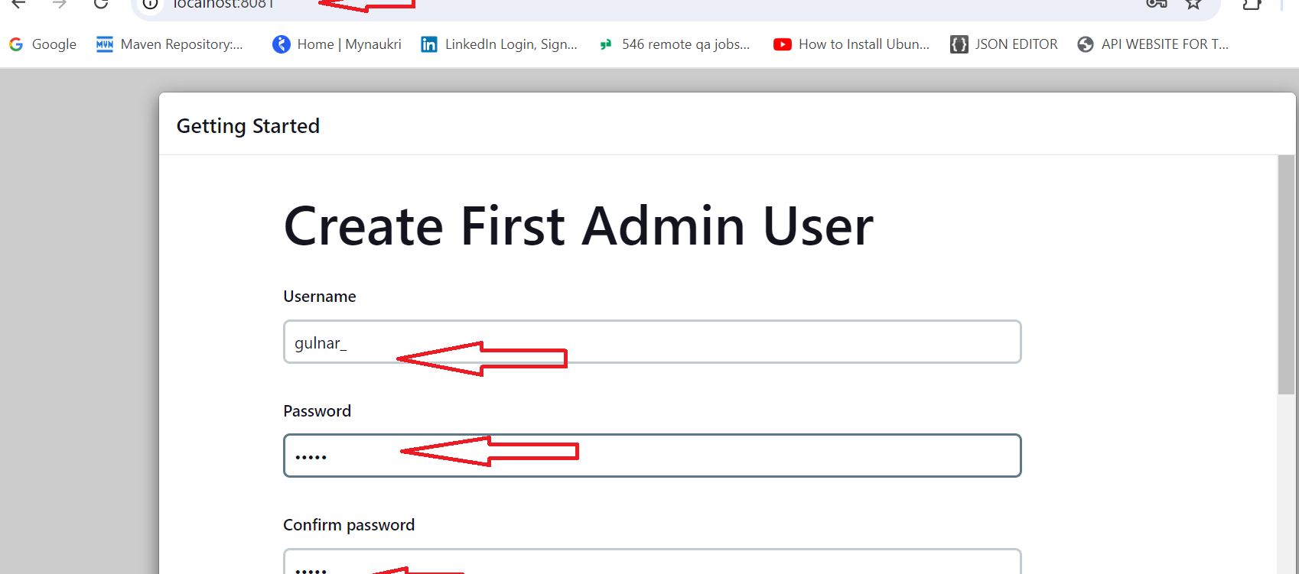

**STEP 6=> IT WILL SHOW MESSAGE "JENKINS IS READY"**

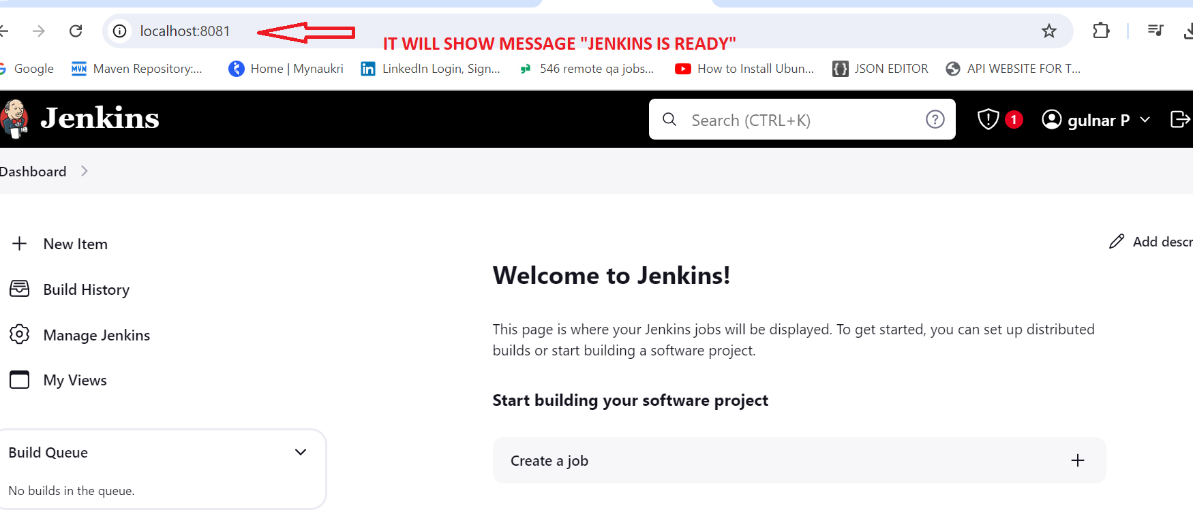

**STEPS 1=> ADD TWO DEPENDENCIES IN POM.XML SUCHAS “REPORTNG” AND “GUICE”**

**STEPS 1=> ADD TWO DEPENDENCIES IN POM.XML SUCHAS “REPORTNG” AND “GUICE”**

**STEPS 1=> ADD TWO DEPENDENCIES IN POM.XML SUCHAS “REPORTNG” AND “GUICE”**

**STEPS 1=> ADD TWO DEPENDENCIES IN POM.XML SUCHAS “REPORTNG” AND “GUICE”**

**STEPS 1=> ADD TWO DEPENDENCIES IN POM.XML SUCHAS “REPORTNG” AND “GUICE”**

**STEPS 1=> ADD TWO DEPENDENCIES IN POM.XML SUCHAS “REPORTNG” AND “GUICE”**

**STEP 29=>**

**STEP 30=>**

**STEP 31=>**

**STEP 32=>**

**STEP 33=>**

**STEP 34=>**

**STEP 35=>**

**STEP 36=>**

**STEP 37=>**

**STEP 38=>**

**STEP 39=>**

**STEP 40=>**

**STEP 41=>**

**STEP 42=>**

**STEP 43=>**

**STEP 44=>**

**STEP 45=>**

**STEP 46=>**

**STEP 47=>**

**STEP 48=>**

**STEP 49=>**

**STEP 50=>**

**STEP 51=>**

**STEP 52=>**

**STEP 53=>**

**STEP 54=>**

**STEP 56=>**

**STEP 57=>**

**STEP 58=>**

**STEP 59=>**

**STEP 60=>**

**STEP 61=>**

**STEP 62=>**

**STEP 63=>**

**STEP 64=>**

**STEP 65=>**

**STEP 66=>**

**STEP 67=>**

**STEP 68=>**

**STEP 69=>**

**STEP 70=>**

**STEP 71=>**

**STEP 72=>**

**STEP 73=>**

**STEP 74=>**

**STEP 75=>**

**STEP 76=>**

**STEP 77=>**

**STEP 78=>**

**STEP 79=>**

**STEP 80=>**